CMR INSTITUTE OF TECHNOLOGY
Affiliated to Visvesvaraya Technological University(VTU)
Sri Nivasa Reddy Layout, AECS Layout,
Marathahalli,Bengaluru, Karnataka 560037



Department of Information Science and Engineering

DEVOPS (BCSL657D)
Faculty Name: Prof. Bindiya A J/Prof. Neeraj/Prof. Janhavi Patil/Prof. Vijayanthi/Prof. Nidhi Joshi Parsai

AWS account Creation Steps:

1)Visit : https://aws.amazon.com/resources/create-account/

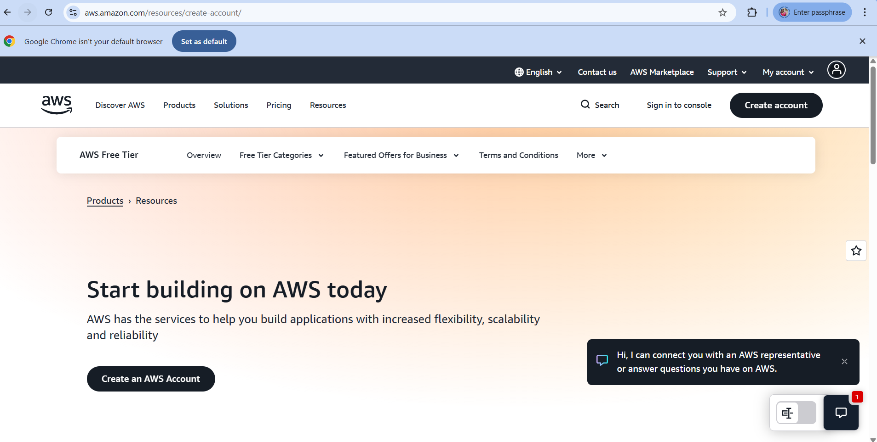

2) Sign in to console and Click on “Create new aws account”

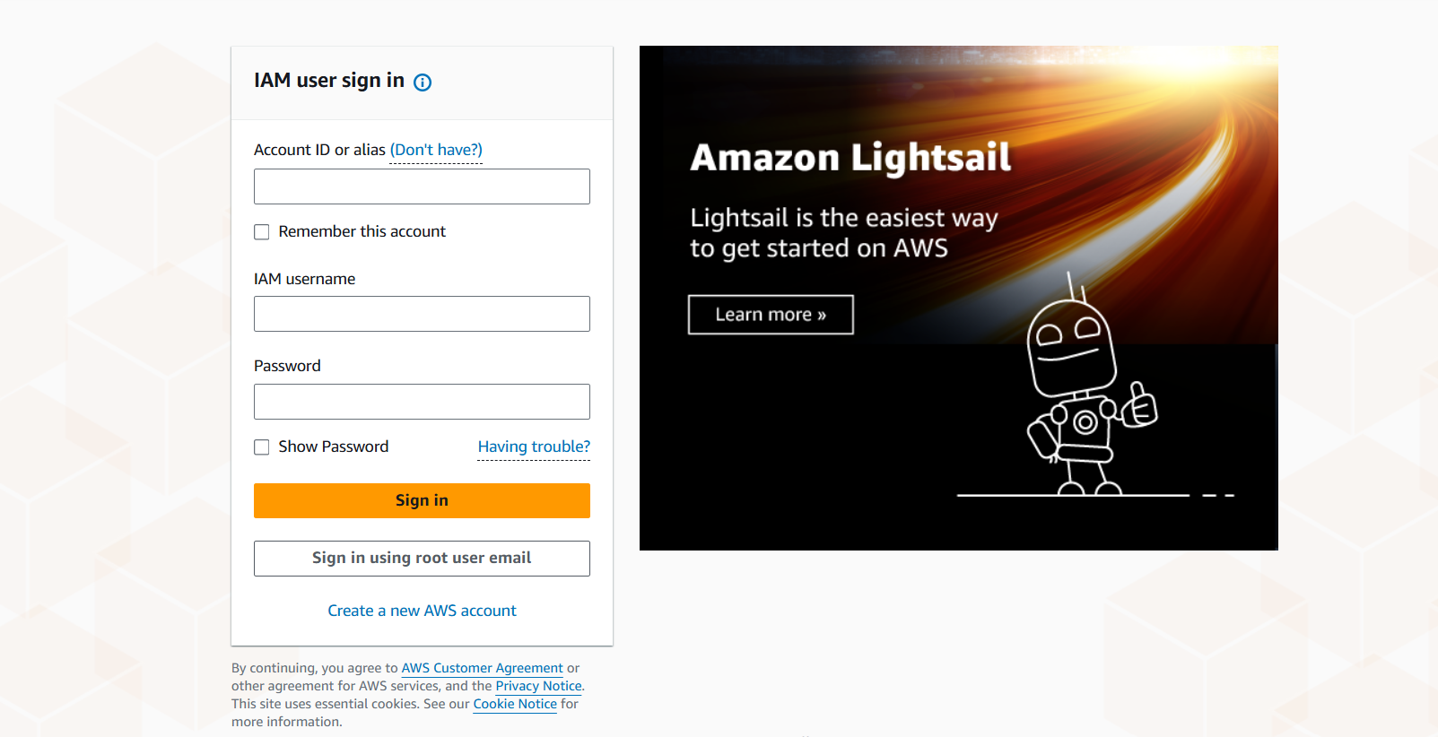

3) Enter “root user” email id and “Name” and “verify email address”

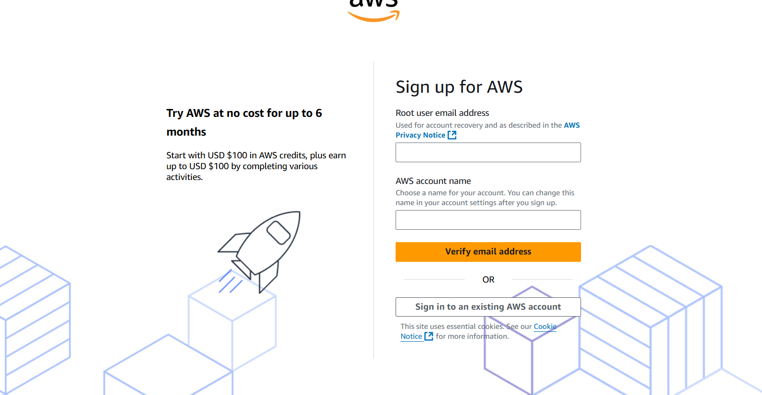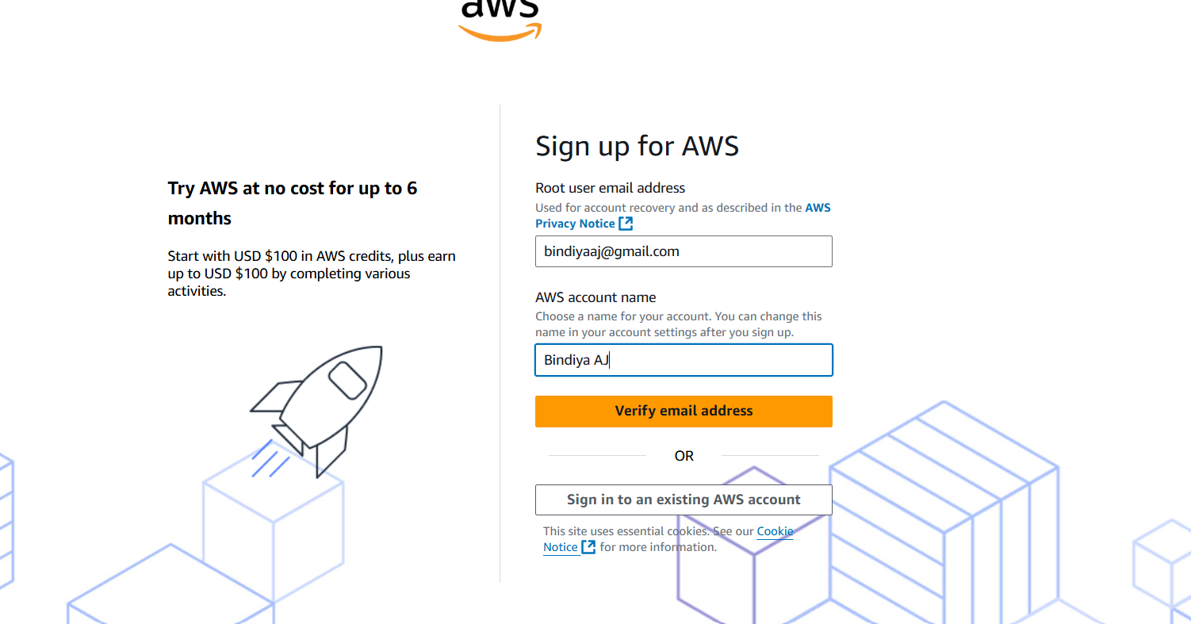

4) Sign up for AWS and choose free plan
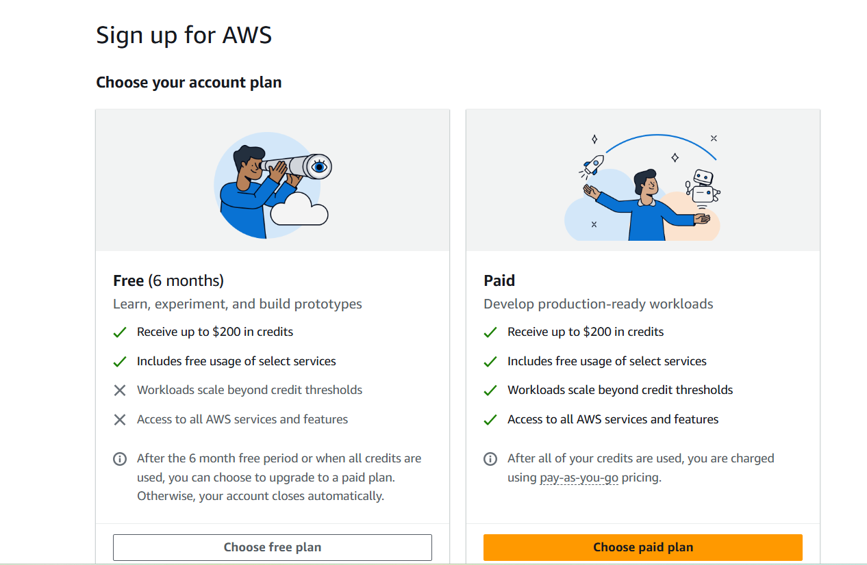
5)Enter your “personal data”

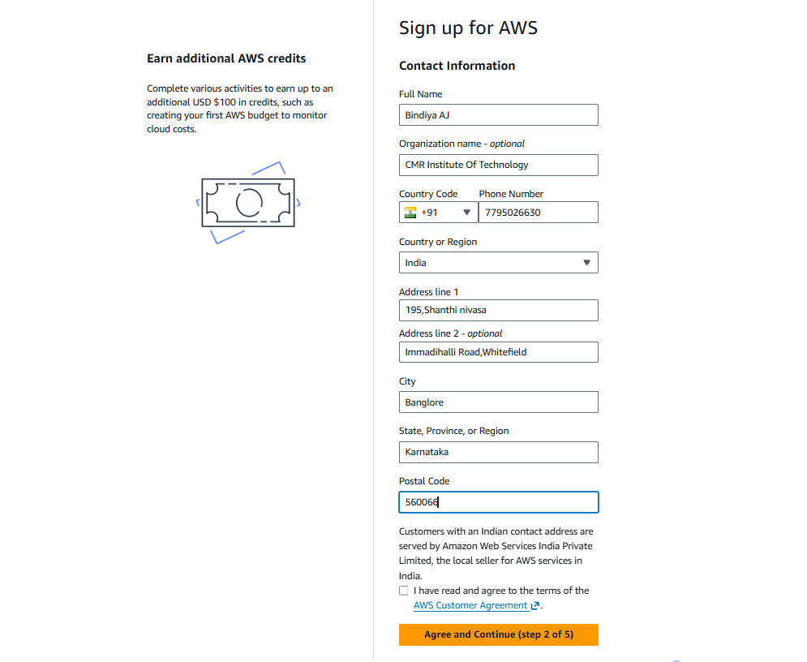

6)Enter billing information “UPI” or “Credit/debitCard”

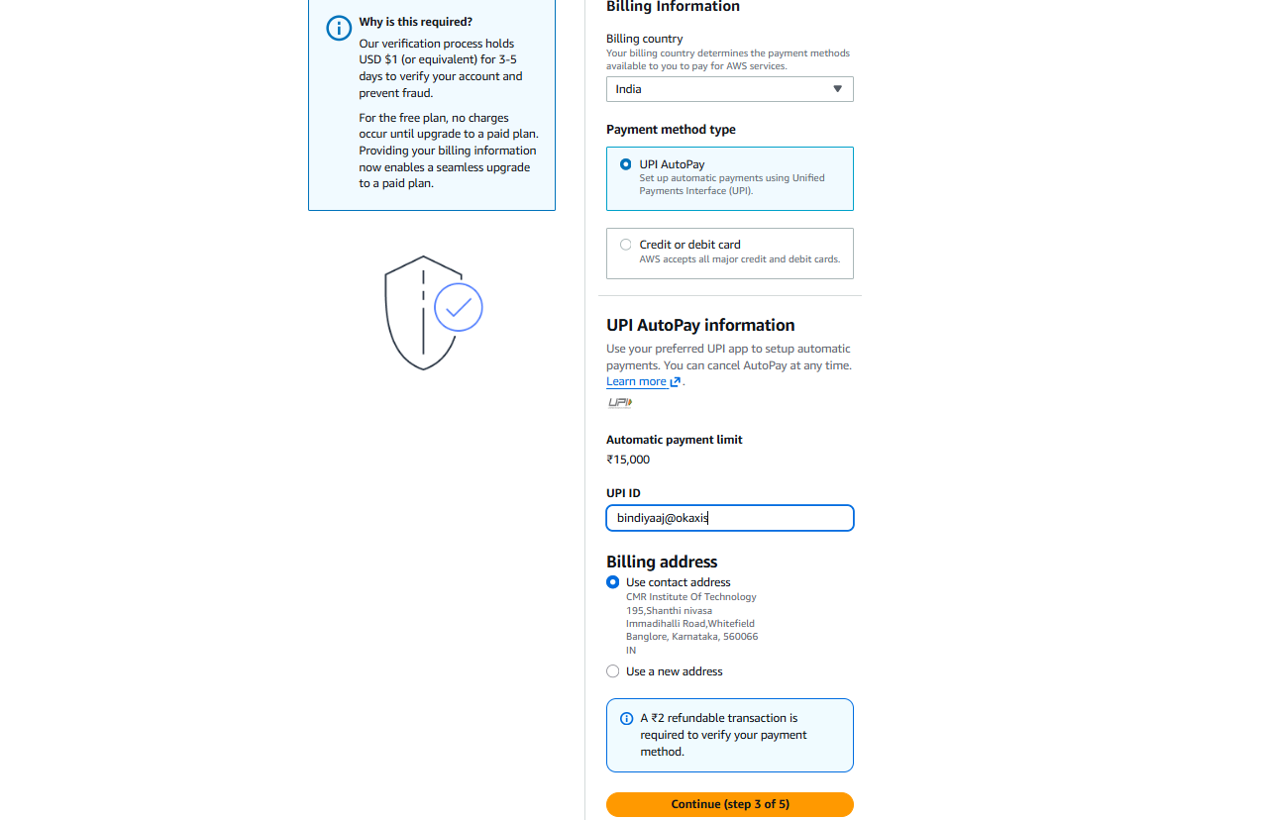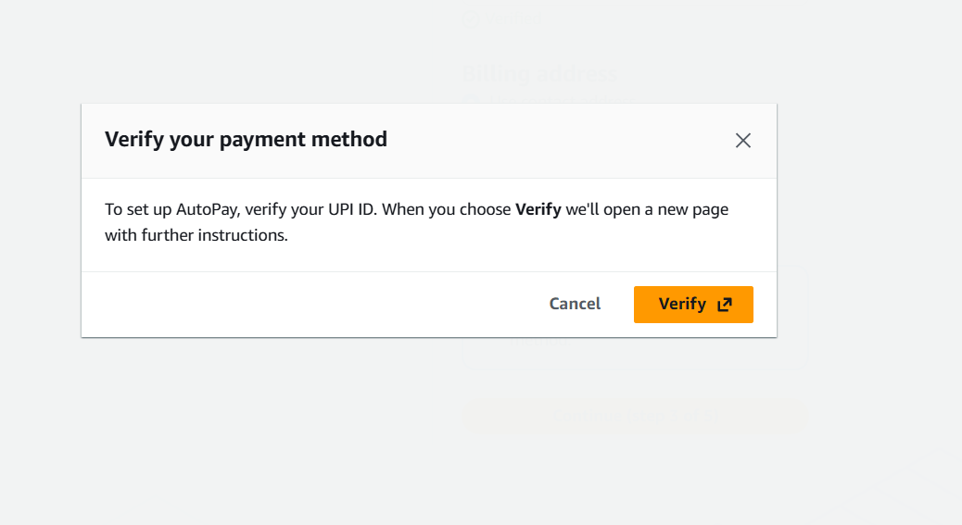

7)Confirm your identity by filling your authorized ID card data
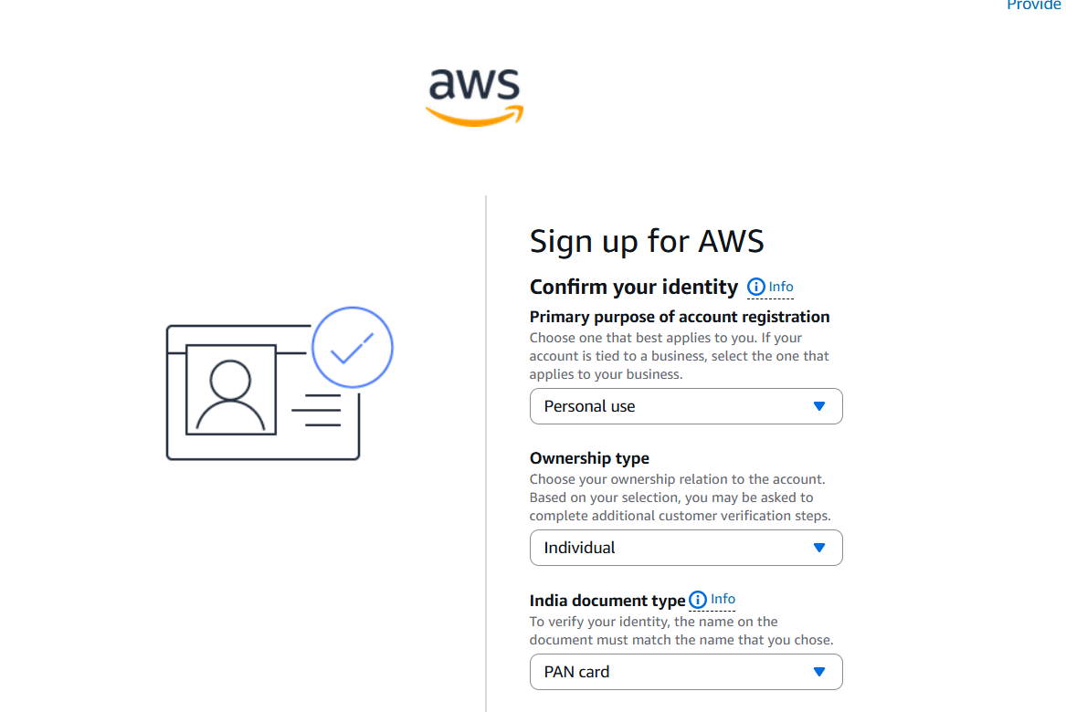
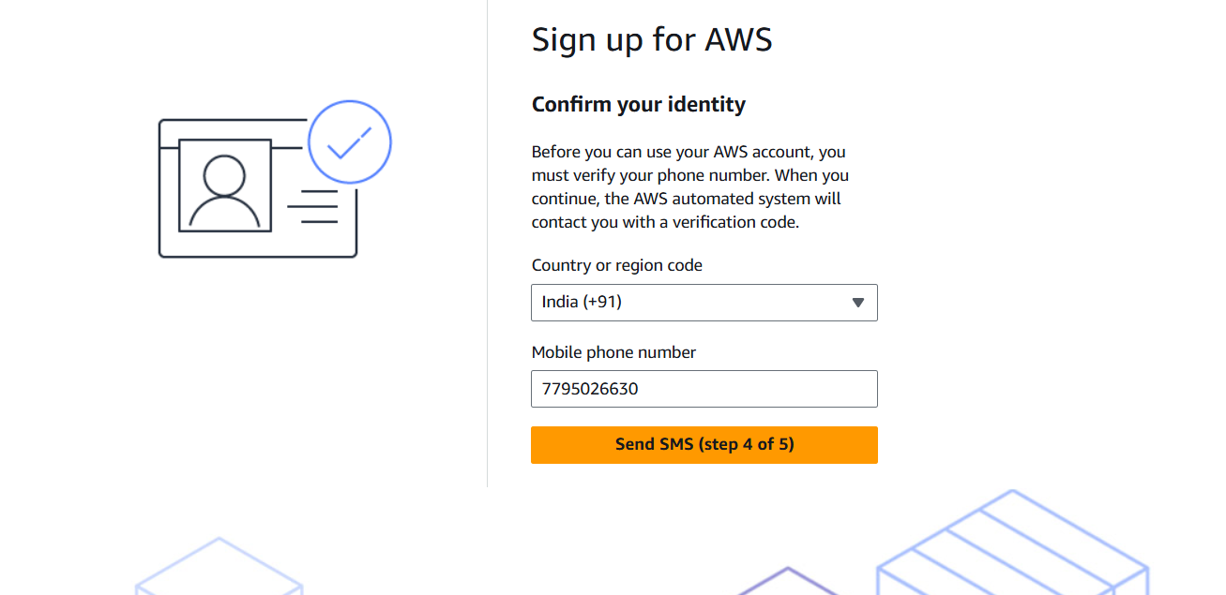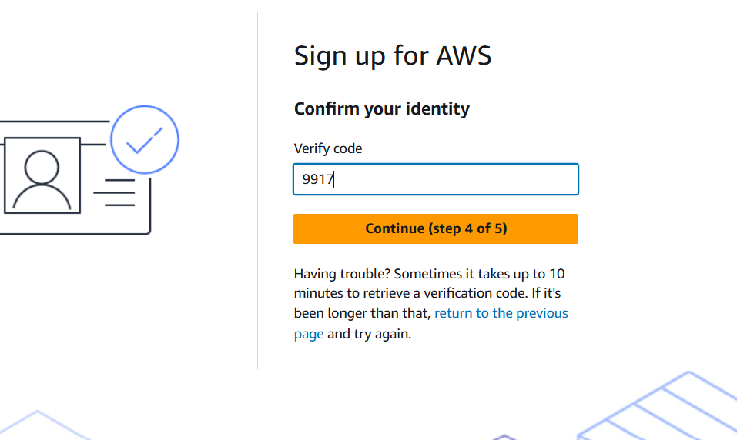

8)Login Page with credit points on right top of the page

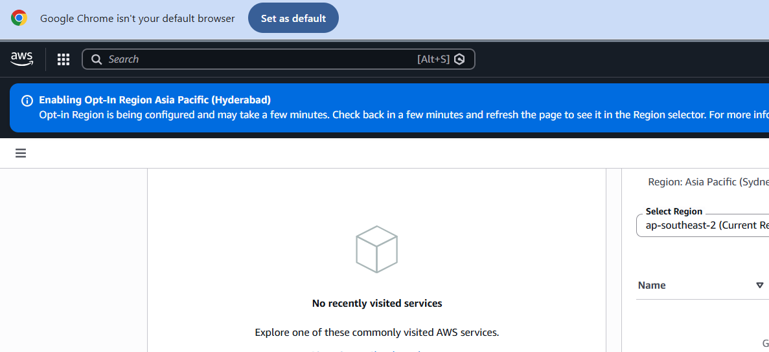

9) Search for EC2 instance

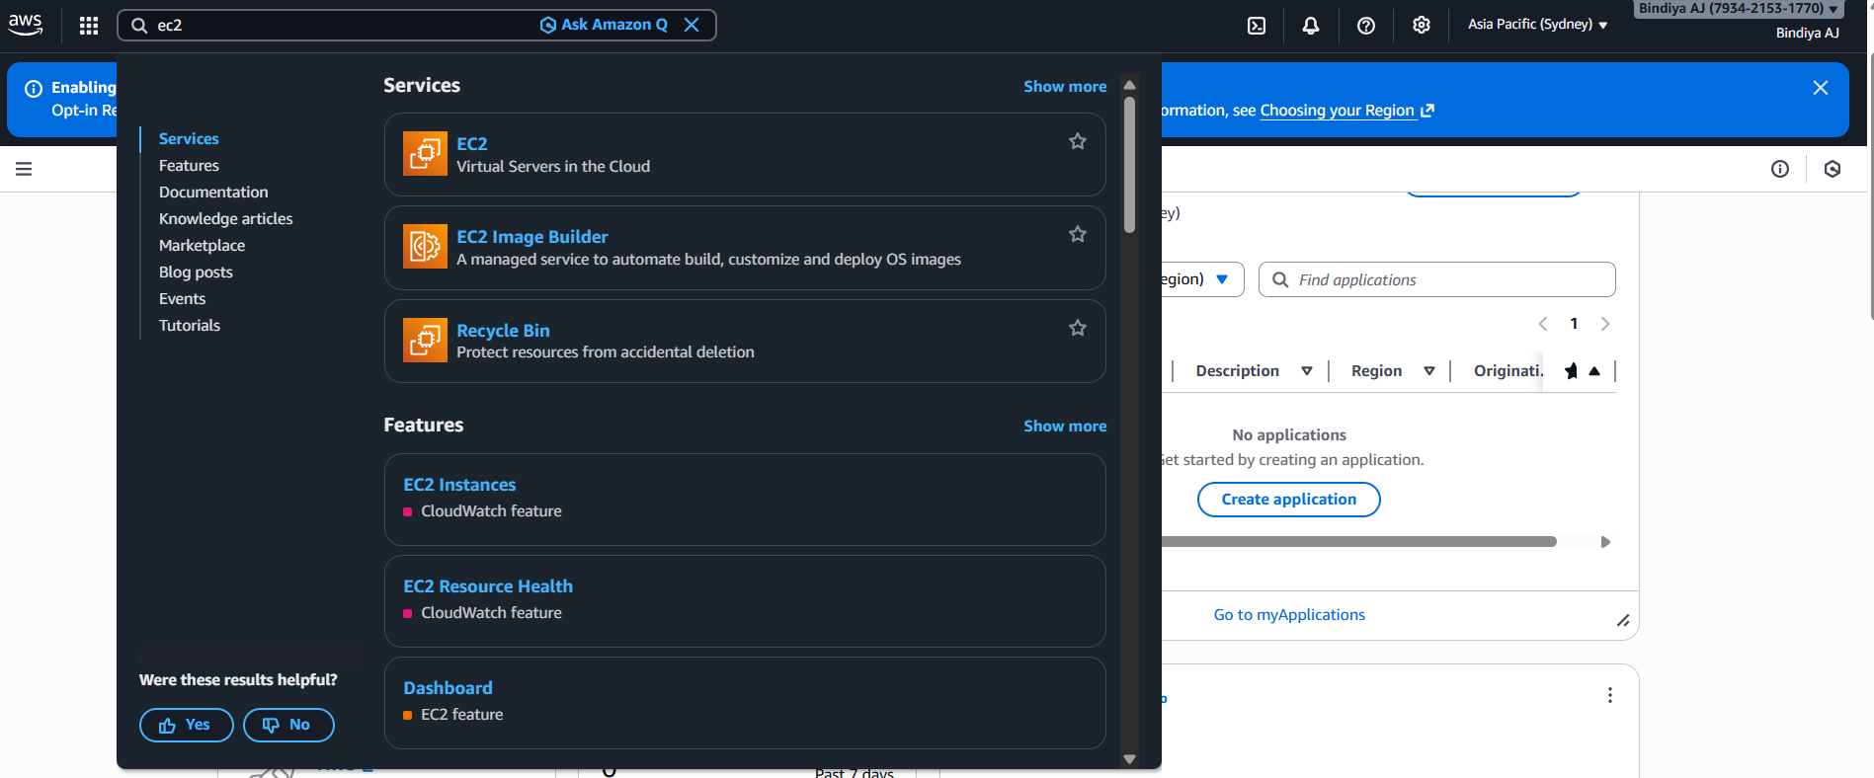

10) Select launch instance
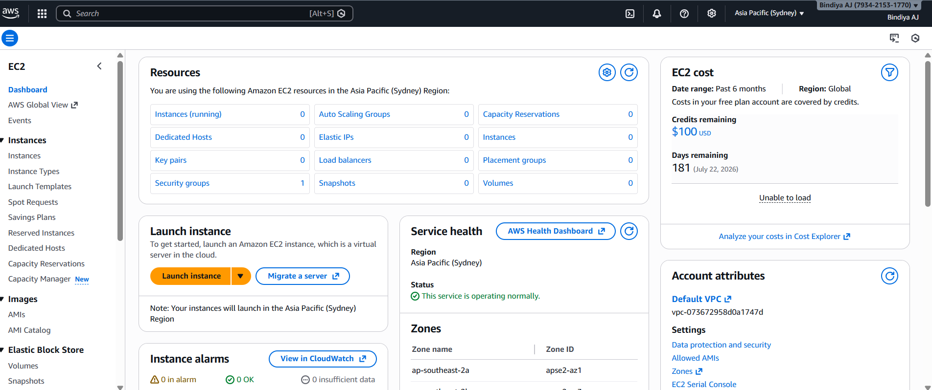
11) Enter any name for instance and select AWS linus
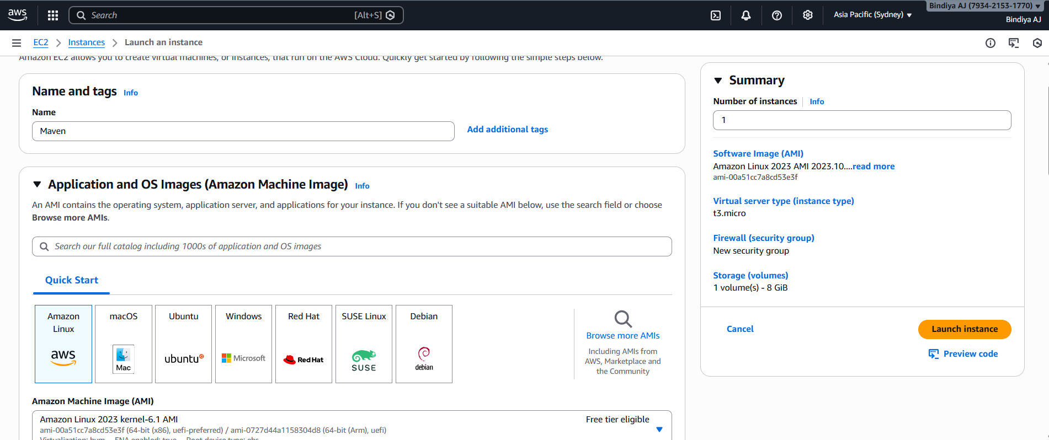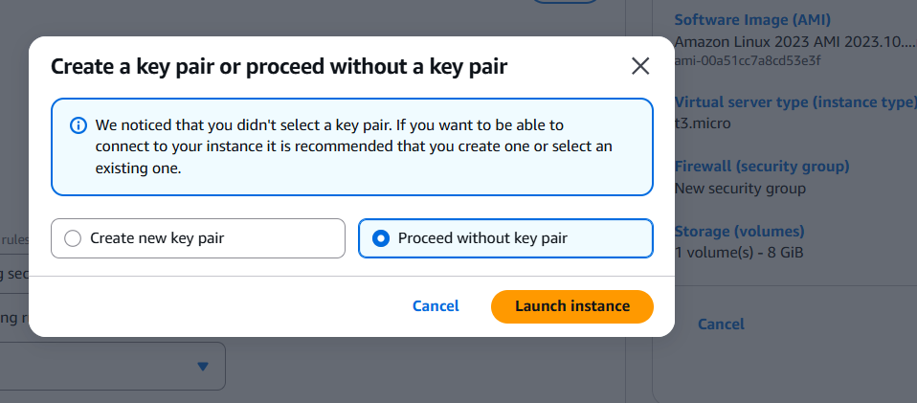

12) you can view list of “ instance on top of the page”

Now select the instance and connect

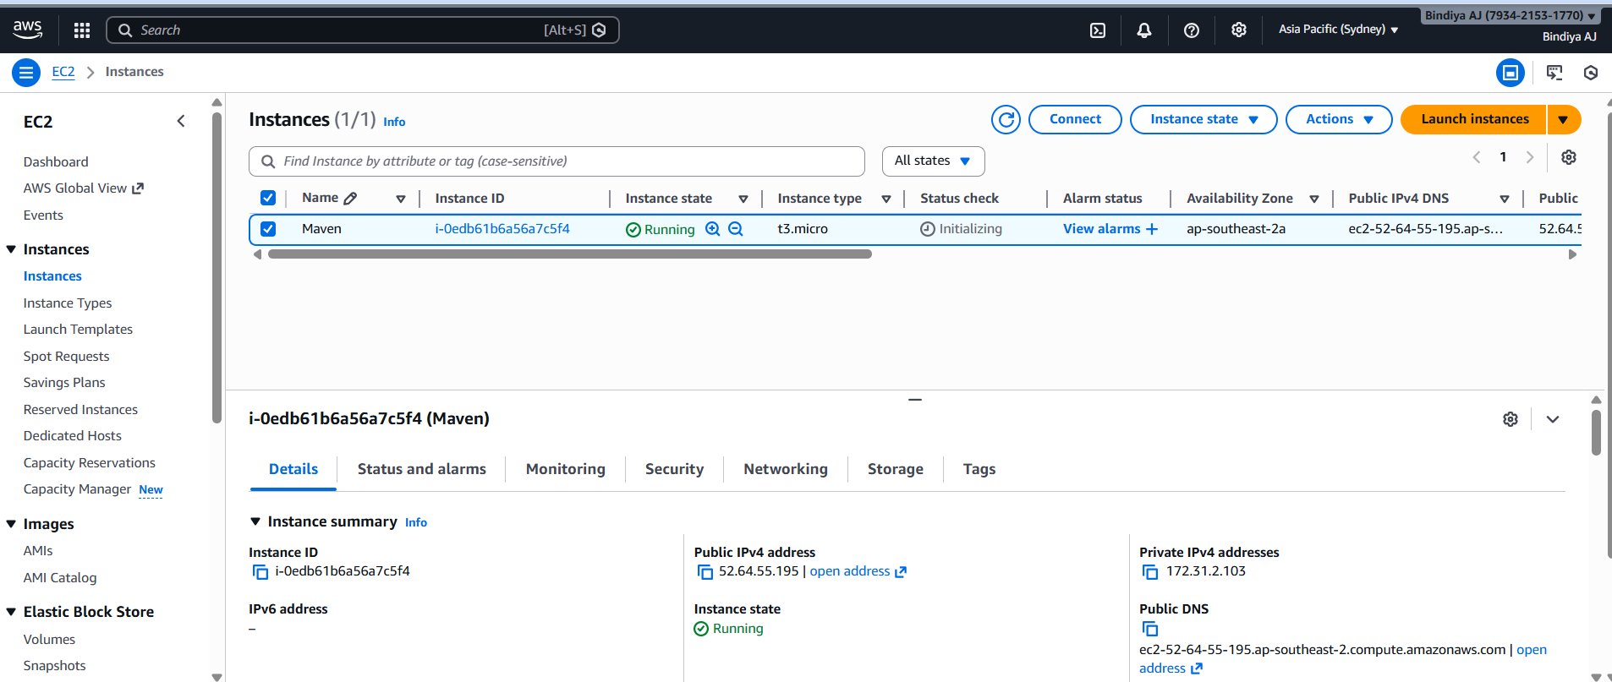

13) Linux command line interface will appear
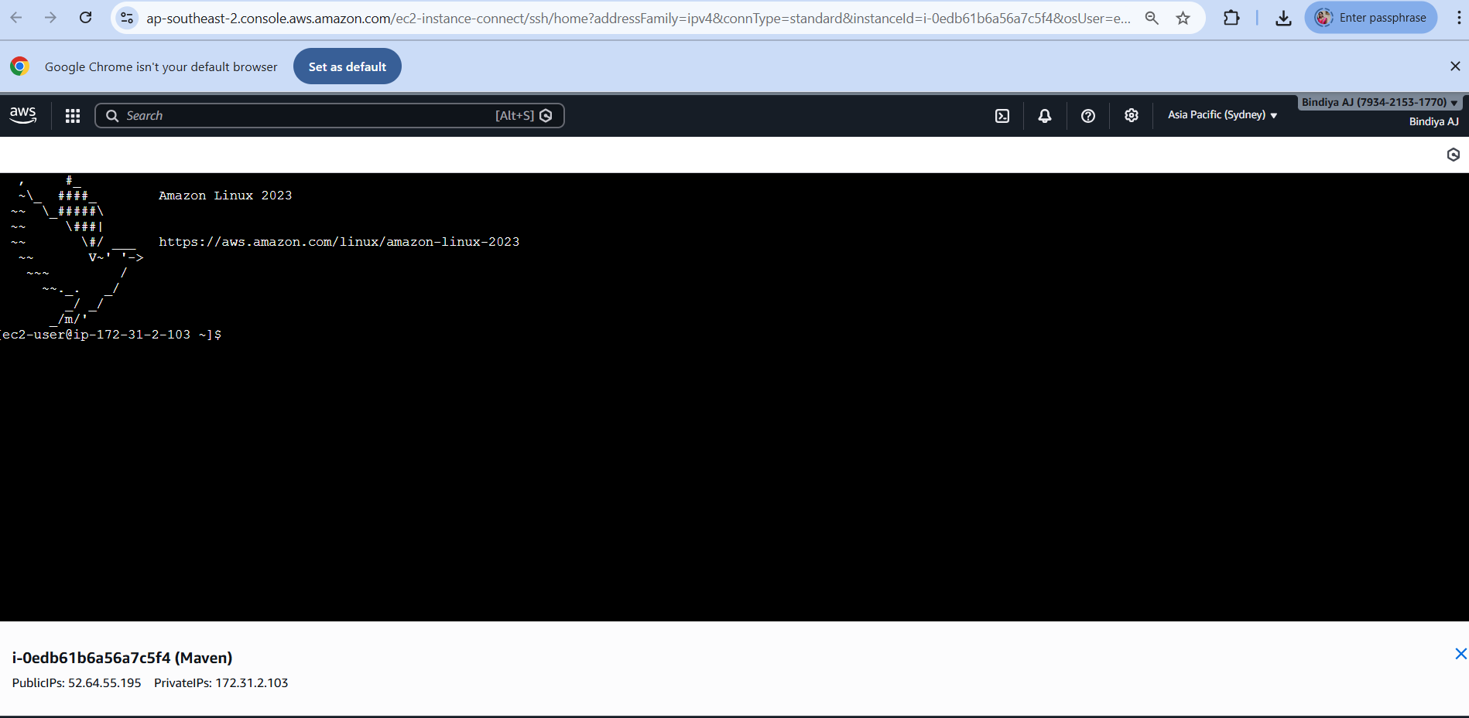

1. Understanding DevOps
What is DevOps?
DevOps is a set of cultural philosophies, practices, and tools that combine software development (Dev) and IT operations (Ops). Its goal is to shorten the systems development life cycle while delivering features, fixes, and updates frequently in close alignment with business objectives. DevOps promotes:
• Collaboration: Breaking down silos between development and operations teams. • Automation: Automating repetitive tasks (builds, tests, deployments) to improve efficiency.
• Continuous Integration/Delivery (CI/CD): Regularly integrating code changes and deploying them to production with minimal manual intervention.
• Monitoring and Feedback: Constantly monitoring the performance and behavior of applications in production to rapidly address issues.
Why is DevOps Used?
• Speed and Agility: Faster development cycles and quicker time-to-market. • Quality: Automated testing and integration help catch issues early.
• Reliability: Frequent, smaller updates reduce the risk of large-scale failures. • Efficiency: Automation reduces manual errors and repetitive tasks.
• Scalability: Processes and infrastructure can grow with the business. Examples of DevOps in Action:
• Continuous Integration (CI): Tools like Jenkins or Azure Pipelines automatically build and test code on every commit.
• Continuous Deployment (CD): Systems automatically deploy tested code to production environments.
• Monitoring: Tools such as Prometheus, Grafana, or New Relic continuously monitor application performance.

Experiment 1:

Introduction to Maven and Gradle: Overview of Build Automation Tools, Key
Differences Between Maven and Gradle, Installation and Setup
Introduction to Maven and Gradle
What is Maven?
Maven is a build automation and project management tool primarily used for Java projects. It uses a central configuration file known as the POM (Project Object Model), written in XML, which defines the project structure, its dependencies, build order, and plugins.
Key Features and Roles of Maven:
• Convention over Configuration: Maven enforces a standard directory structure (e.g., src/main/java, src/test/java), which simplifies project setup.
• Dependency Management: Automatically downloads and manages external libraries and dependencies from repositories like Maven Central.
• Build Lifecycle: Defines a fixed lifecycle (e.g., compile, test, package, install, deploy) which standardizes the build process.
• Plugin Ecosystem: Provides a rich set of plugins to extend functionality (e.g., unit testing, code coverage, reporting).
What is Gradle?
Gradle is a modern build automation tool that is known for its flexibility and performance. It uses a Groovy or Kotlin DSL (Domain Specific Language) to define build logic, which allows for more dynamic and customizable configurations compared to Maven’s XML-based approach.
Key Features and Roles of Gradle:
• Flexible Build Scripts: Instead of a rigid XML file, Gradle build scripts written in Groovy or Kotlin allow you to include logic, conditionals, and loops.
• Incremental Builds: Gradle tracks changes in source files and only rebuilds what is necessary, which can significantly speed up the build process.
• Multi-project Builds: Easily manages complex projects with multiple modules or subprojects.
• Extensibility: A robust plugin system that enables you to integrate various languages, frameworks, and tools.
• Parallel Execution: Can run tasks in parallel, optimizing build times for large projects.
Why Use Maven and Gradle?
Both Maven and Gradle are used to automate the build process and manage project dependencies. Here’s why they are so popular in the DevOps ecosystem:
• Automated Build and Testing: They allow developers to compile code, run tests, and package applications without manual intervention.
• Consistent Build Environment: By enforcing standardized project structures and dependency management, they help avoid the “it works on my machine” problem. • Ease of Integration: Both tools integrate well with Continuous Integration (CI) servers like Jenkins, enabling automated pipelines.
• Dependency Resolution: They simplify the process of managing external libraries and ensure that all developers are using the same versions.
Detailed Differences Between Maven and Gradle
Below is a detailed comparison highlighting their main differences:
Aspect | Maven | Gradle
Build Script Language | Uses an XML-based configuration file (pom.xml). | Uses a DSL based on Groovy or Kotlin (build.gradle or build.gradle.kts).
Configuration Style | Declarative and rigid – follows strict conventions (convention over configuration). | Flexible and dynamic – allows you to write custom logic and conditions within the build script.
Build Lifecycle | Provides a fixed lifecycle (e.g., validate, compile, test, package, install, deploy). | Uses a task-based approach where tasks can be defined, customized, and linked in a flexible manner.
Dependency  Management | Manages dependencies through the POM file; downloads them from central repositories (e.g., Maven Central). | Similar dependency management; supports dynamic version resolution and customizable dependency configurations.

Performance | Generally slower for large projects because of the fixed build lifecycle and less emphasis on incremental builds. | Often faster, thanks to incremental builds, caching, and parallel execution of tasks.
Extensibility & Plugins | Rich ecosystem of plugins but customization can be more challenging due to XML’s verbosity and limitations in scripting. | Highly extensible through its scripting capabilities; writing custom tasks or plugins in Groovy/Kotlin is more straightforward.
Multi-Project Builds | Handles multi-module projects well but requires a strict directory layout and a parent POM for aggregating modules. | Excels in multi-project builds with simple configuration, allowing each subproject to be configured in a flexible manner.
Learning Curve | Easier for beginners due to its structured, convention-based approach but can become complex with large configurations. | More flexible but may have a steeper learning curve initially if you need to leverage its dynamic features and custom logic.
Community & Maturity | Has been around longer, so many legacy projects and extensive documentation exist. | Relatively newer; it has gained popularity due to its modern features, especially in Android and multi-language projects.
Integration with CI/CD | Well-supported by most CI/CD tools (like Jenkins, Azure Pipelines) with stable, predictable behavior. | Also integrates seamlessly with CI/CD tools and is often chosen for its faster build times and flexibility in pipeline scripting.
Maven Project Layout and Components
After generating the project, you will notice the following standard Maven directory structure:
MyMavenApp/
├── pom.xml
└── src
├── main
│ └── java
│ └── com
│ └── example
│ └── App.java
└── test
└── java
└── com
└── example
└── AppTest.java
Explanation of Key Components
• pom.xml:
The Project Object Model (POM) file is the core of any Maven project. It contains configuration details such as project coordinates (groupId, artifactId, version), dependencies, plugins, and build settings.
• src/main/java:
This directory holds the source code of your application. In our example, the package structure com.example is created, and you have an App.java file.
• src/test/java:
This directory is for your test cases. The default example includes a basic test class, AppTest.java.
Understanding the POM File (pom.xml)
The pom.xml file is written in XML and is essential to how Maven operates. It includes several key sections:
Basic Structure of a POM File
<project xmlns="http://maven.apache.org/POM/4.0.0"
xmlns:xsi="http://www.w3.org/2001/XMLSchema-instance" xsi:schemaLocation="http://maven.apache.org/POM/4.0.0 http://maven.apache.org/xsd/maven-4.0.0.xsd"> <modelVersion>4.0.0</modelVersion>

<!-- Project Coordinates -->
<groupId>com.example</groupId>
<artifactId>MyMavenApp</artifactId>
<version>1.0-SNAPSHOT</version>

<!-- Properties: Customize Java version or plugin versions --> <properties>
<maven.compiler.source>11</maven.compiler.source>
<maven.compiler.target>11</maven.compiler.target>
</properties>

<!-- Dependencies -->
<dependencies>
<!-- Example: JUnit dependency for testing -->
<dependency>
<groupId>junit</groupId>
<artifactId>junit</artifactId>
<version>4.13.2</version>
<scope>test</scope>
</dependency>
</dependencies>

<!-- Build: Configuring plugins and build settings -->
<build>
<plugins>
<!-- Example: Maven Compiler Plugin to compile Java code --> <plugin>
<groupId>org.apache.maven.plugins</groupId>
<artifactId>maven-compiler-plugin</artifactId>
<version>3.8.1</version>
<configuration>
<source>1.6</source>
<target>1.6</target>
</configuration>

</plugin>

<!-- Example: Maven Surefire Plugin to run tests --> <plugin>
<groupId>org.apache.maven.plugins</groupId>
<artifactId>maven-surefire-plugin</artifactId>
<version>2.22.2</version>
</plugin>
</plugins>
</build>
</project>
Key Elements Explained
• Project Coordinates:
o <groupId>: Acts like a namespace, usually following the reverse domain name convention.
o <artifactId>: The name of the project.
o <version>: The current version of the project.
• Properties:
o Used to define values that can be referenced elsewhere in the POM (e.g., Java source and target versions).
• Dependencies:
o Dependency Management: Maven downloads and manages external libraries. In the example, JUnit is added for testing.
o Scope: Determines when a dependency is used (e.g., compile, test, runtime). • Build and Plugins:
o Maven Compiler Plugin: Ensures that your Java code is compiled with the specified Java version.
o Maven Surefire Plugin: Executes unit tests during the build process.
Dependency Management with Maven
How Maven Manages Dependencies
• Automatic Download: When you specify a dependency in the <dependencies> section, Maven automatically downloads the library from a remote repository (usually Maven Central).
• Transitive Dependencies: Maven also resolves dependencies required by your dependencies.
• Version Control: You can specify precise versions for each dependency, ensuring consistency across builds.
Example Dependency
To add a dependency for JUnit, include the following snippet in your <dependencies> section:
<dependency>
<groupId>junit</groupId>
<artifactId>junit</artifactId>
<version>4.13.2</version>
<scope>test</scope>
</dependency>
• groupId, artifactId, version: These three elements uniquely identify the dependency.
• scope: The test scope ensures that this dependency is only available during the test phase and not included in the final artifact.
6. Maven Plugins: Extending Maven Functionality
Plugins are key to Maven’s flexibility, adding tasks to your build process. Example 1: Maven Compiler Plugin
This plugin is used to compile your Java source code.
<plugin>
<groupId>org.apache.maven.plugins</groupId>
<artifactId>maven-compiler-plugin</artifactId>
<version>3.8.1</version>
<configuration>
<source>11</source>
<target>11</target>
</configuration>
</plugin>
• Configuration: Specifies that the project should be compiled using Java 11.
Maven Surefire Plugin
This plugin runs your unit tests during the test phase.
<plugin>
<groupId>org.apache.maven.plugins</groupId>
<artifactId>maven-surefire-plugin</artifactId>
<version>2.22.2</version>
</plugin>
• Purpose: Automatically detects and runs tests in the src/test/java directory.
Building and Testing Your Maven Project
Once your project is set up and your pom.xml is defined, you can use Maven commands to build and test your application.

Installing Maven on linux.
Commands
Install Java
1) sudo yum update -y
2) sudo yum install java-17-amazon-corretto -y
OR
3)sudo dnf install -y java-1.8.0-amazon-corretto
4) java -version
Install Maven
5) sudo yum install maven -y
6) mvn -version
*********************************************************************************************************
- sudo yum update -y
used to update all installed packages on a system that uses YUM (typically RHEL, CentOS, Amazon Linux, older Fedora).
- sudo → runs the command with administrator (root) privileges
- yum → the package manager
- update → checks for newer versions of installed packages and upgrades them
- -y → automatically answers “yes” to all prompts (no manual confirmation)

- sudo yum install java-17-amazon-corretto -y
used to install Amazon Corretto JDK 17 on a YUM-based Linux system (like Amazon Linux, RHEL, CentOS).

What each part does
- sudo → runs the command as administrator
- yum → package manager
- install → installs a new package
- java-17-amazon-corretto → Amazon’s free, long-term supported Java 17 (LTS) distribution
- -y → automatically confirms the installation

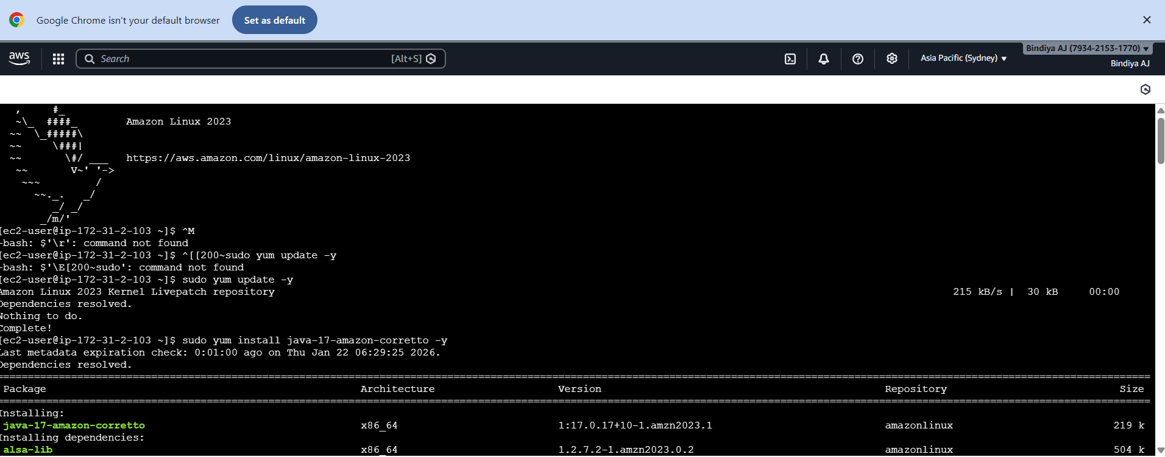

- java -version
java -version is used to check which Java version is installed and currently active on your system.

- sudo dnf install -y java-1.8.0-amazon-corretto

That command is for installing Java 8 (Amazon Corretto) on a Linux system that uses DNF (Fedora, RHEL, Amazon Linux 2023, etc.).

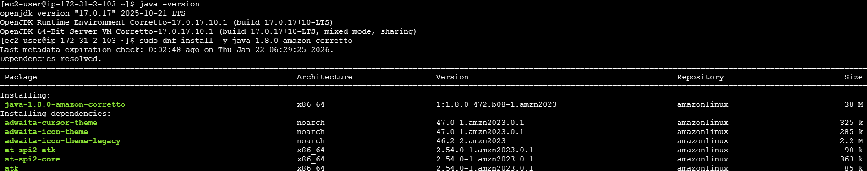

5)sudo yum install maven -y

sudo → run the command as administrator
yum → Linux package manager
install → install a package
maven → the software being installed
-y → automatically say “yes” to prompts

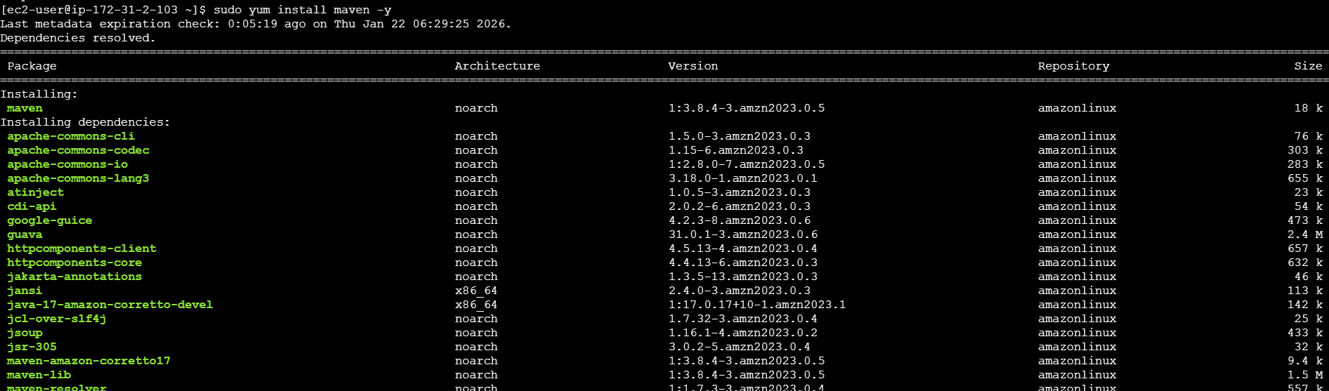
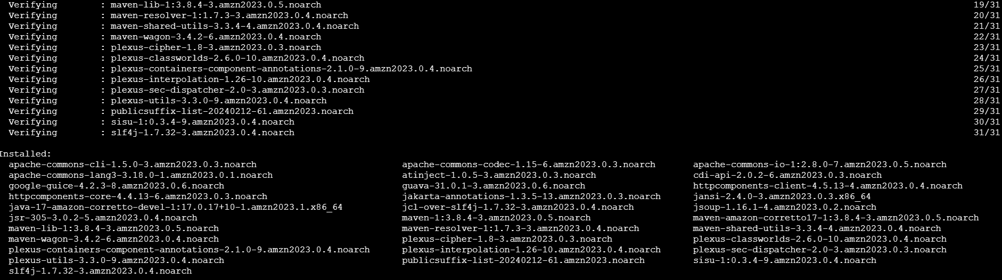

6)mvn -version
Displays the installed Maven version, Java version, and related environment details (like OS).
mvn → Maven command-line tool
-version → shows version information

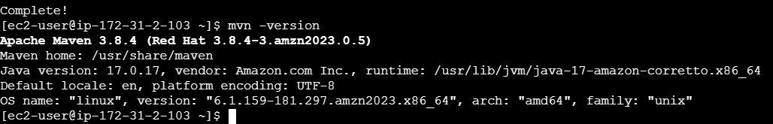

Experiment 2:
Working with Maven: Creating a Maven Project, Understanding the POM File, Dependency Management and Plugins

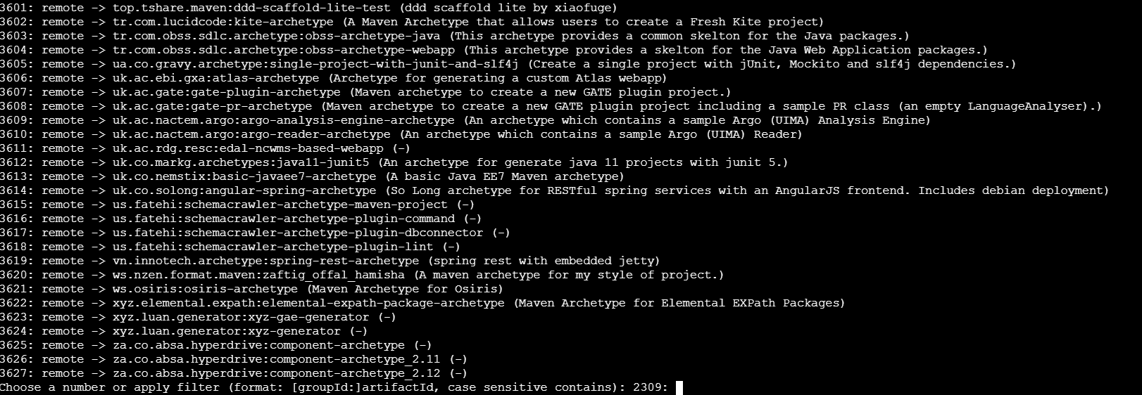
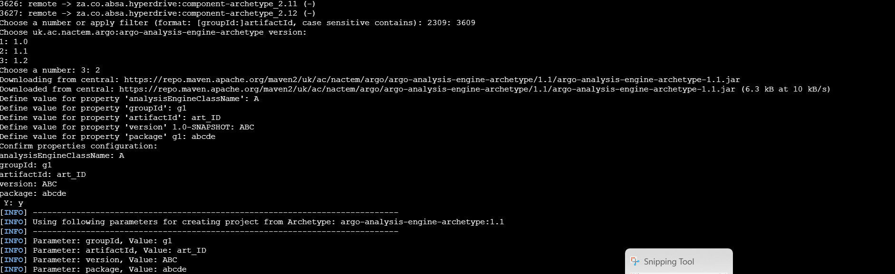
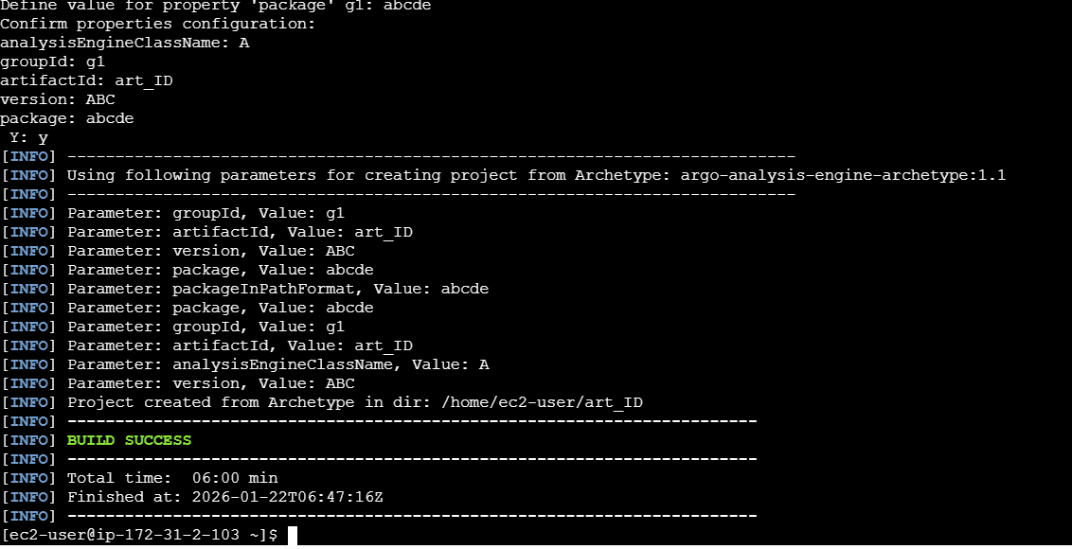

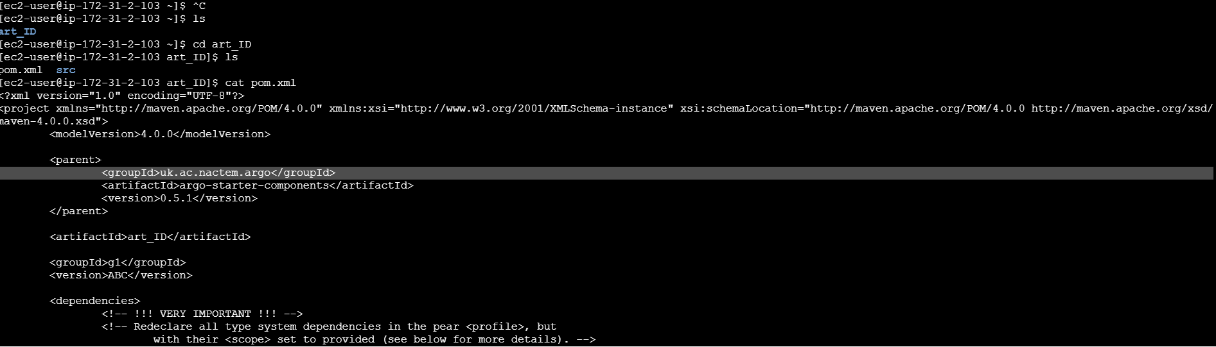
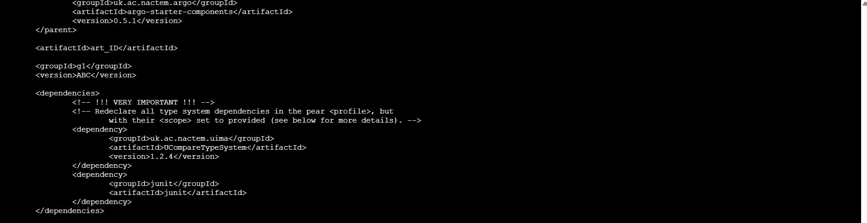

mvn clean install package
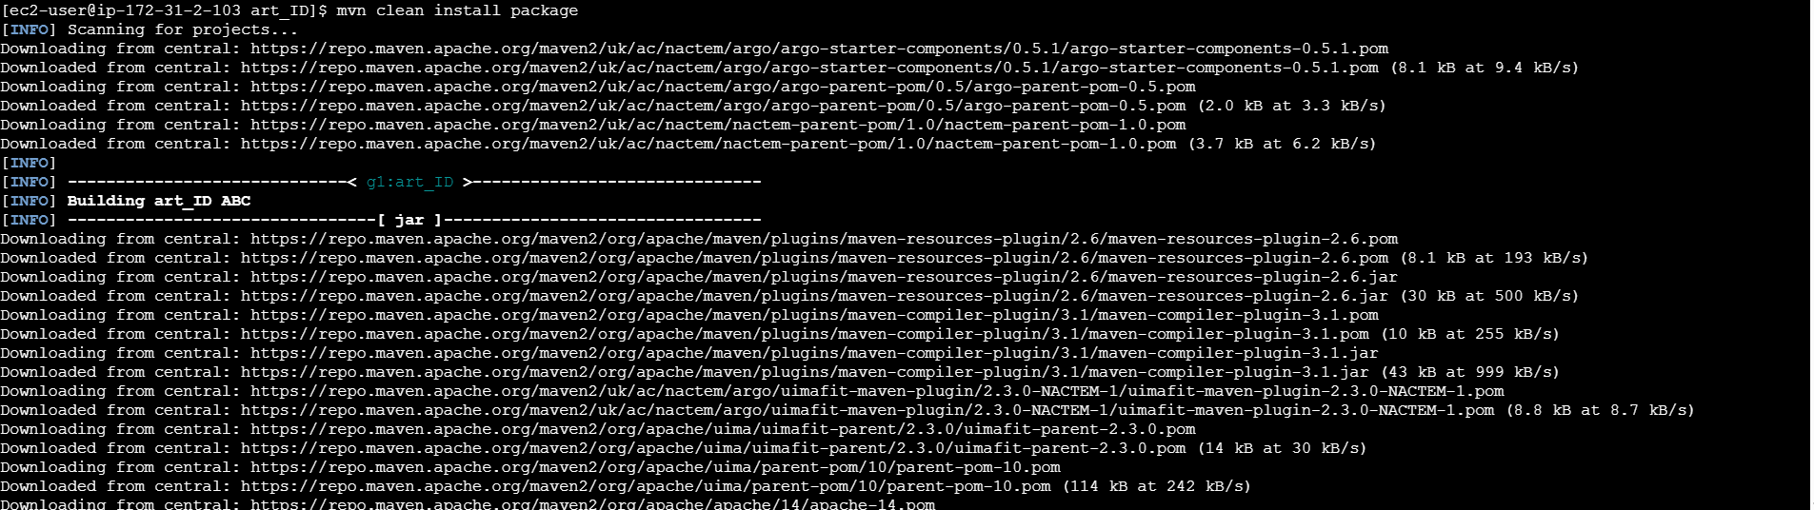

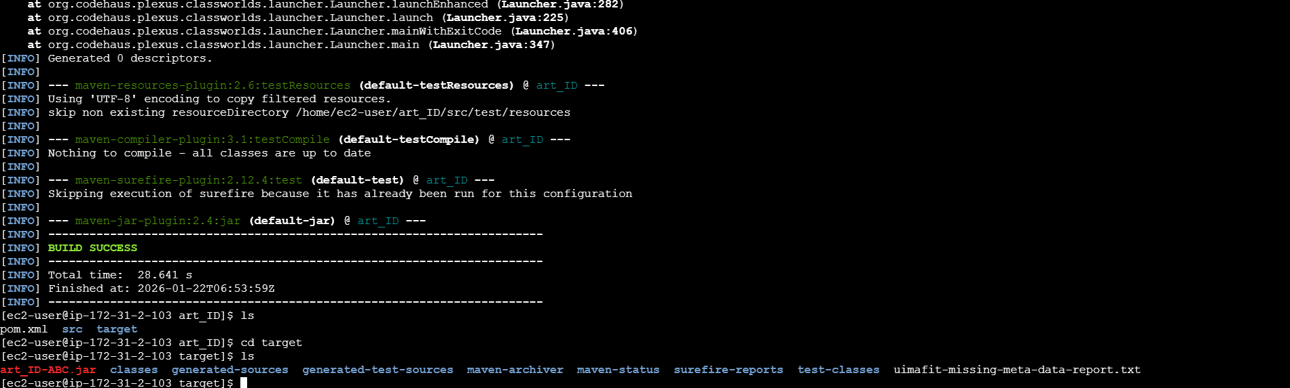

Once after creating maven project close the terminal
Come back to aws instance page →instance state→stop→terminate
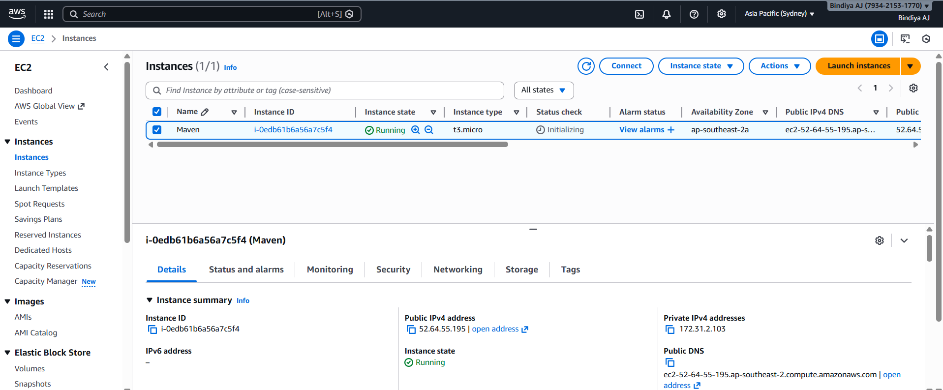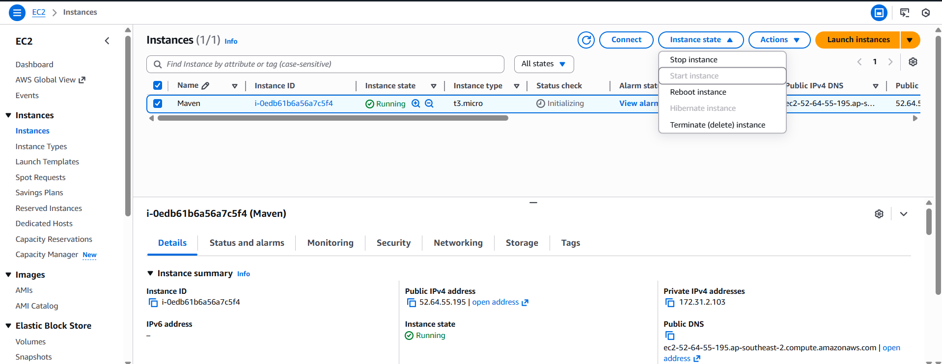
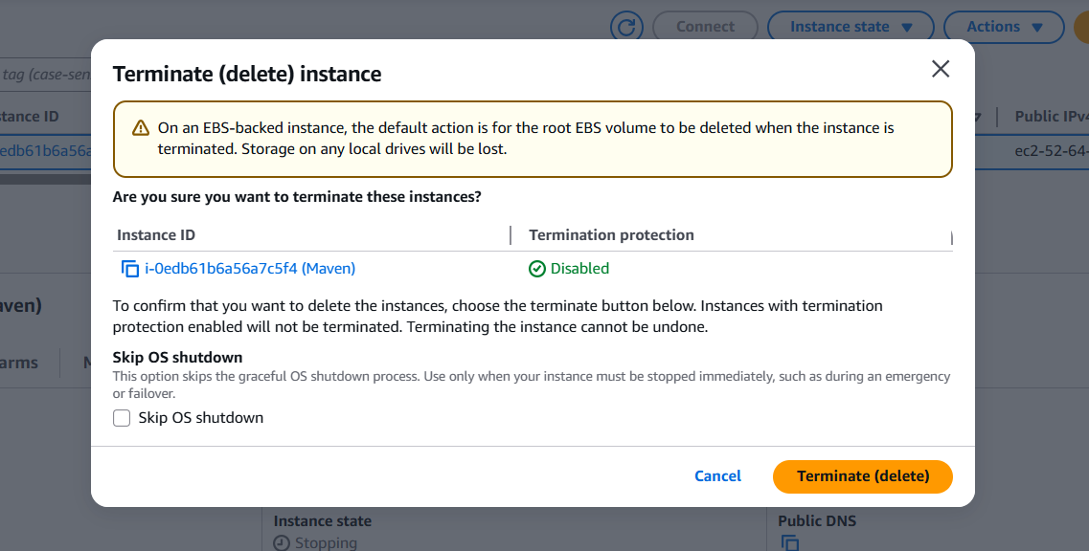

Finally signout
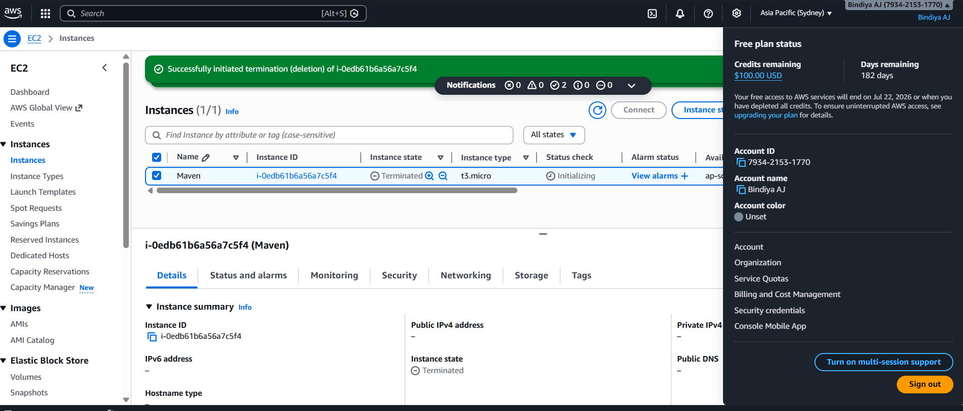

Recap: all installation commands
===========
sudo yum update -y

sudo yum install java-17-amazon-corretto -y

java -version

sudo amazon-linux-extras enable corretto8

sudo yum install maven -y

mvn -version

mvn archetype:generate

mvn clean install package

3. Working with Gradle: Setting Up a Gradle Project, Understanding Build Scripts (Groovy and Kotlin DSL), Dependency Management and Task Automation
gradle
1)Install Java and Gradle

sudo yum update
sudo yum install -y java-17-amazon-corretto-devel
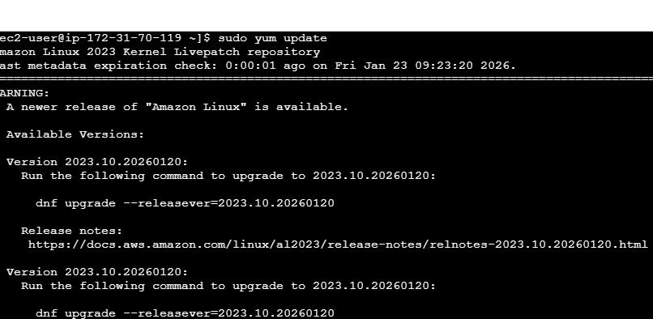

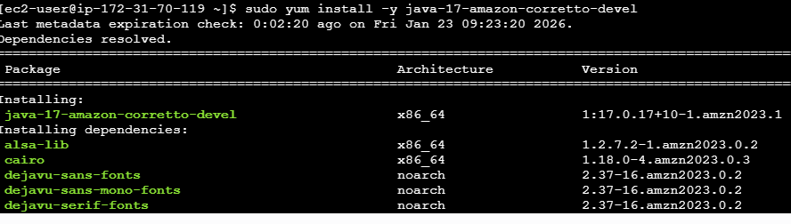

java -version

sudo yum install -y unzip
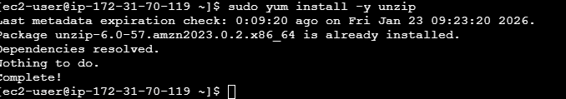
wget https://services.gradle.org/distributions/gradle-8.5-bin.zip
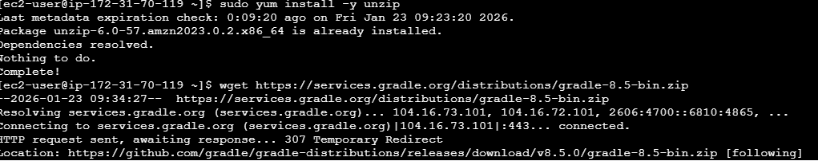

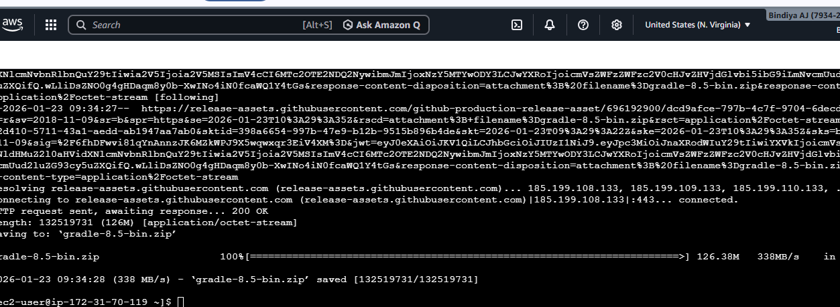

sudo mkdir -p /opt/gradle
Unzip Gradle
sudo unzip gradle-8.5-bin.zip -d /opt/gradle
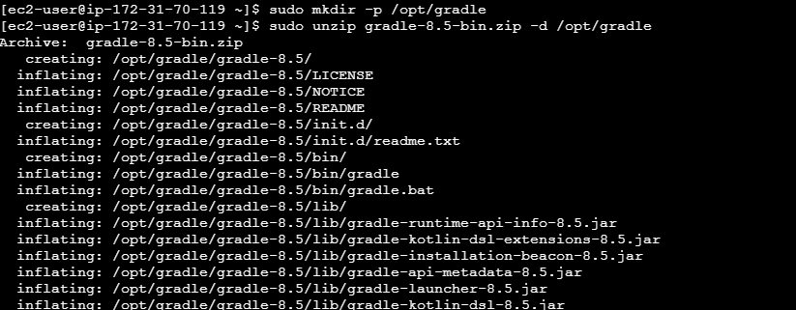

Command
sudo vi /etc/profile.d/gradle.sh

What this command does
It creates or opens a file named gradle.sh inside /etc/profile.d/.
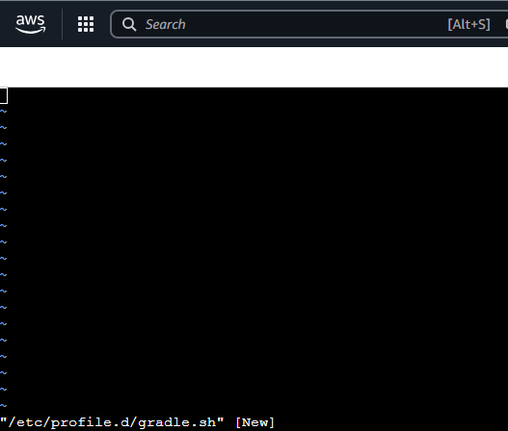

Add in the gradle.sh
Press i to insert below 2 lines
export GRADLE_HOME=/opt/gradle/gradle-8.5
export PATH=$PATH:$GRADLE_HOME/bin
:wq! → to come out

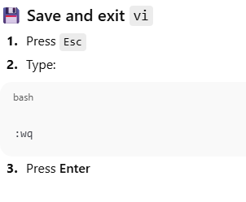
export GRADLE_HOME=/opt/gradle/gradle-8.5 — why this?

1️⃣ What GRADLE_HOME means
GRADLE_HOME is an environment variable that tells Linux:
“This is the main directory where Gradle is installed.”

[ec2-user@ip-172-31-70-119 ~]$ sudo vi /etc/profile.d/gradle.sh
[ec2-user@ip-172-31-70-119 ~]$ source /etc/profile.d/gradle.sh
[ec2-user@ip-172-31-70-119 ~]$ cat /etc/profile.d/gradle.sh

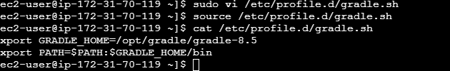
Verify Gradle Installation
gradle -v
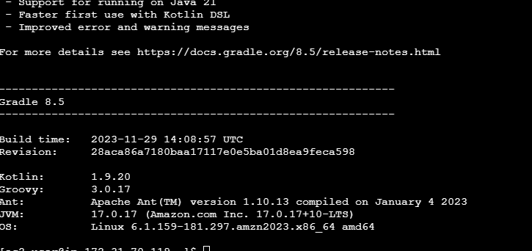
Create a Gradle Project
mkdir my-gradle-project && cd my-gradle-project
[ec2-user@ip-172-31-75-40 ~]$ mkdir my-gradle-project && cd my-gradle-project
[ec2-user@ip-172-31-75-40 my-gradle-project]$ gradle init
Starting a Gradle Daemon (subsequent builds will be faster)

Select type of project to generate:
1: basic
2: application
3: library
4: Gradle plugin
Enter selection (default: basic) [1..4] 2

Select implementation language:
1: C++
2: Groovy
3: Java
4: Kotlin
5: Scala
6: Swift
Enter selection (default: Java) [1..6] 3

Generate multiple subprojects for application? (default: no) [yes, no] no
Select build script DSL:
1: Kotlin
2: Groovy
Enter selection (default: Kotlin) [1..2] 2

Select test framework:
1: JUnit 4
2: TestNG
3: Spock
4: JUnit Jupiter
Enter selection (default: JUnit Jupiter) [1..4] 4
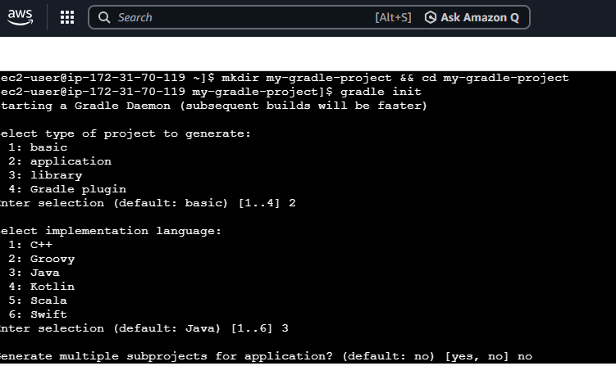
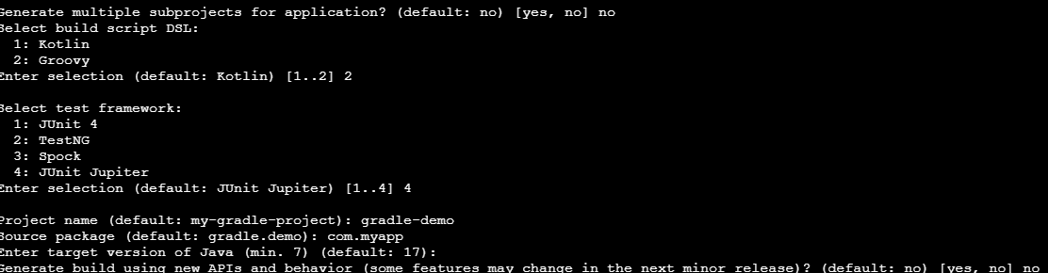
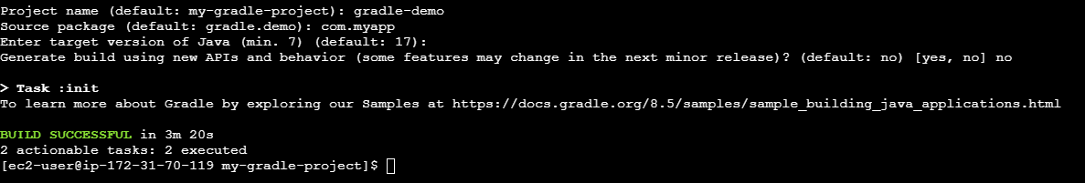
gradle build
gradle run
gradle test
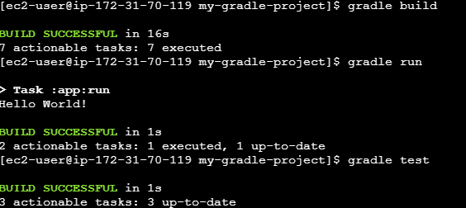

gradle tasks
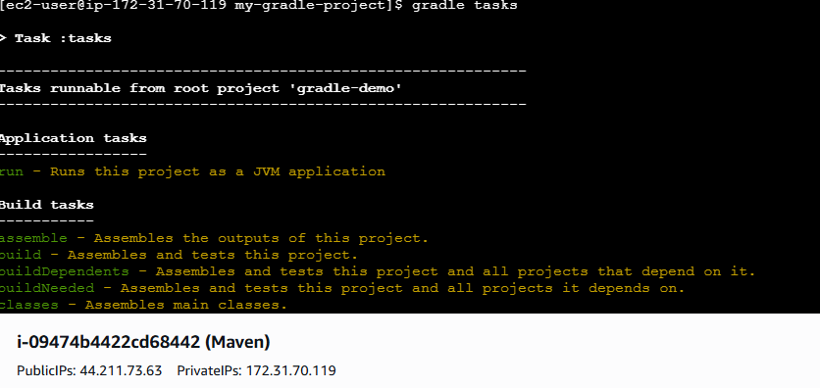
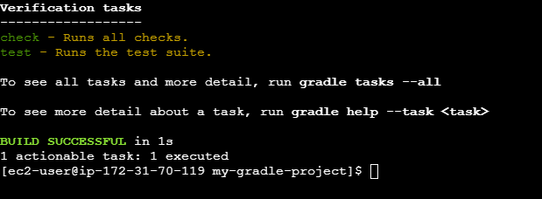

gradle dependencies
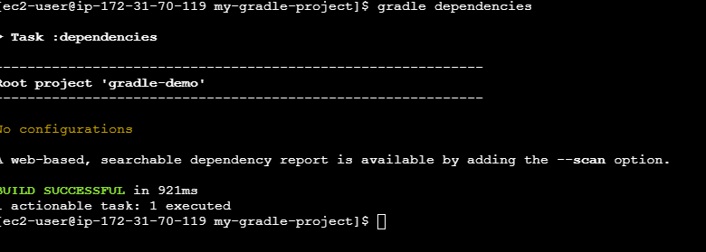

gradle
==============
installation- java is required for gradle
==========================================
//1: Install Java and Gradle

//1.1.Update and Install Java

sudo apt update
sudo apt install -y openjdk-17-jdk
java -version

//1.2.Download and Install Gradle

sudo apt install unzip -y
wget https://services.gradle.org/distributions/gradle-8.5-bin.zip
sudo mkdir /opt/gradle
sudo unzip -d /opt/gradle gradle-8.5-bin.zip

1.3.Set Up Environment Variables
echo "export PATH=/opt/gradle/gradle-8.5/bin:\$PATH" | sudo tee -a /etc/profile.d/gradle.sh
source /etc/profile.d/gradle.sh
gradle -v

2: Create a Gradle Project

mkdir my-gradle-project && cd my-gradle-project

gradle init

Select type of project to generate:
1: basic
2: application
3: library
4: Gradle plugin
Enter selection (default: basic) [1..4] 2

Select implementation language:
1: C++
2: Groovy
3: Java
4: Kotlin
5: Scala
6: Swift
Enter selection (default: Java) [1..6] 3

Generate multiple subprojects for application? (default: no) [yes, no] no
Select build script DSL:
1: Kotlin
2: Groovy
Enter selection (default: Kotlin) [1..2] 2

Select test framework:
1: JUnit 4
2: TestNG
3: Spock
4: JUnit Jupiter
Enter selection (default: JUnit Jupiter) [1..4] 4

Project name (default: my-gradle-project): gradle-demo
Source package (default: gradle.demo): com.myapp
Enter target version of Java (min. 7) (default: 17):
Generate build using new APIs and behavior (some features may change in the next minor release)? (default: no) [yes, no] no

3.gradle build

4. gradle run

5.gradle test

6. gradle tasks

7.gradle depencies

1)//1: Install Java and Gradle

//1.1.Update and Install Java

sudo apt update
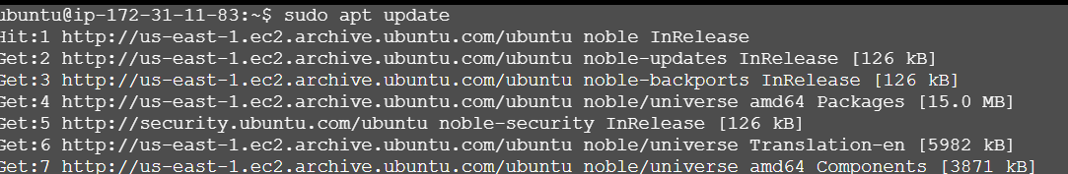

sudo apt install -y openjdk-17-jdk

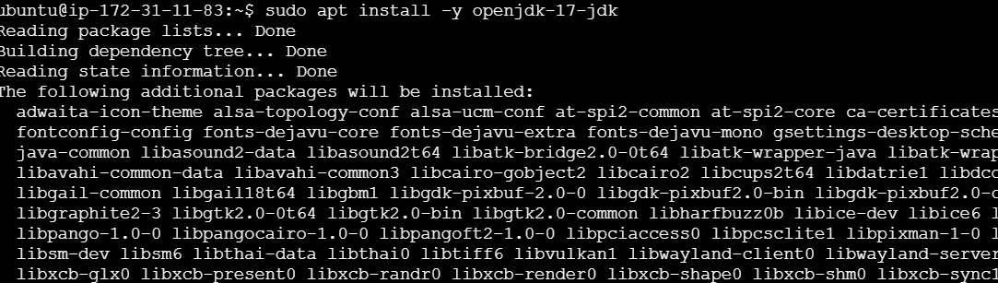
java -version

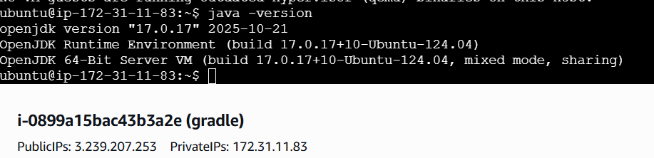

//1.2.Download and Install Gradle

sudo apt install unzip -y
wget https://services.gradle.org/distributions/gradle-8.5-bin.zip
sudo mkdir /opt/gradle
sudo unzip -d /opt/gradle gradle-8.5-bin.zip

1.3.Set Up Environment Variables
echo "export PATH=/opt/gradle/gradle-8.5/bin:\$PATH" | sudo tee -a /etc/profile.d/gradle.sh
source /etc/profile.d/gradle.sh
gradle -v

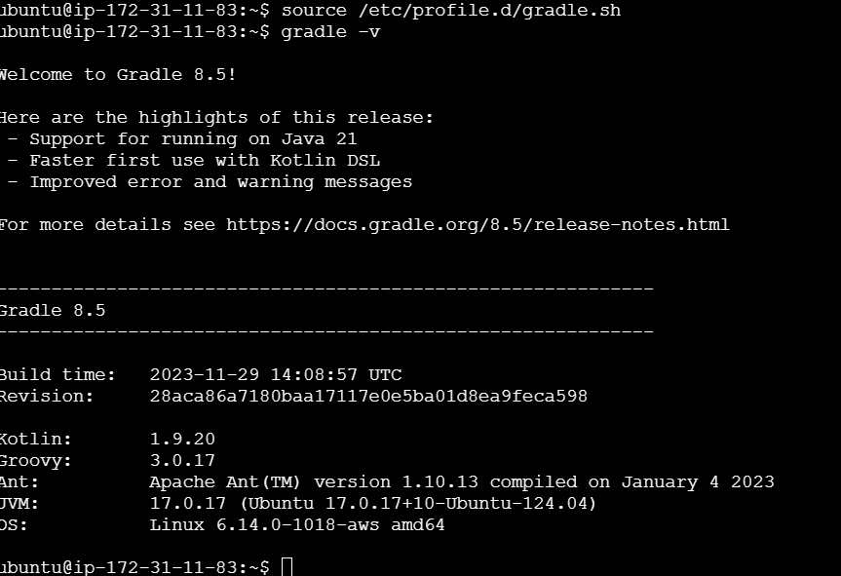
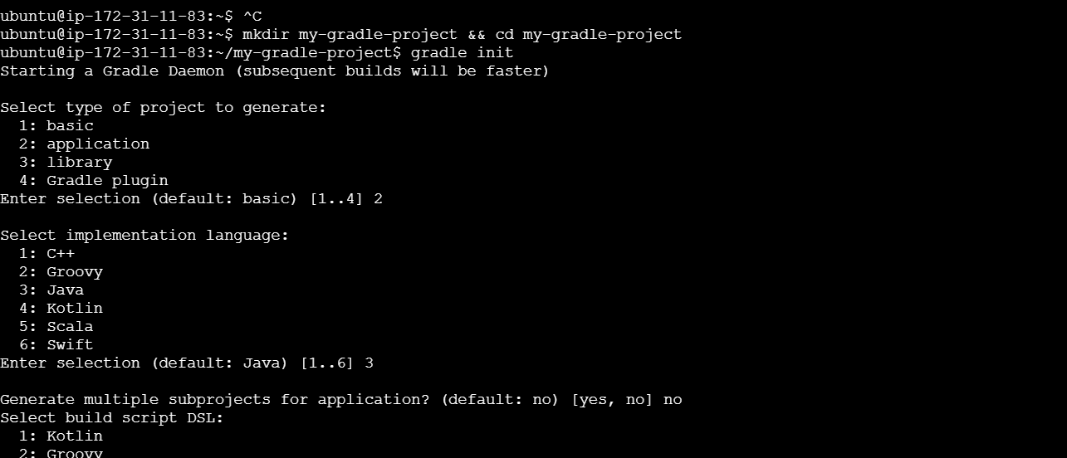
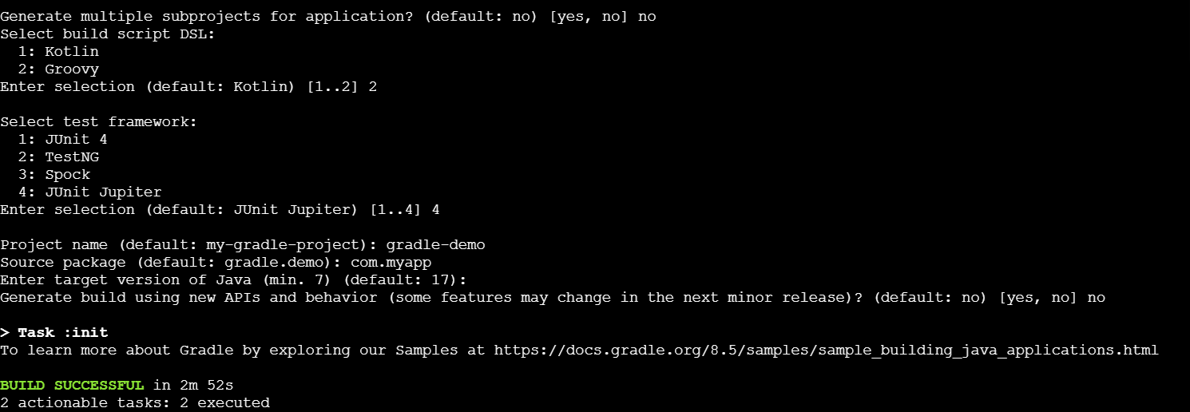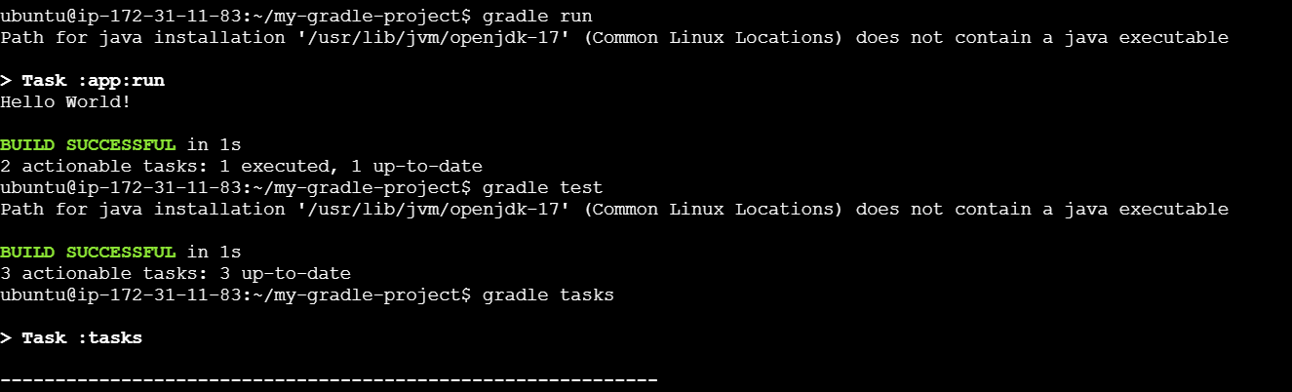
See the “hello world “ content

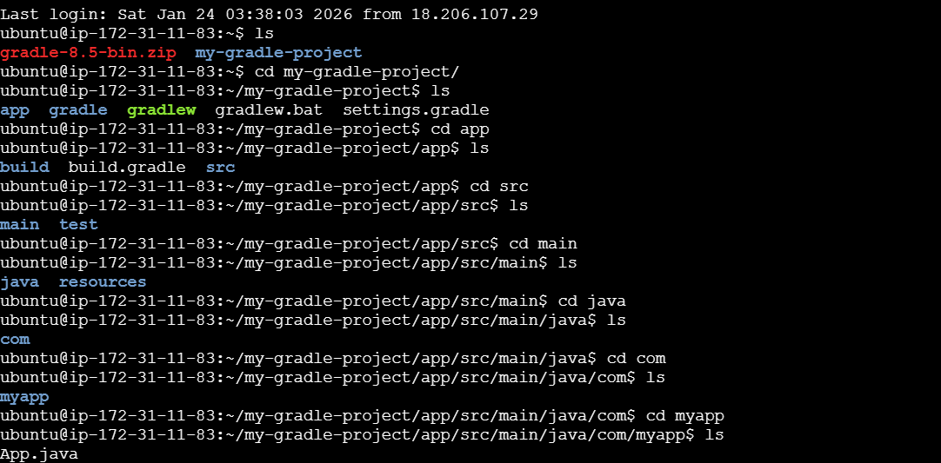
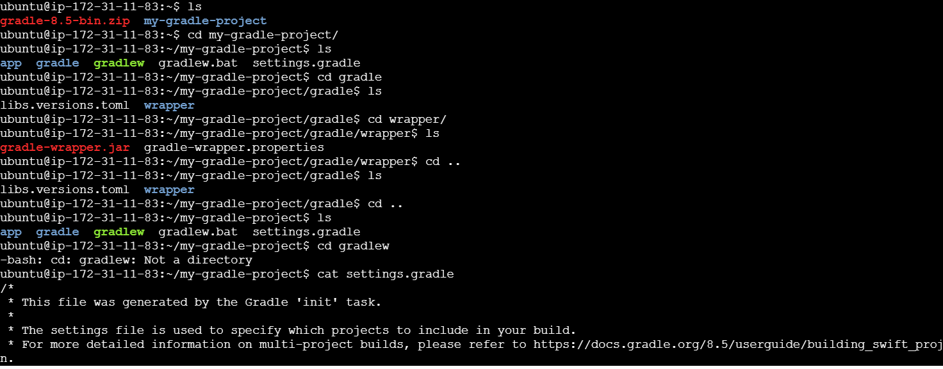

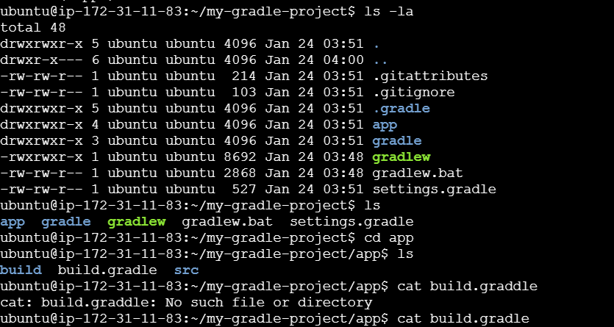
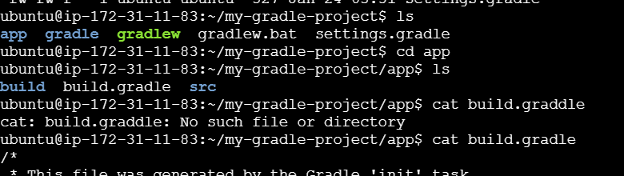
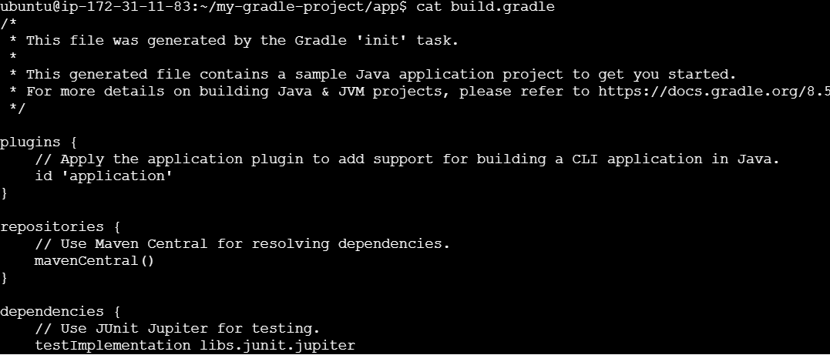
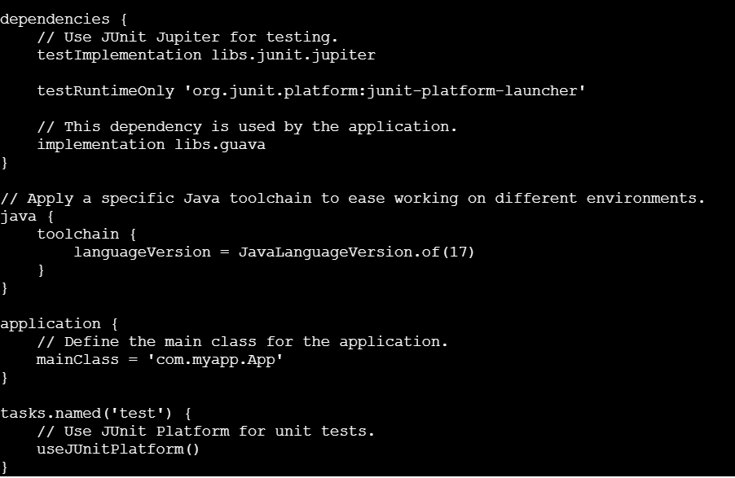

4)Practical Exercise: Build and Run a Java Application with Maven, Migrate the Same Application to Gradle
maven to gradle
================
java -jar target/*.jar

1. //install java
sudo apt update && sudo apt upgrade -y
sudo apt install openjdk-17-jdk -y
java -version

Create git hub account:

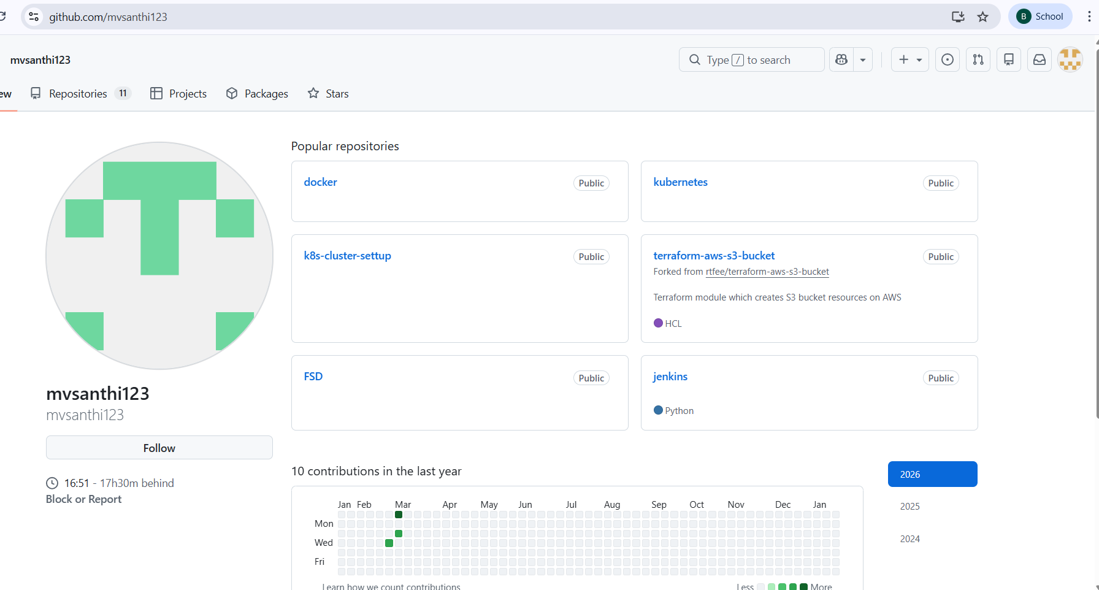
https://github.com/bindiyaaj-blr/simple-java-maven-app.git

maven to gradle
================
java -jar target/*.jar

1. //install java
sudo apt update && sudo apt upgrade -y
sudo apt install openjdk-17-jdk -y
java -version
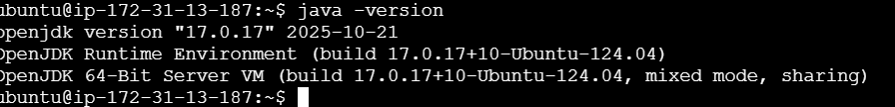
2.install git to clone one repo into our local machine
sudo apt install git -y
git --version
//in google first open your git hub later fork the below repo-https://github.com/jenkins-docs/simple-java-maven-app
git clone https://github.com/mvsanthi123/simple-java-maven-app.git

//3.install maven
wget https://archive.apache.org/dist/maven/maven-3/3.9.2/binaries/apache-maven-3.9.2-bin.tar.gz
sudo tar -xvf apache-maven-3.9.2-bin.tar.gz -C /opt
sudo ln -sfn /opt/apache-maven-3.9.2 /opt/maven
echo 'export PATH=/opt/maven/bin:$PATH' >> ~/.bashrc
source ~/.bashrc
mvn -version

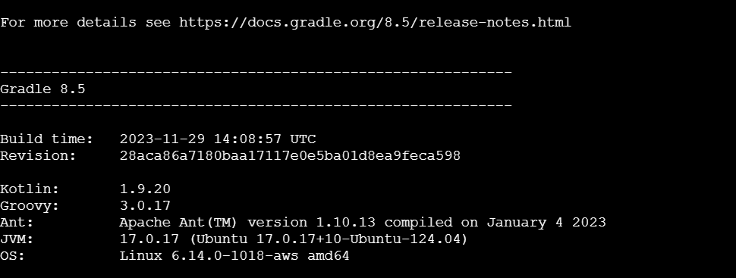

//4.generate a build using maven
cd simple-java-maven-app
mvn clean package
ls//to see target

//5. install gradle
cd ..
sudo apt install unzip -y
wget https://services.gradle.org/distributions/gradle-8.5-bin.zip
sudo mkdir /opt/gradle
sudo unzip -d /opt/gradle gradle-8.5-bin.zip
echo 'export PATH=$PATH:/opt/gradle/gradle-8.5/bin' >> ~/.bashrc
source ~/.bashrc
gradle -v

//6. initialize gradle
cd simple-java-maven-app
gradle init
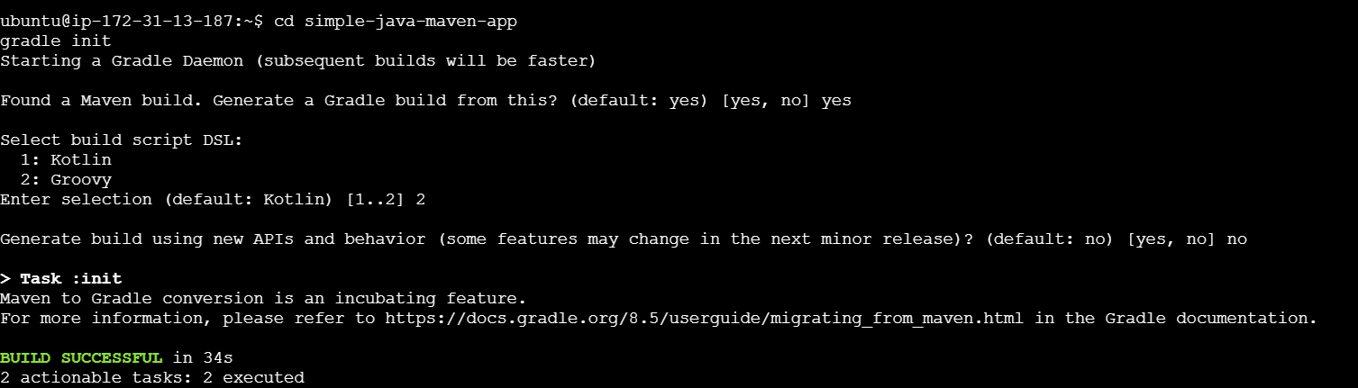
Found a Maven build. Generate a Gradle build from this? (default: yes) [yes, no] yes

Select build script DSL:
1: Kotlin
2: Groovy
Enter selection (default: Kotlin) [1..2] 2

Generate build using new APIs and behavior (some features may change in the next minor release)? (default: no) [yes, no] no

now gradle related files will be created

now open build.gradle with vi editior like vi build.gradle and hit enter after that do the follwoing changes

plugins {
id 'java-library'
id 'maven-publish'
id 'application'
}

application {
mainClass = 'com.mycompany.app.App' // Replace with your actual main class
}

jar {
manifest {
attributes(
'Main-Class': 'com.mycompany.app.App' // Ensure this matches your actual main class
)
}
}
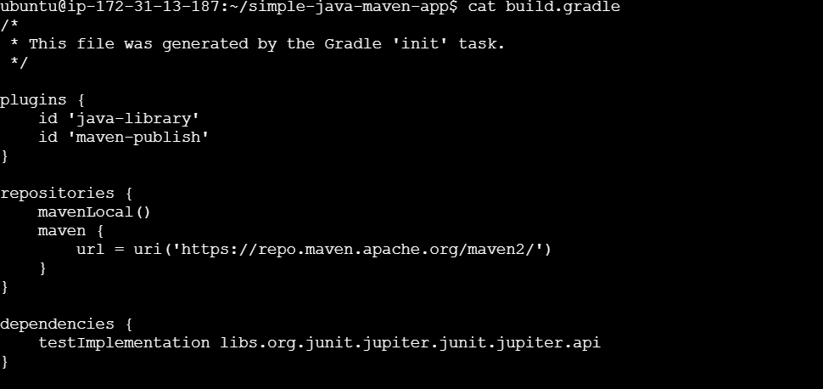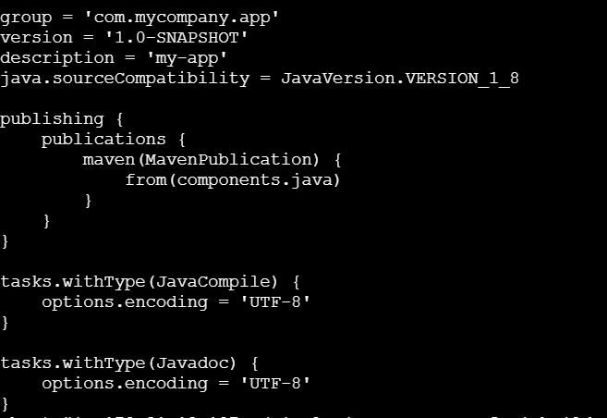

Add using vi editor
ubuntu@ip-172-31-13-187:~/simple-java-maven-app$ vi build.gradle
ubuntu@ip-172-31-13-187:~/simple-java-maven-app$ vi build.gradle
ubuntu@ip-172-31-13-187:~/simple-java-maven-app$ cat build.gradle
/*
* This file was generated by the Gradle 'init' task.
*/

plugins {
id 'java-library'
id 'maven-publish'
id 'application'
}
application {
mainClass = 'com.mycompany.app.App' // Replace with your actual main class
}
jar {
manifest {
attributes(
'Main-Class': 'com.mycompany.app.App' // Ensure this matches your actual main class
)
}

//7. now generte build
gradle build

now here can see the jar file-cd build/libs/

//8. how to check outcome

java -jar build/libs/my-app-1.0-SNAPSHOT.jar

//9.how toclean build

gradle clean build

//10. how to check maven build output

java -jar target/*.jar

//checking
==========
ubuntu@ip-172-31-42-54:~/simple-java-maven-app$ ls
LICENSE.txt azure-pipelines-1.yml build gradle gradlew.bat pom.xml src
README.md azure-pipelines.yml build.gradle gradlew jenkins settings.gradle target
ubuntu@ip-172-31-42-54:~/simple-java-maven-app$ java -jar build/libs/my-app-1.0-SNAPSHOT.jar
Hello World!
ubuntu@ip-172-31-42-54:~/simple-java-maven-app$ java -jar target/*.jar
Hello World!

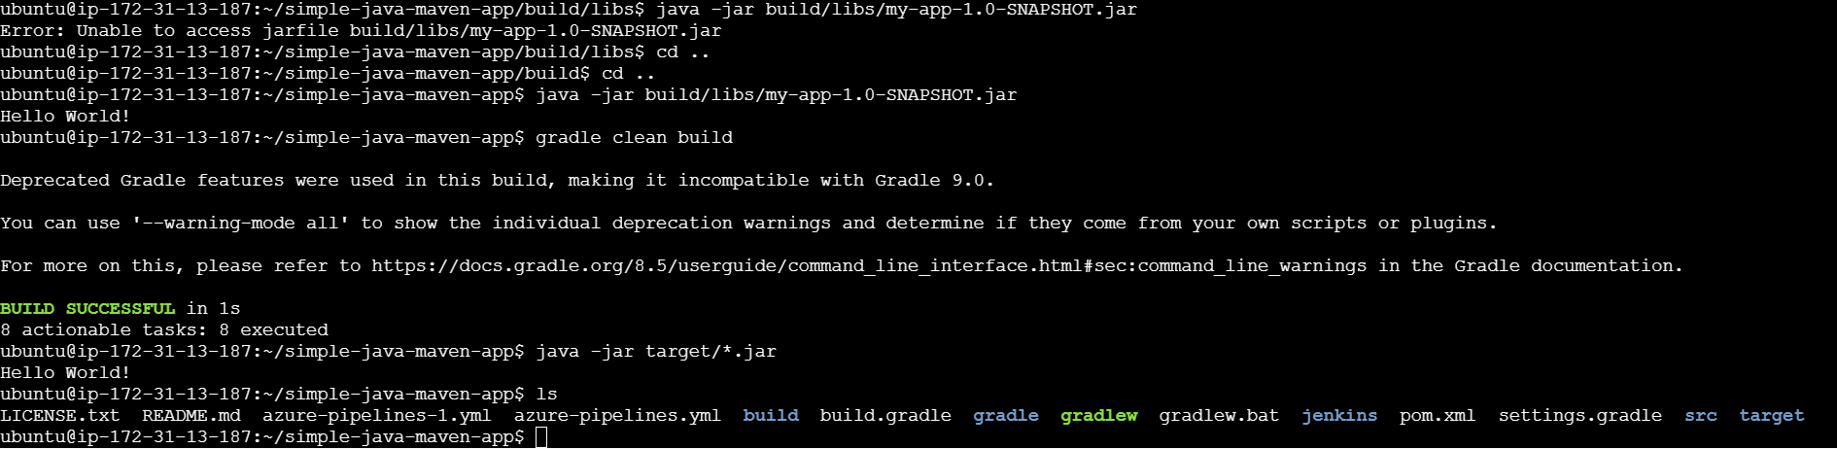

Experiment5: Introduction to Jenkins: What is Jenkins ? Installing Jenkins on Local or Cloud Environment, Configuring Jenkins for First Use

What is Jenkins ?
Jenkins is a tool that automates software work like building, testing, and deploying applications.
Jenkins helps developers save time and avoid mistakes by doing repetitive tasks automatically.

CI – Continuous Integration
What CI means

Developers frequently merge code into a shared repository, and every merge is
automatically tested.

CI Flow

Developer writes code
Code is pushed to Git
CI tool starts automatically
Code is built
Tests are run
Developer gets feedback

Why CI matters

✔ Finds bugs early
✔ Prevents broken code from reaching main branch
✔ Encourages small, safe changes

CD – Continuous Delivery vs Deployment

Continuous Delivery
Code is always ready to deploy
Deployment needs manual approval

Continuous Deployment
Code is automatically deployed
No human approval

What Jenkins Does (Main Jobs)
Think of Jenkins as a robot assistant for developers.

1. Build Automation

Converts source code into a working application
Example: turns Java code into a .jar file

2. Test Automation
Runs tests automatically
Tells you if something broke after new code was added

3. Deployment Automation
Sends the app to a server (Dev / Test / Production)
No need to upload files manually

How Jenkins Works (Simple Flow)

1. Developer writes code
2. Code is pushed to Git (GitHub/GitLab/Bitbucket)
3. Jenkins detects the change
4. Jenkins builds the code
5. Jenkins runs tests
6. Jenkins deploys the app
7. Jenkins sends success/failure notification

Step 1:Create aws instance→ select ubuntu machine→network setting(default SSH)
→configuration storage(default)

1) Update System and Install Java
sudo apt update
sudo apt install -y default-jre default-jdk
java -version
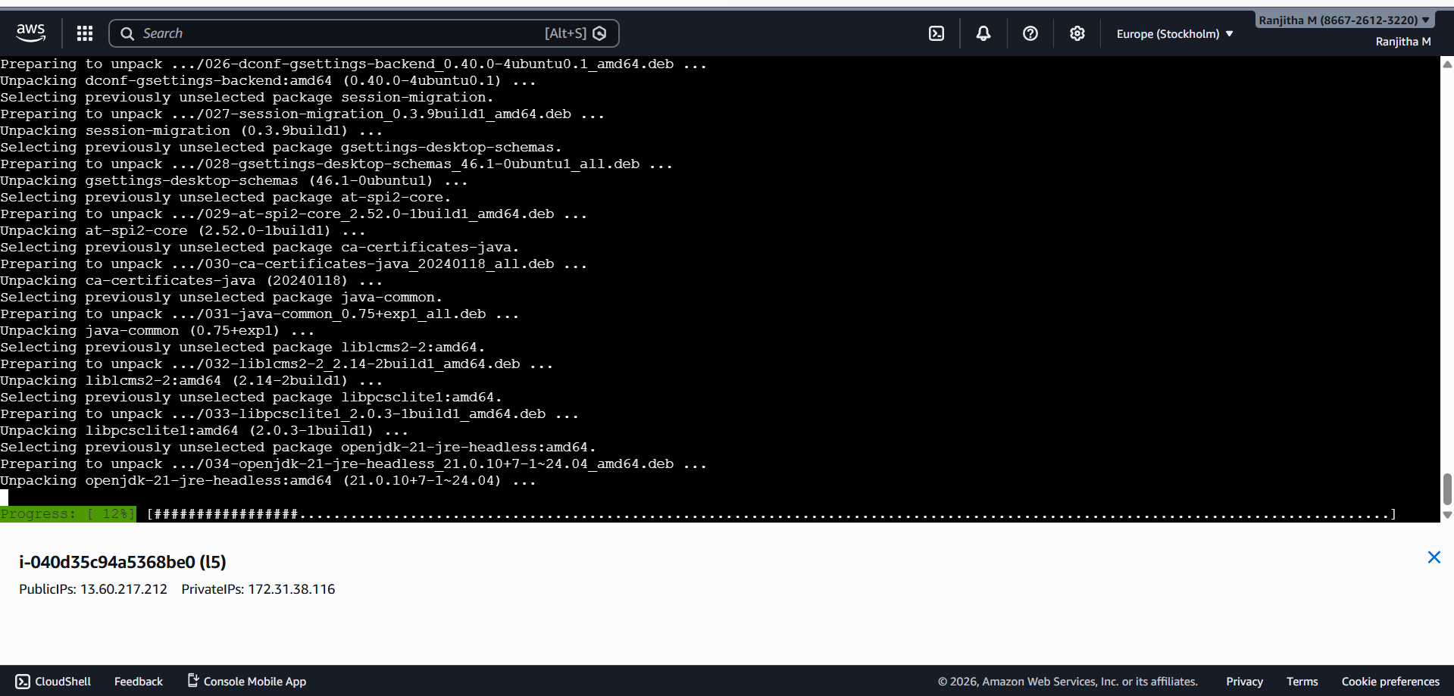

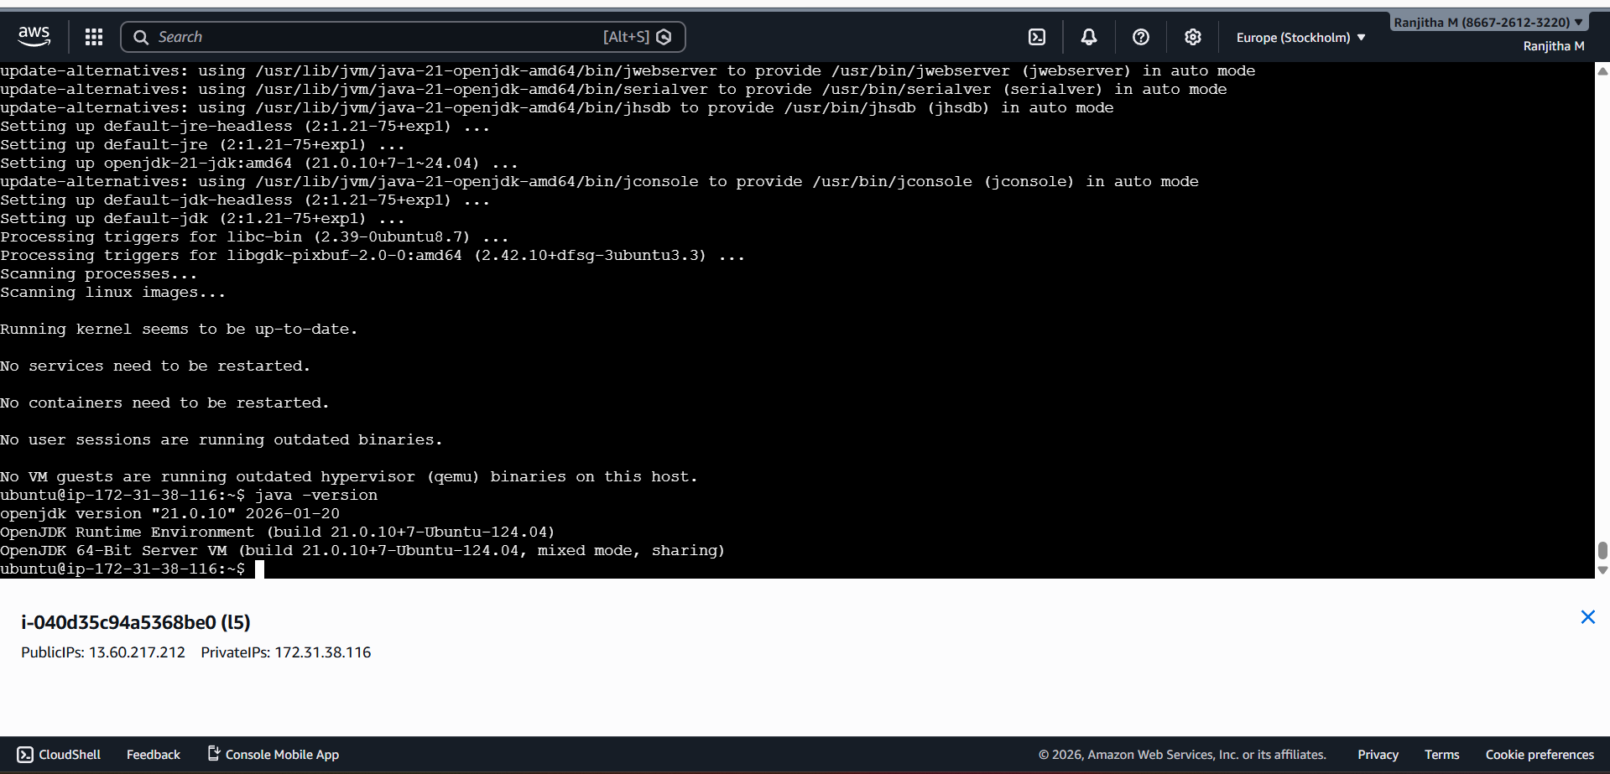
2) visit “https://pkg.jenkins.io/” and click “debian-stable/”-->debian jenkins package will
appear.
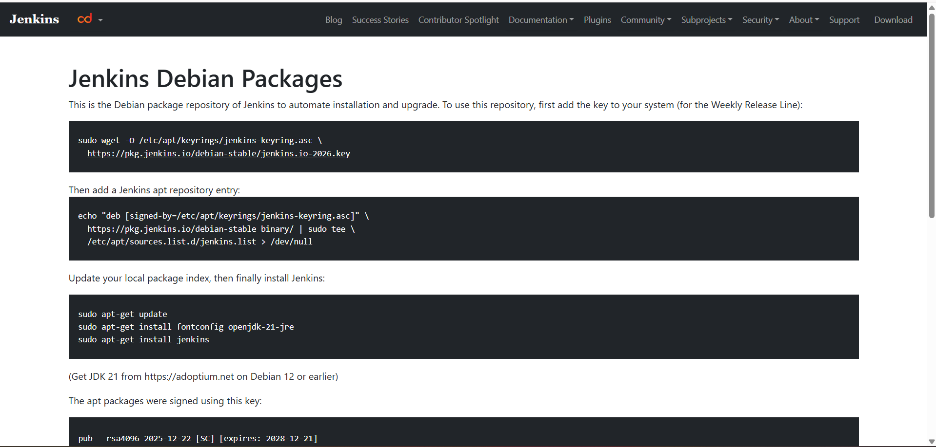
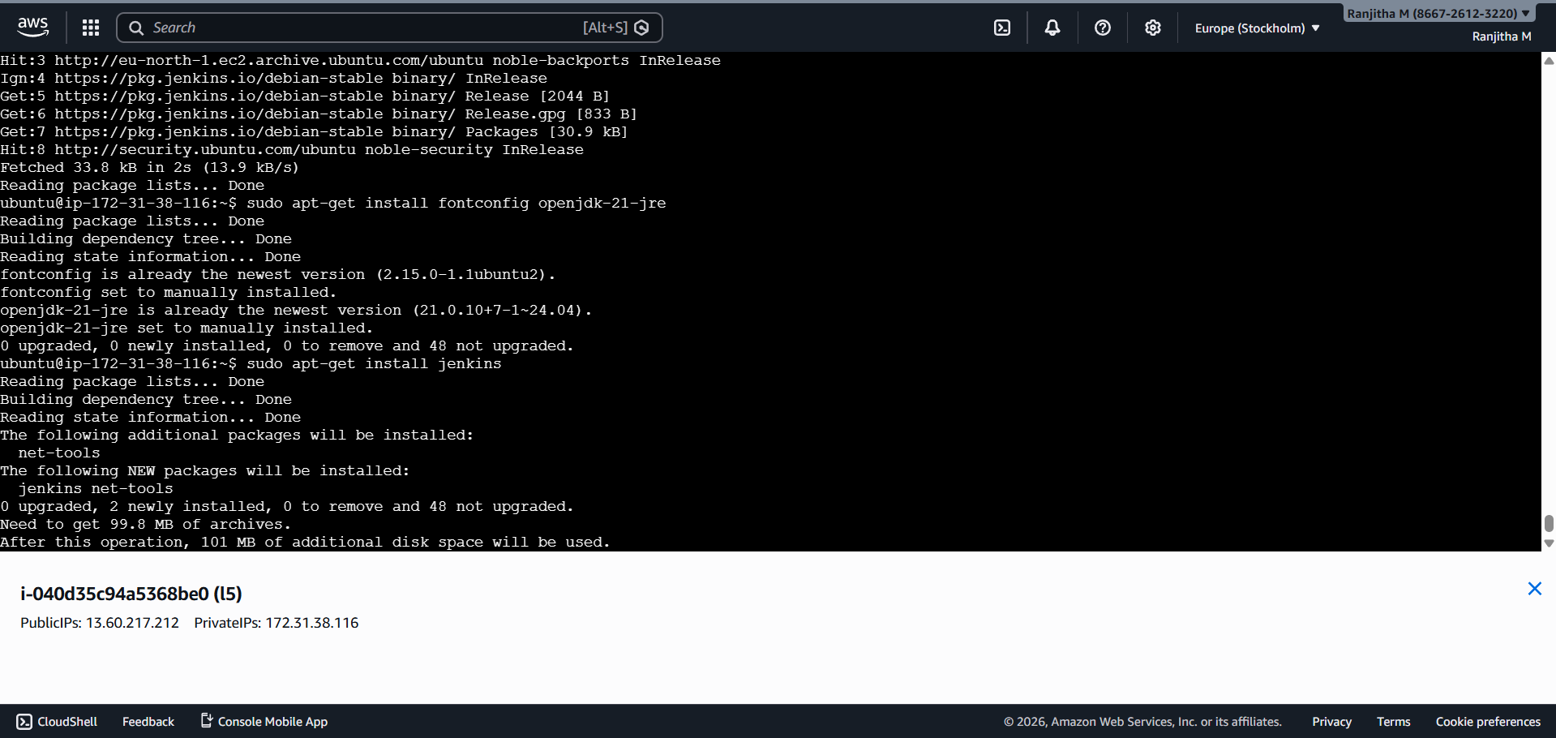
sudo systemctl start jenkins
sudo systemctl enable jenkins
sudo systemctl status jenkins
or
sudo service jenkins start
sudo service jenkins status
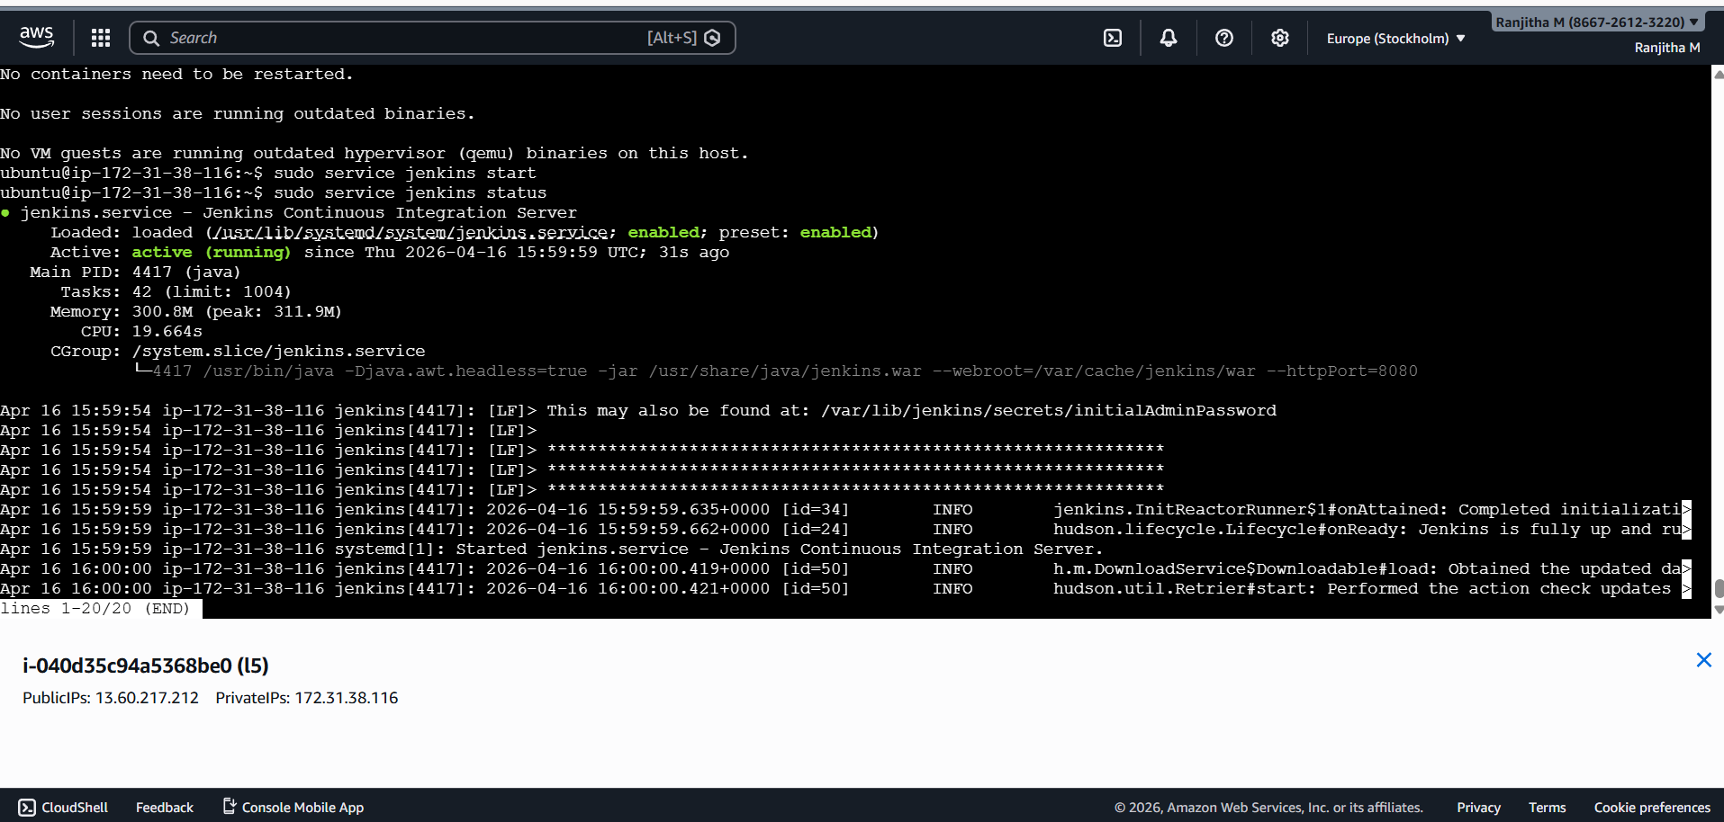
By default jenkin’s access 8080 port, so set up port in security section in aws

Click on “instance ID”-->copy public ip address→enter in url space of webpage “:” 8080
port number Ex:http://52.91.222.41:8080/

If not working→go to instance→security section→security group→inbound rules→edit in
bound rule→add rule→custom tcp→port range 8080→search 0.0.0.0/0 →save
Refresh the URL:http://52.91.222.41:8080/

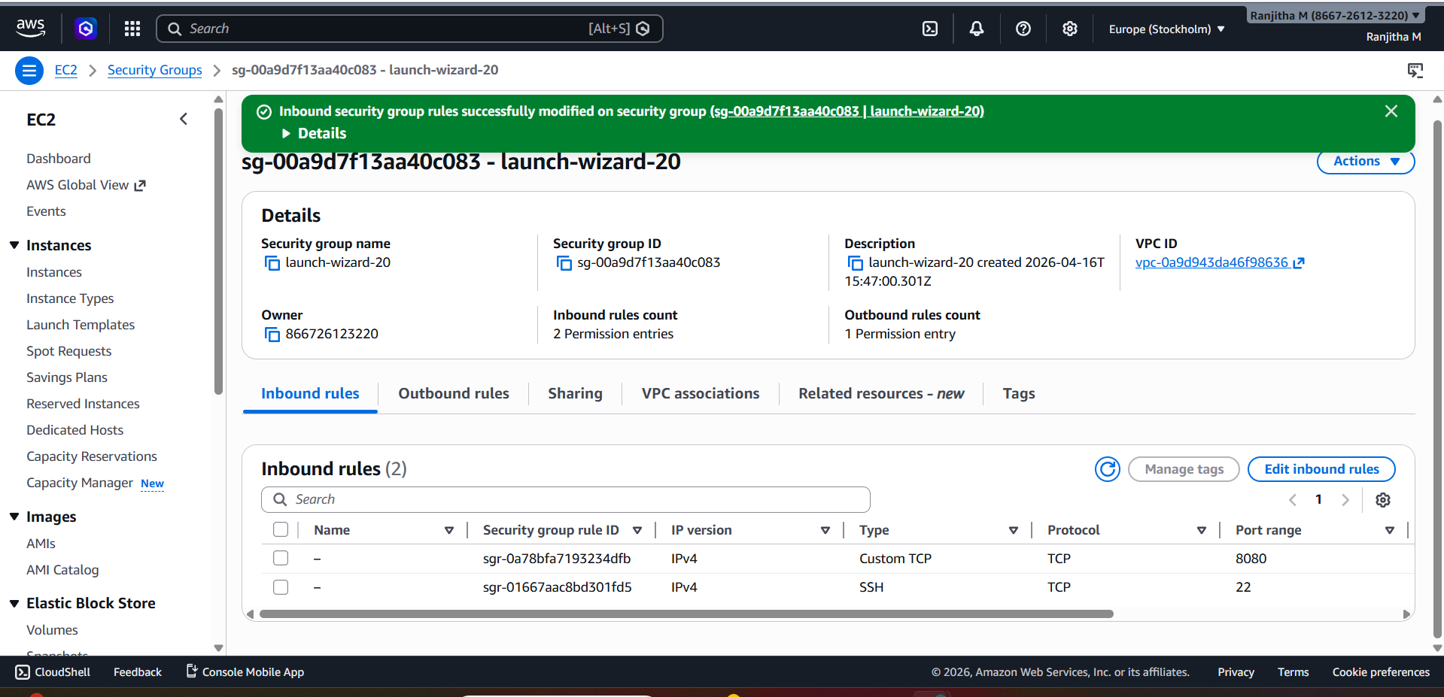
Copy URL from jenkin page and type :”sudo cat/var/lib/jenkins/secrets/initialAdminPassword “ it will display security key to login to jenkins

Ex:5954a9940d2d4d3eb2bcd7b6f19e48d4
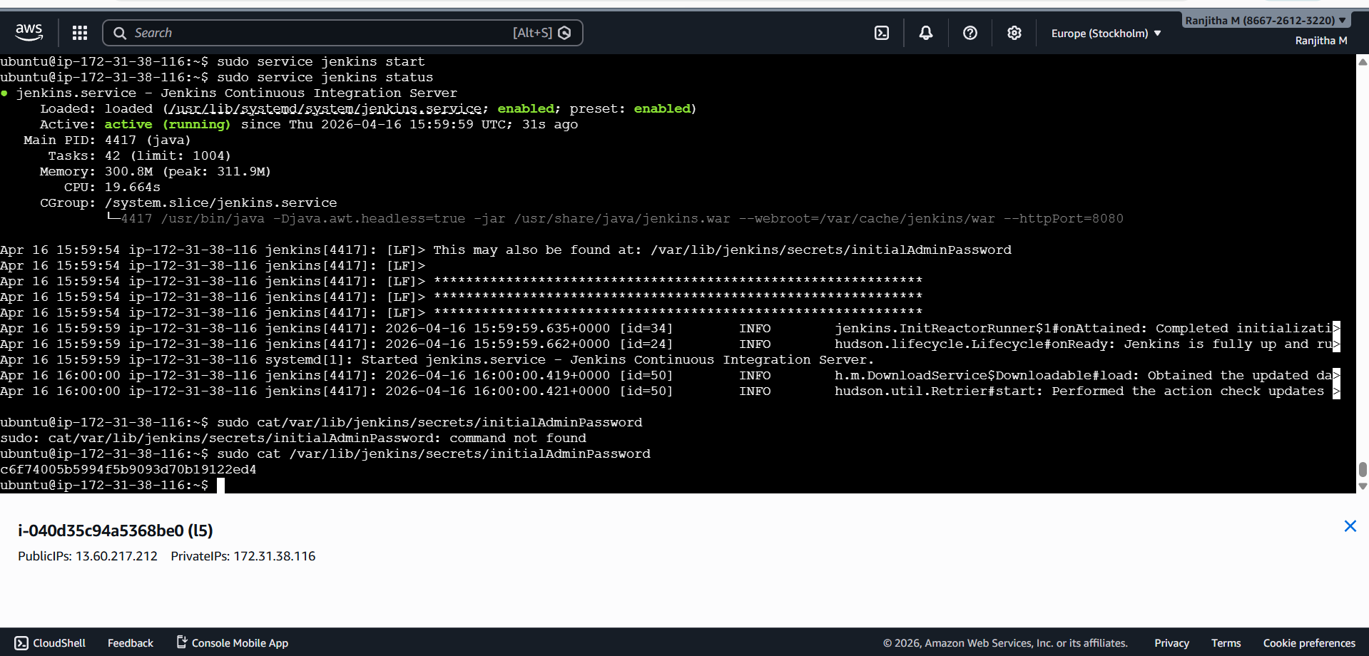
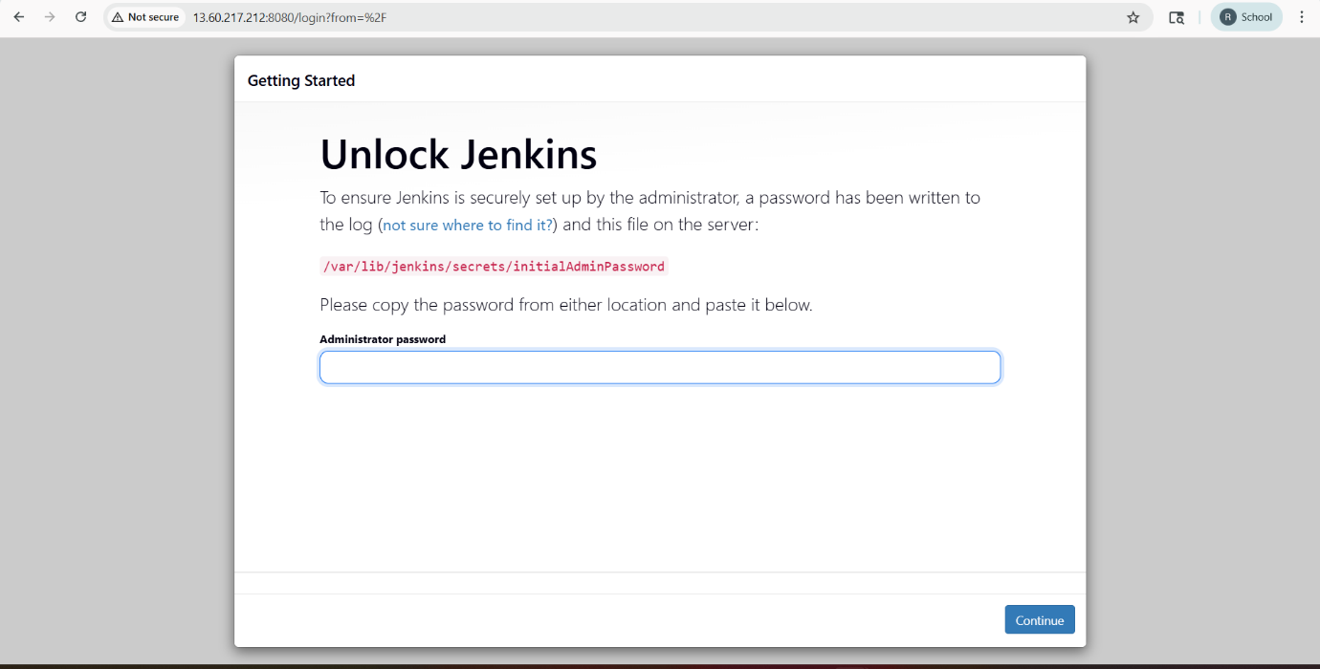
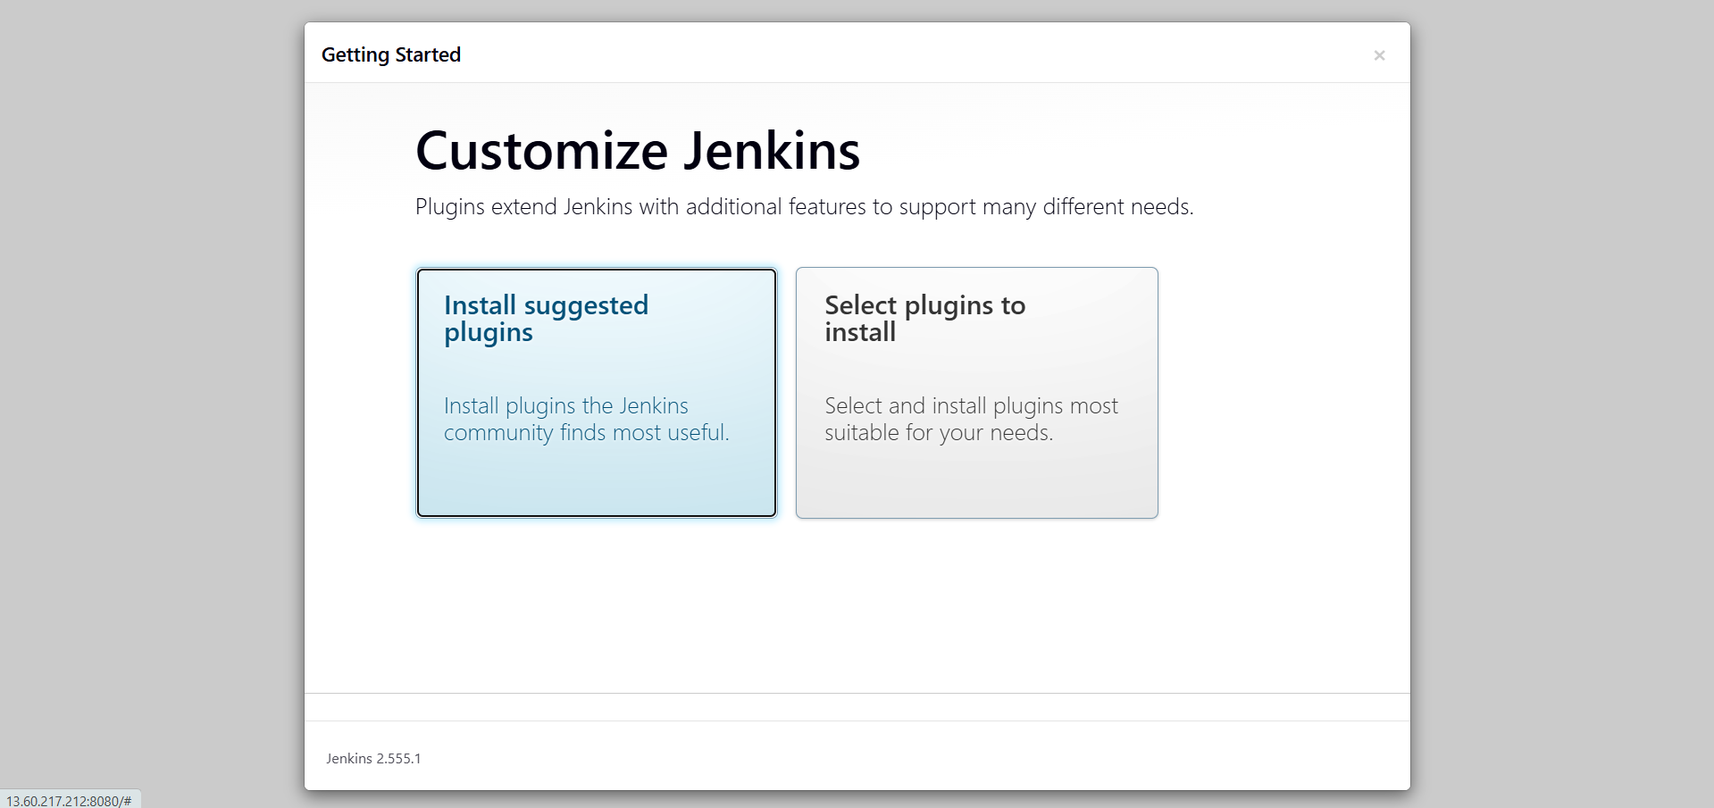
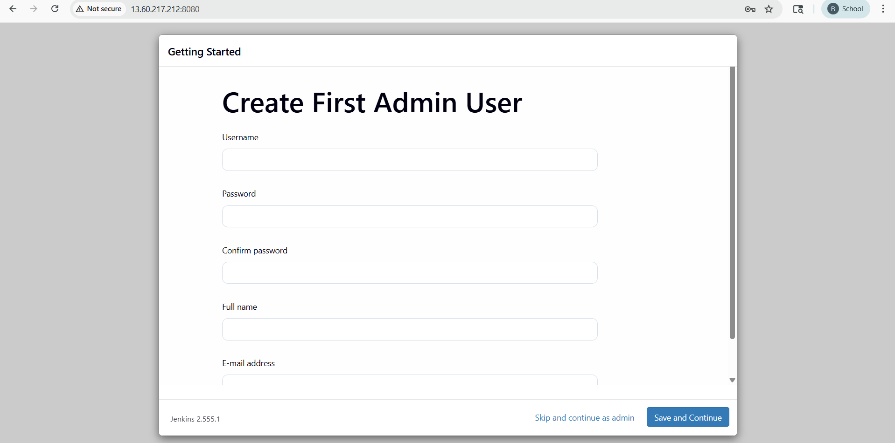

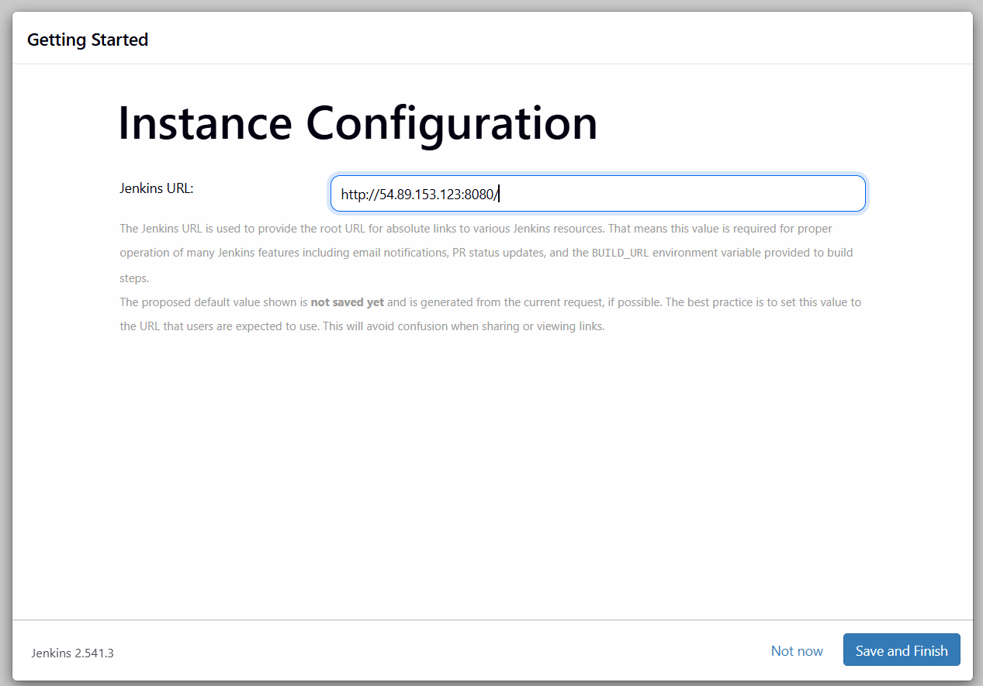

Experiment 6: Continuous Integration with Jenkins: Setting Up a CI Pipeline, Integrating Jenkins with Maven/Gradle, Running Automated Builds and Tests

Continuous Integration (CI) is a software development practice in which developers frequently merge their code changes into a shared repository. Whenever new code is committed, an automated pipeline is triggered to build, test, and validate the application. This helps in identifying bugs early and improves software quality.

Jenkins is an open-source automation server widely used for implementing CI/CD pipelines. It automates the stages of software development such as code checkout, build, test execution, packaging, and deployment. Jenkins supports integration with version control systems like Git and build tools such as Maven and Gradle using plugins.
Jenkins with Maven
Maven is a project management and build automation tool mainly used for Java projects. Jenkins integrates with Maven using the Maven Integration Plugin.
Jenkins with Gradle
Gradle is another build automation tool that is faster and more flexible than Maven. Jenkins integrates with Gradle using the Gradle Plugin.
Jenkins Integration with Gradle
Gradle is another modern build automation tool known for:
- Faster builds
- Incremental compilation
- Flexible scripting
- Better dependency management
Jenkins integrates with Gradle using the Gradle Plugin
Advantages
- Early detection of code issues
- Reduced integration problems
- Faster software delivery
- Automatic testing and reporting
- Easy integration with Git, Maven, Gradle
- Supports plugins and distributed builds
- Better software reliability
Step 1:Create aws instance→ select ubuntu machine→network setting(default SSH)
→configuration storage(default)

1) Update System and Install Java
sudo apt update
sudo apt install -y default-jre default-jdk
java -version

2) visit “https://pkg.jenkins.io/” and click “debian-stable/”-->debian jenkins package will
appear.
sudo systemctl start jenkins
sudo systemctl enable jenkins
sudo systemctl status jenkins
or
sudo service jenkins start
sudo service jenkins status
By default jenkin’s access 8080 port, so set up port in security section in aws

Click on “instance ID”-->copy public ip address→enter in url space of webpage “:” 8080
port number Ex:http://52.91.222.41:8080/

If not working→go to instance→security section→security group→inbound rules→edit in
bound rule→add rule→custom tcp→port range 8080→search 0.0.0.0/0 →save
Refresh the URL:http://52.91.222.41:8080/

Copy URL from jenkin page and type :”sudo cat/var/lib/jenkins/secrets/initialAdminPassword “ it will display security key to login to jenkins

Ex:5954a9940d2d4d3eb2bcd7b6f19e48d4

next install maven
Wget https://archive.apache.org/dist/maven/maven-3/3.9.6/binaries/apache-maven-3.9.6-bin.tar.gz
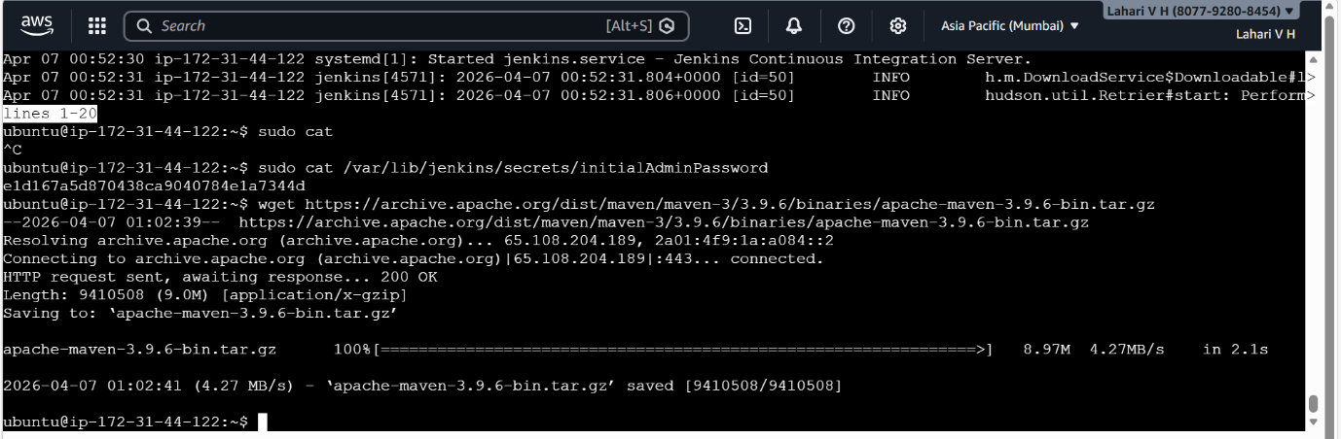
sudo tar -xvzf apache-maven-3.9.6-bin.tar.gz -C /opt/
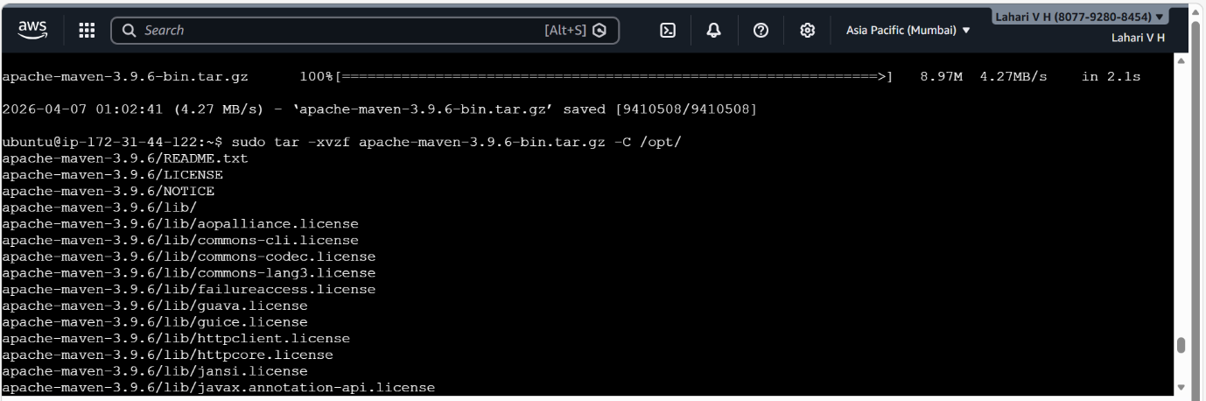

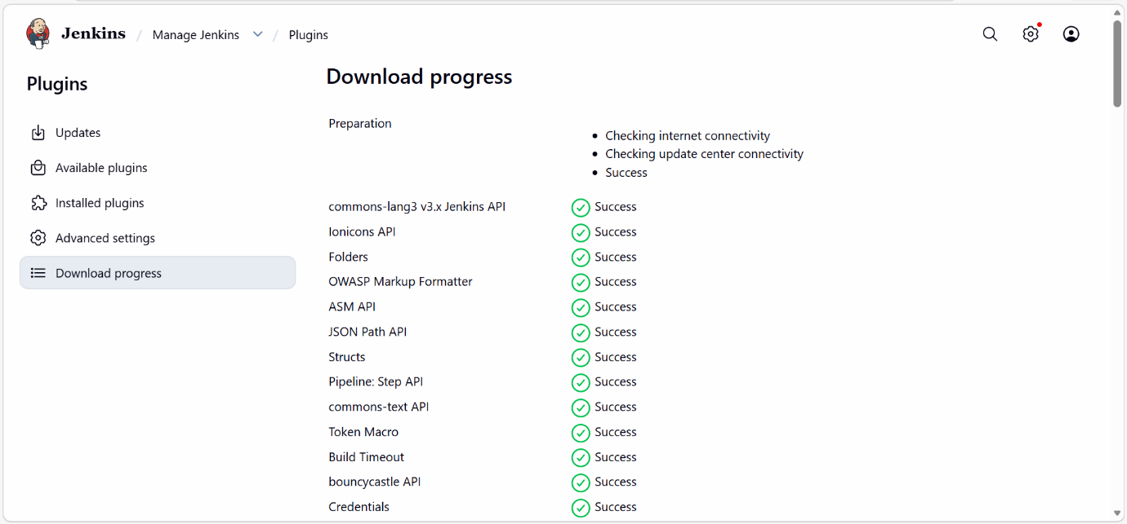

7.next go to jenkins ui there under manage plugins , install maven integration plugin,next go to tools there add maven like give name as maven 3.9.6, uncheck install automatically there u type /opt/apache-maven-3.9.6
click save

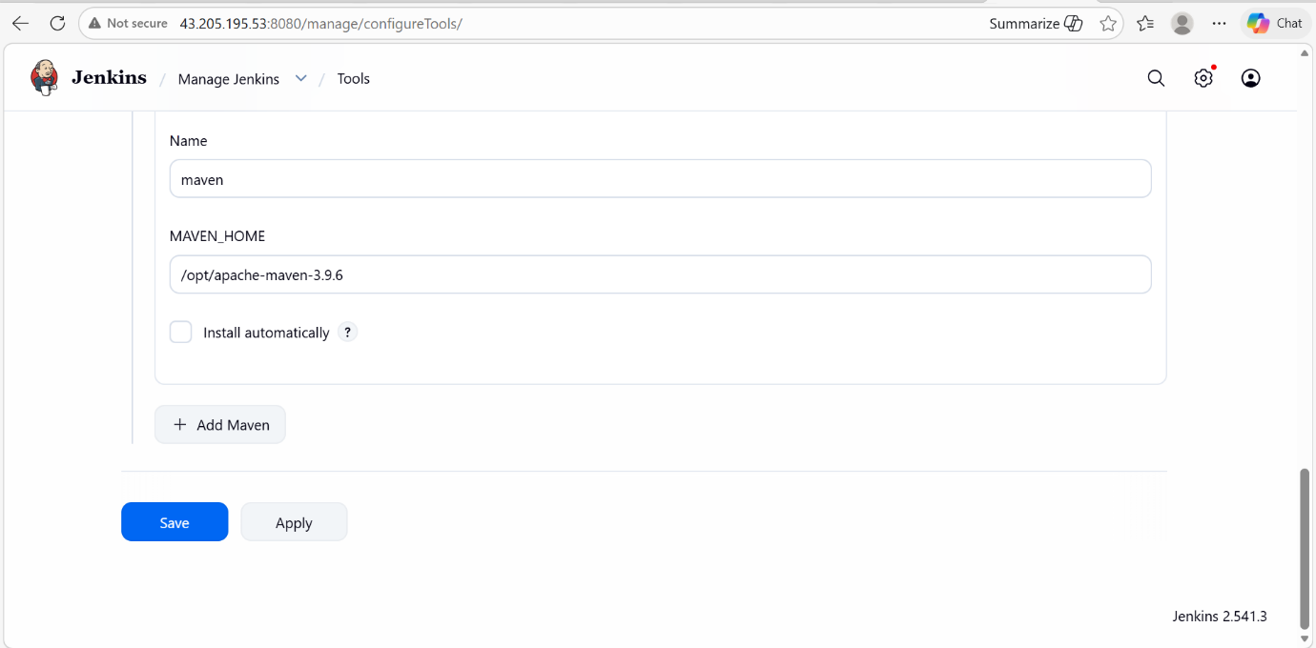\

8.next create a freestyle job under this give git repo(https://github.com/mvsanthi123/) and underbuild steps
select Invoke top-level Maven targets next type maven version as Maven 3.9.6 and goals as clean install and save
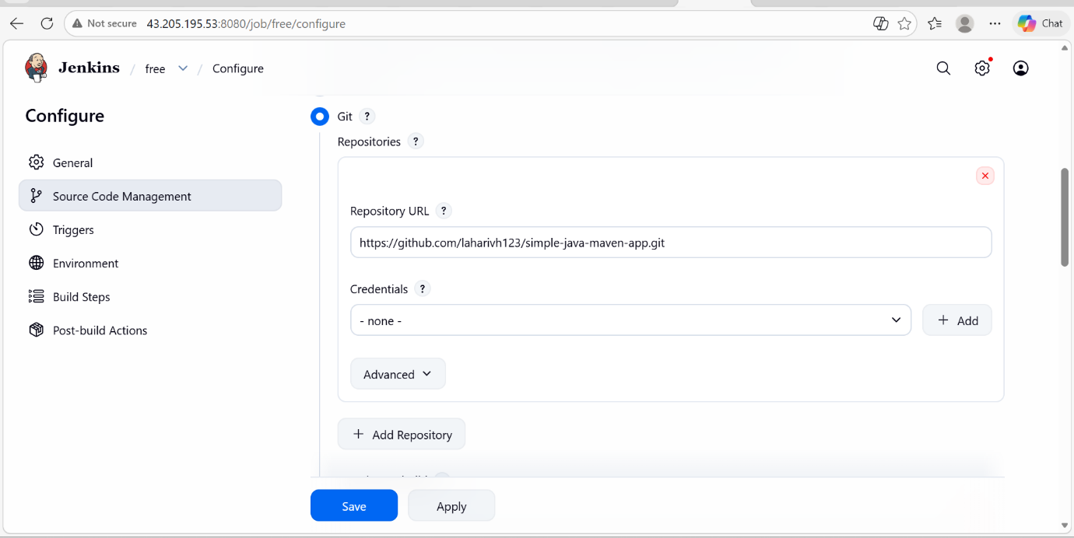
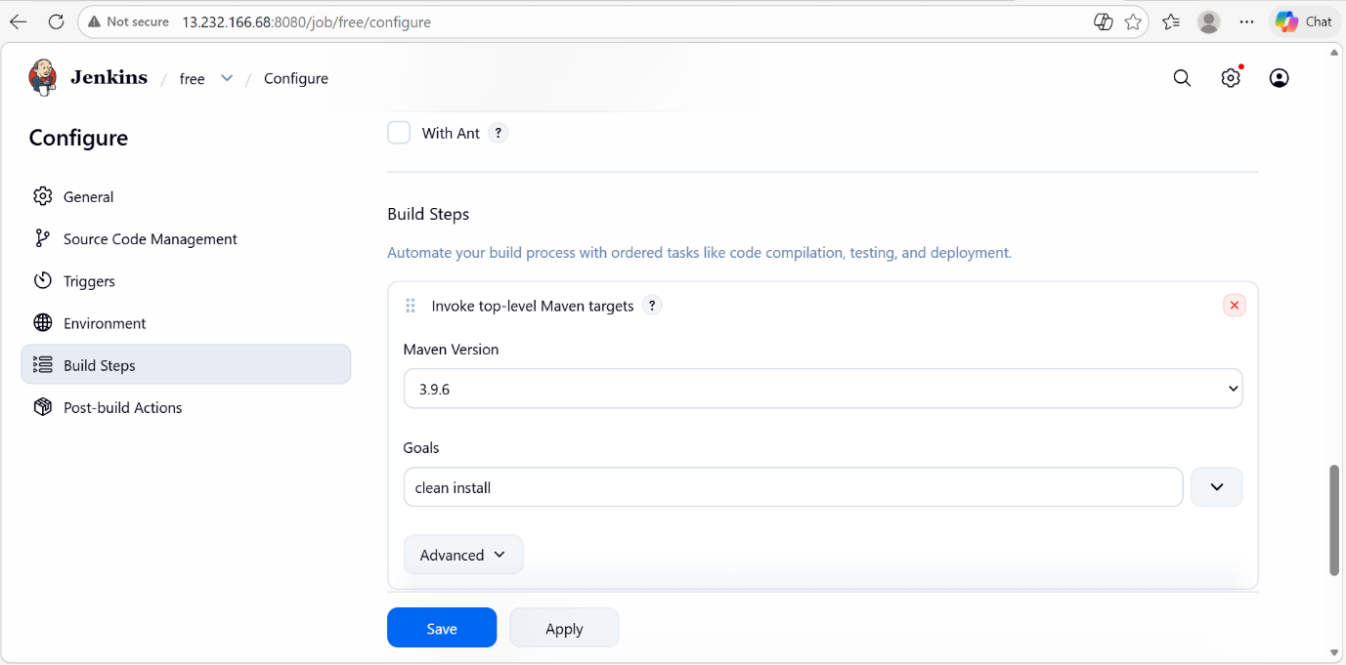
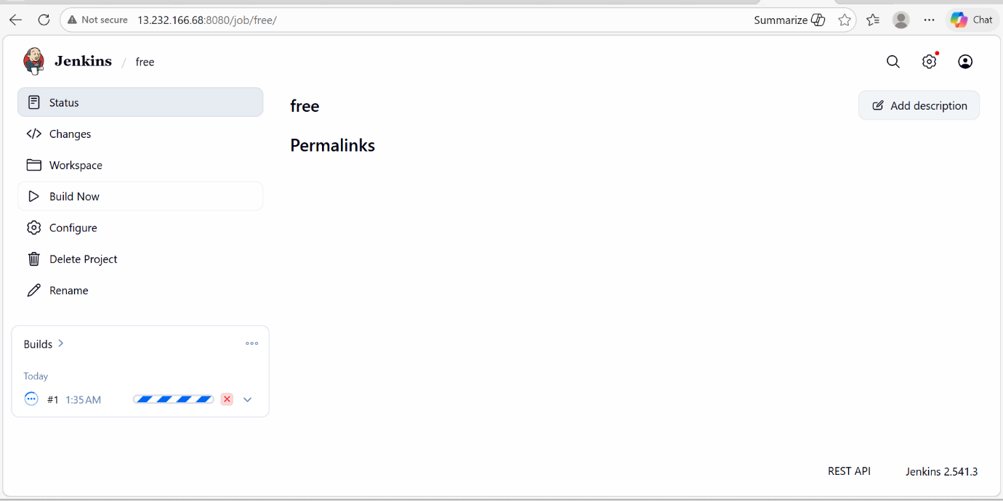
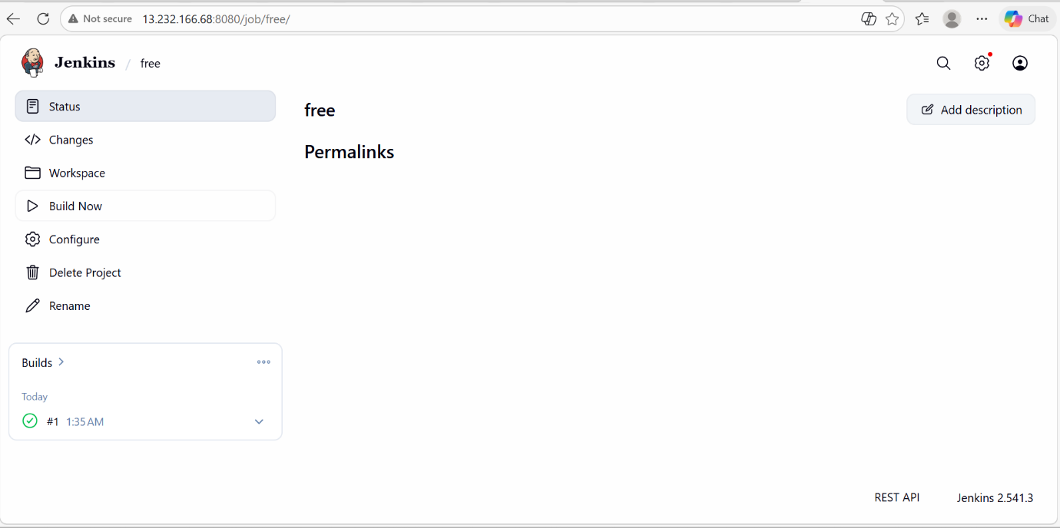
next run the build, there it will show you the jar file creation

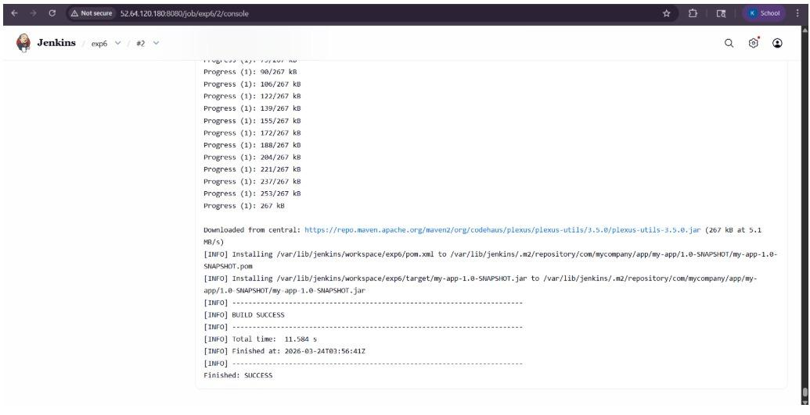
10. to check our jar file
sudo su - jenkins
cd /var/lib/jenkins/.m2/repository/com/mycompany/app/my-app/1.0-SNAPSHOT/
11.to see the outcome of jar file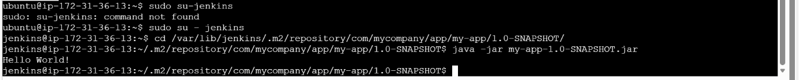
Experiment 7: Configuration Management with Ansible: Basics of Ansible: Inventory, Playbooks and Modules, Automating Server Configurations with Playbooks, Hands-On: Writing and Running a Basic Playbook

Ansible is an open-source automation tool used for configuration management, application deployment, and task automation. It is agentless, meaning it does not require any software to be installed on client machines—communication happens over SSH.

Key Features of Ansible
- Agentless architecture (uses SSH)
- Simple YAML-based configuration
- Idempotent (safe to run multiple times)
- Easy to learn and use
- Supports multi-tier deployments
Ansible Architecture
Ansible consists of:
- Control Node: Machine where Ansible is installed
- Managed Nodes: Systems being configured
- Inventory: List of managed nodes
- Playbooks: Automation scripts
- Modules: Units of work
Inventory in Ansible
The inventory file defines the list of hosts and groups.
Example Inventory:
[webservers]
192.168.1.10
192.168.1.11
[dbservers]
192.168.1.20
Ansible Playbooks
A playbook is a YAML file that defines automation tasks.
Structure:
- Hosts: Target machines
- Tasks: Actions to perform
- Modules: Tools used in tasks

Step 1: Create 2 Instances

Master Machine : Ubuntu
Node Machine : Ubuntu

Step 2: Install Ansible on Master Machine

sudo apt update
sudo apt install -y ansible
ansible --version

ansible localhost -m ping

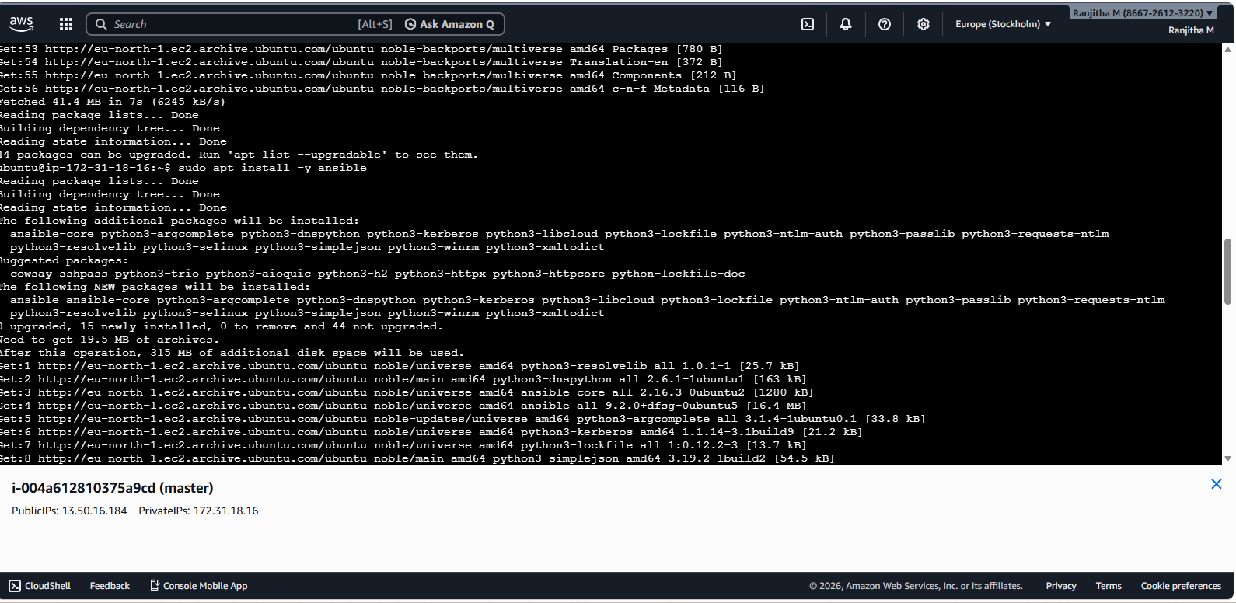

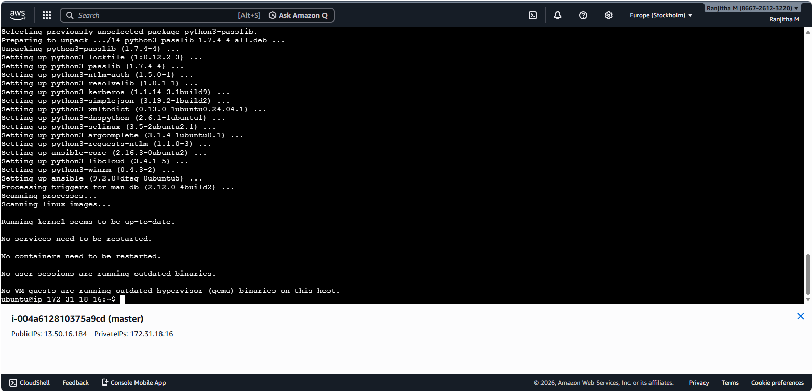
sudo apt install -y ansible
ansible localhost -m ping
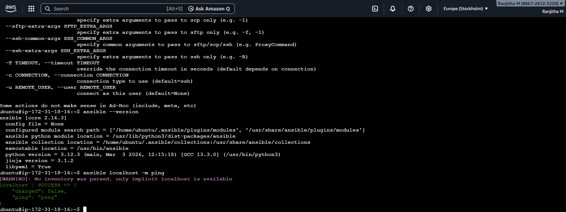

Step 4: Configure SSH Access to Node Machine
ssh-keygen
cd .ssh
ls
cat id_ed25519.pub

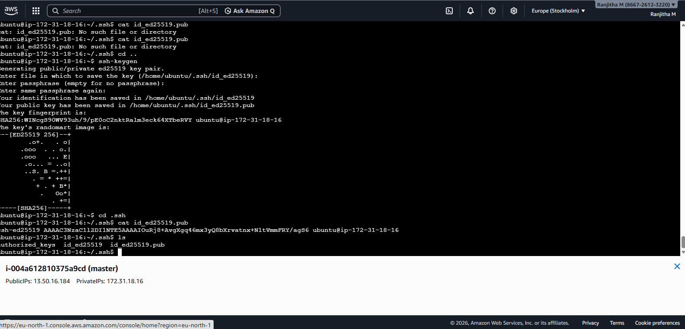
2)echo "ssh-ed25519
AAAAC3NzaC1lZDI1NTE5AAAAIGVEapGvCUJC+vo7aaHqpiuVWDtCJSzccbtEKe4cdtWZ ubuntu@ip-172-31-71-191" >>~/.ssh/authorized_keys // that ip is private ip of master node
Step 6: cd ..
Edit files using nano and add public ip of node machine
Run on Master Machine

1.nano ~/inventory.ini
now here add the public ip of node machine and save it like
cntrl-o+enter+cntrl-x

[node_machines]
3.239.119.125 ansible_ssh_user=ubuntu

to save give cntrl-o+enter+cntrl-x
Step 8:
2.nano ~/install_package.yml

---
- name: Install a package on the node machine
hosts: node_machines
become: yes
tasks:
- name: Update apt cache
apt:
update_cache: yes
- name: Install Nginx
apt:
name: nginx
state: present
to save give ctrl-o+enter+ctrl-x
Step 9: Master Machine

ansible-playbook -i ~/inventory.ini ~/install_package.yml

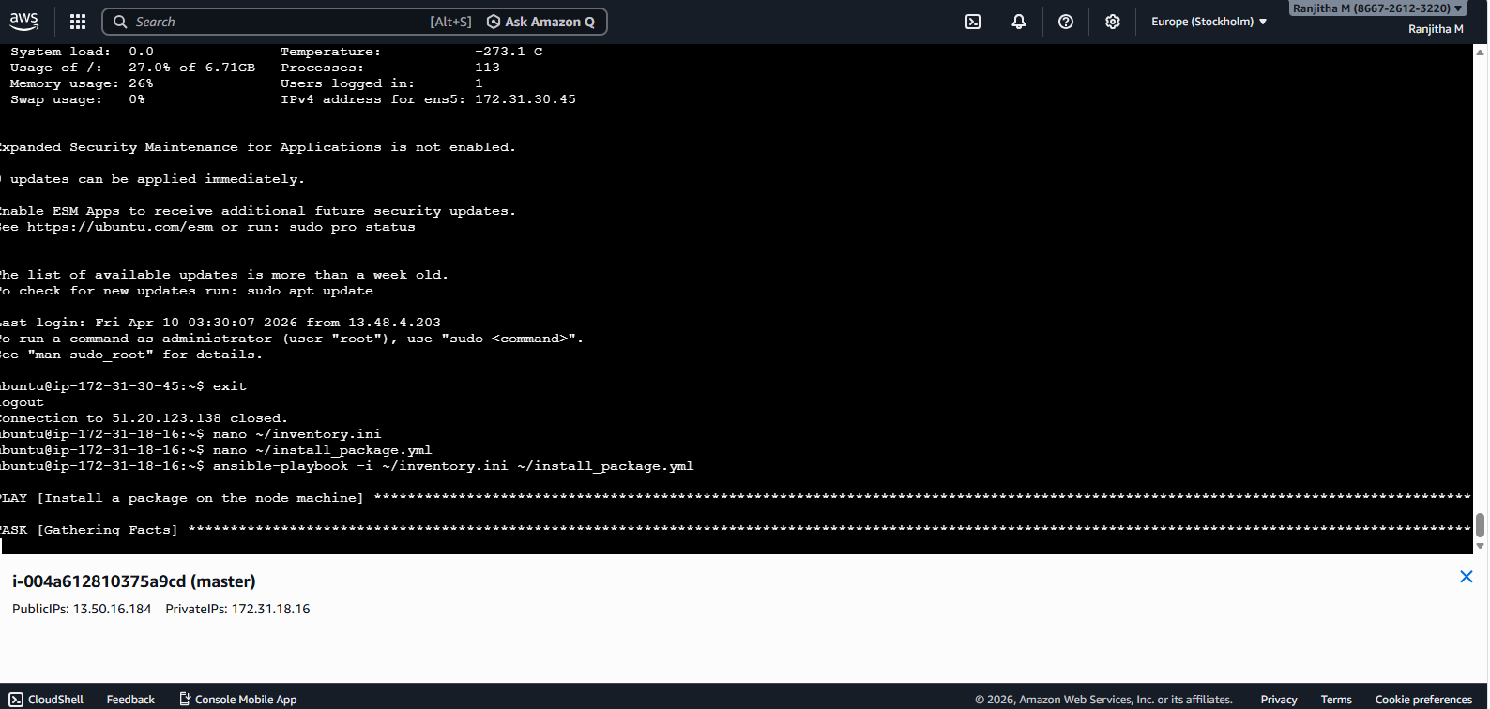

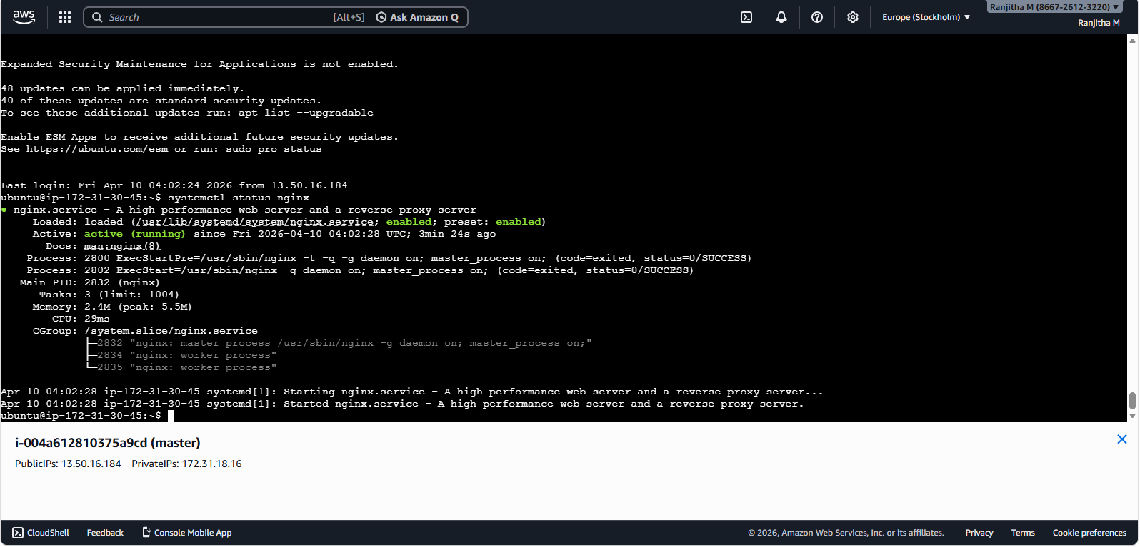

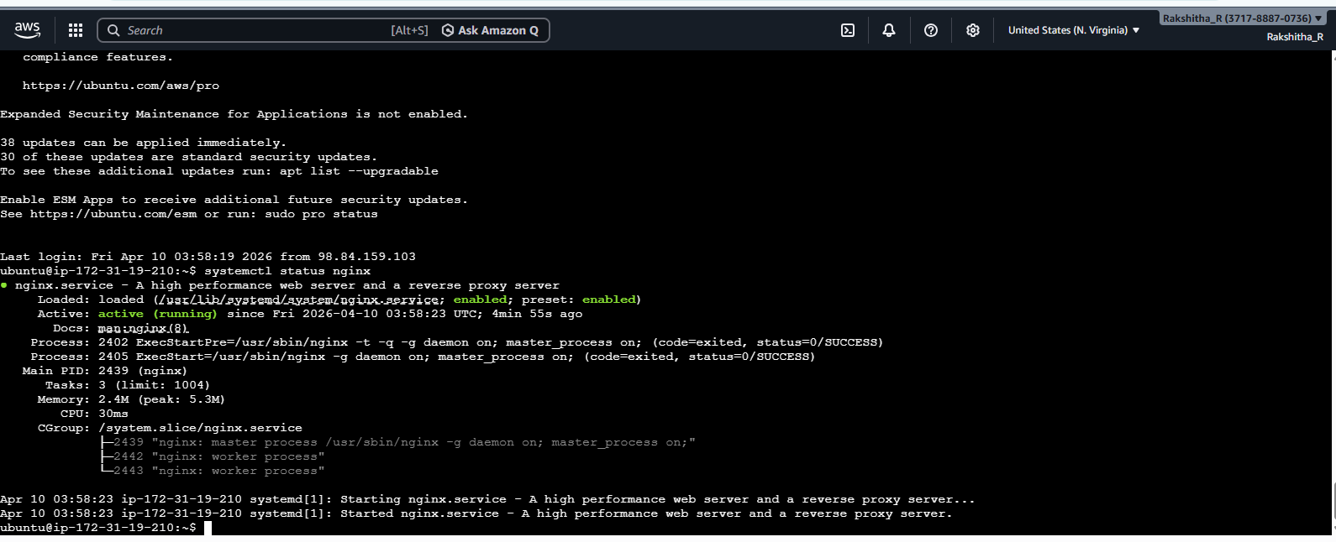
Step 12: In aws go to node machine there in
security groups allow http 80 port from anywhere
ipv4 , after that in browser page type
http://node-ip:80, it will display nginx welcome page
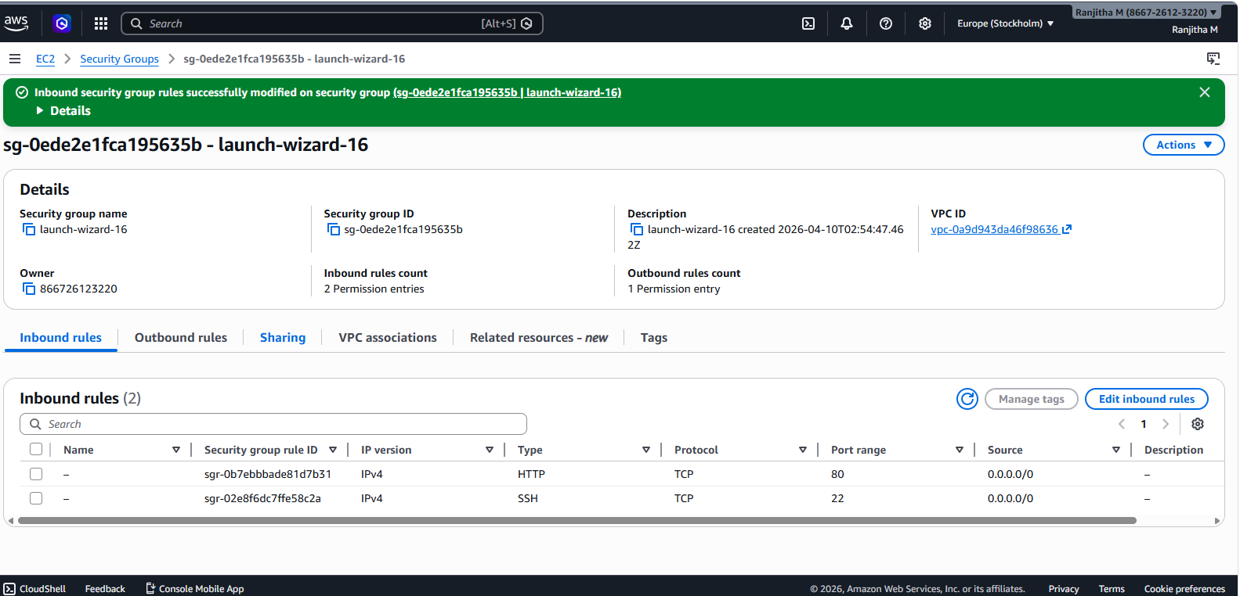
Step 13: http://node-ip:80

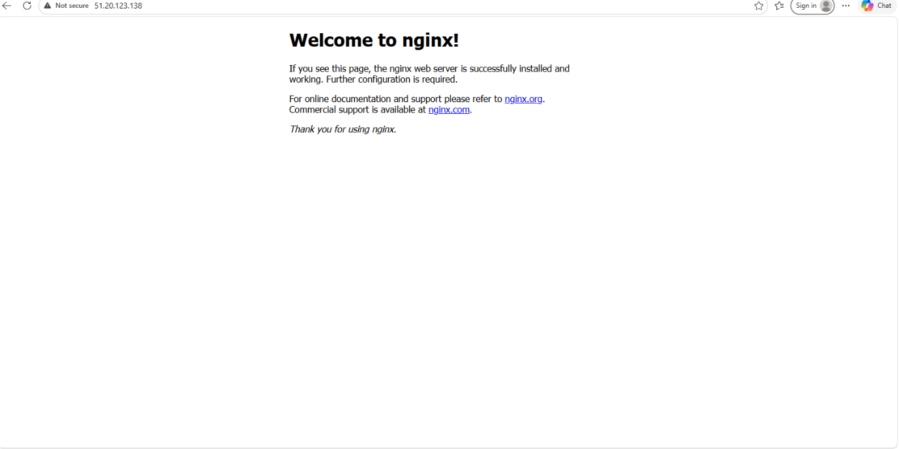

Experiment 8:
Set Up a Jenkins CI Pipeline for a Maven Project, Use Ansible to Deploy Artifacts Generated by Jenkins

master
======
1.sudo apt update
sudo apt install openjdk-21-jdk -y

2. maven installation

wget https://archive.apache.org/dist/maven/maven-3/3.9.6/binaries/apache-maven-3.9.6-bin.tar.gz
sudo tar -xzf apache-maven-3.9.6-bin.tar.gz -C /opt/
echo 'export PATH=/opt/apache-maven-3.9.6/bin:$PATH' | sudo tee /etc/profile.d/maven.sh
source /etc/profile.d/maven.sh
mvn -version

3.ansible installation

sudo apt install -y ansible
ansible --version

4.jenkins installation

https://pkg.jenkins.io/debian-stable/
===========================

sudo wget -O /etc/apt/keyrings/jenkins-keyring.asc \
https://pkg.jenkins.io/debian-stable/jenkins.io-2026.key

echo "deb [signed-by=/etc/apt/keyrings/jenkins-keyring.asc]" \
https://pkg.jenkins.io/debian-stable binary/ | sudo tee \
/etc/apt/sources.list.d/jenkins.list > /dev/null

sudo apt-get update
sudo apt-get install fontconfig openjdk-21-jre
sudo apt-get install jenkins

sudo systemctl start jenkins
sudo systemctl status jenkins

sudo cat /var/lib/jenkins/secrets/initialAdminPassword

first allow custom tcp port 8080 by selecting anywhere with ipv4 with all zeros in security grops of that instance
http://your-server-ip(public-ip):8080

b91d832b311d4f538e775a07765e29c5

5. now create steps to connect from master to node

in master run-ssh-keygen, from here copy the public key to node machine like

echo "ssh-ed25519 AAAAC3NzaC1lZDI1NTE5AAAAIPIQJSHs1gROFtO1voZ9RrhWNxr4rQxy1idP1L7vnAjO ubuntu@ip-172-31-17-150" >> ~/.ssh/authorized_keys
=======================================

on matser machie run the following commands
===========================================
sudo mkdir -p /var/lib/jenkins/.ssh
sudo cp /home/ubuntu/.ssh/id_ed25519 /var/lib/jenkins/.ssh/
sudo cp /home/ubuntu/.ssh/id_ed25519.pub /var/lib/jenkins/.ssh/
sudo chown -R jenkins:jenkins /var/lib/jenkins/.ssh
sudo chmod 700 /var/lib/jenkins/.ssh

6. now under master machine

here create inventory and deploy files

invenroty file-inventory.ini-nano ~/inventory.ini
==========
[webserver]
100.52.246.148 ansible_user=ubuntu ansible_ssh_private_key_file=/var/lib/jenkins/.ssh/id_ed25519 ansible_ssh_common_args='-o StrictHostKeyChecking=no'

deploy file-deploy.yml-nano ~/deploy.yml
============
- name: Deploy Maven JAR to Target Server
hosts: webserver
tasks:
- name: Copy JAR file to Remote Server
copy:
src: /var/lib/jenkins/.m2/repository/com/mycompany/app/my-app/1.0-SNAPSHOT/my-app-1.0-SNAPSHOT.jar
dest: /home/ubuntu/app.jar
mode: '0755'

- name: Run Java Application
shell: nohup java -jar /home/ubuntu/app.jar > app.log 2>&1 &

after creating these files in ubuntu user move to jenkins user
sudo mv ~/deploy.yml ~/inventory.ini /var/lib/jenkins/
sudo chown jenkins:jenkins /var/lib/jenkins/deploy.yml /var/lib/jenkins/inventory.ini

7.jenkins configure-mavenansiblejenkins
===============
(i)under manage jenkins
=======
install maven, ansible plugins under plugins.

tools
===========
Ansible, /usr/bin/

maven 3.9.6,/opt/apache-maven-3.9.6

(ii)under pipeline configure at last write
======================================
give git hub url: https://github.com/mvsanthi123/simple-java-maven-app.git

bildsteps-- pls select invoketoplevel maven taget-give name as maven and goal as clean install package

excecute shell:ansible-playbook -i ~/inventory.ini ~/deploy.yml

8.click on build now, now it will create a jar file from artifact and deploy to node machine

Experiment 9: Introduction to Azure DevOps: Overview of Azure DevOps Services, Setting Up an Azure DevOps Account and Project
Overview of Azure DevOps
Azure DevOps is a comprehensive suite of cloud-based services designed to support the entire software development lifecycle. It provides tools for planning, developing, testing, delivering, and monitoring applications. Here are the primary services offered:
• Azure Repos: A set of version control tools that allow you to host Git repositories or use Team Foundation Version Control (TFVC). It offers collaboration features such as pull requests, branch policies, and code reviews.
• Azure Pipelines: A CI/CD service that helps automate builds, tests, and deployments. It supports multiple languages, platforms, and can run on Linux, Windows, or macOS agents.
• Azure Boards: A work tracking system that helps teams manage work items, sprints, backlogs, and Kanban boards. It facilitates agile planning and reporting.
• Azure Test Plans: Provides a solution for managing and executing tests, capturing data about defects, and tracking quality.
• Azure Artifacts: Allows you to create, host, and share packages (such as Maven, npm, NuGet, and Python packages) with your team, integrating package management into your CI/CD pipelines.
These services integrate with each other and with popular third-party tools to create a cohesive DevOps ecosystem.
Setting Up an Azure DevOps Account
Before you can start using Azure DevOps services, you need to set up an account and create an organization. Follow these steps:
Step 1: Sign Up for an Azure DevOps Account
1. Open Your Web Browser:
o Navigate to the Azure DevOps website: https://dev.azure.com.
2. Sign In or Create a Microsoft Account:
o If you already have a Microsoft account (such as Outlook, Hotmail, or Office 365), click “Sign in”.
o If you do not have a Microsoft account, click “Create one!” and follow the instructions to create a new Microsoft account.
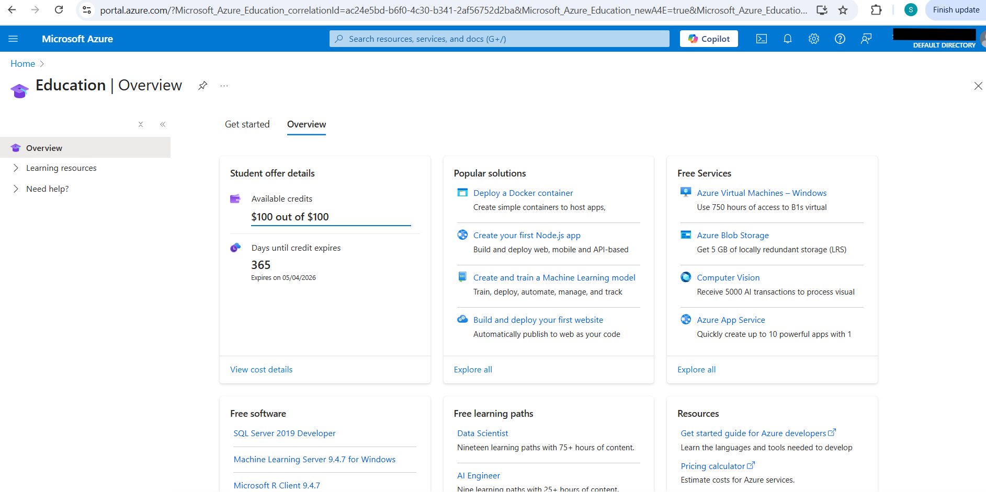
3. Accept the Terms and Conditions:
o Review and accept the terms if prompted.

Step 2: Create an Azure DevOps Organization
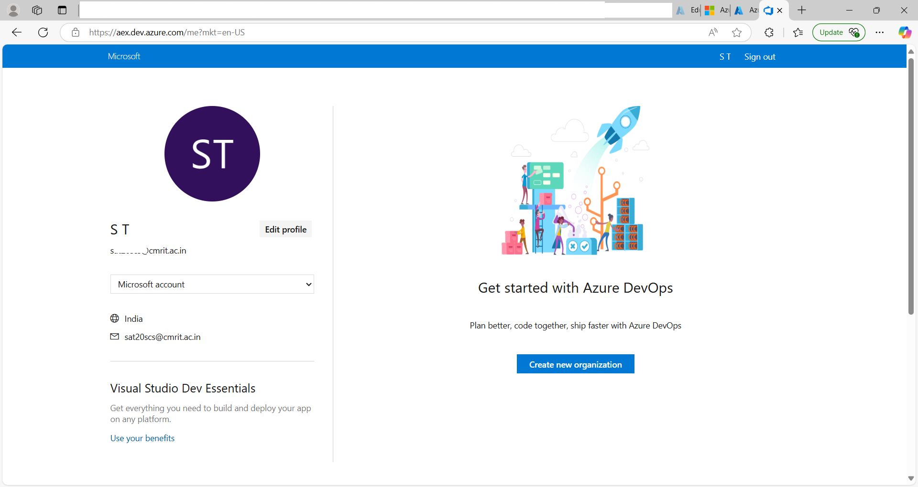
1. Create a New Organization:
o Once signed in, you will be prompted to create an Azure DevOps organization. o Enter a unique name for your organization (e.g., YourCompanyDevOps or MyPersonalOrg).
o Select a Region: Choose the geographic region where your data will be stored (select the one closest to you for optimal performance).
o Click “Continue” or “Create”.

2. Review Your Organization’s Dashboard:
o Once created, you will see an overview dashboard for your organization. This dashboard provides navigation links to Repos, Pipelines, Boards, Test Plans, and Artifacts.
3. Creating an Azure DevOps Project
After setting up your organization, the next step is to create a project. A project in Azure DevOps is a container for all your source code, pipelines, boards, and other resources.
Step 1: Create a New Project
1. Navigate to “New Project”:
o On your organization’s dashboard, click the “New Project” button.
2. Configure Your Project:
o Project Name: Enter a descriptive name for your project (e.g., HelloDevOps). o Description: Optionally, provide a brief description (e.g., “A sample project to demonstrate Azure DevOps services”).
o Visibility:
▪ Choose “Private” if you want to restrict access to your project.
▪ Choose “Public” if you are okay with the project being accessible to anyone.
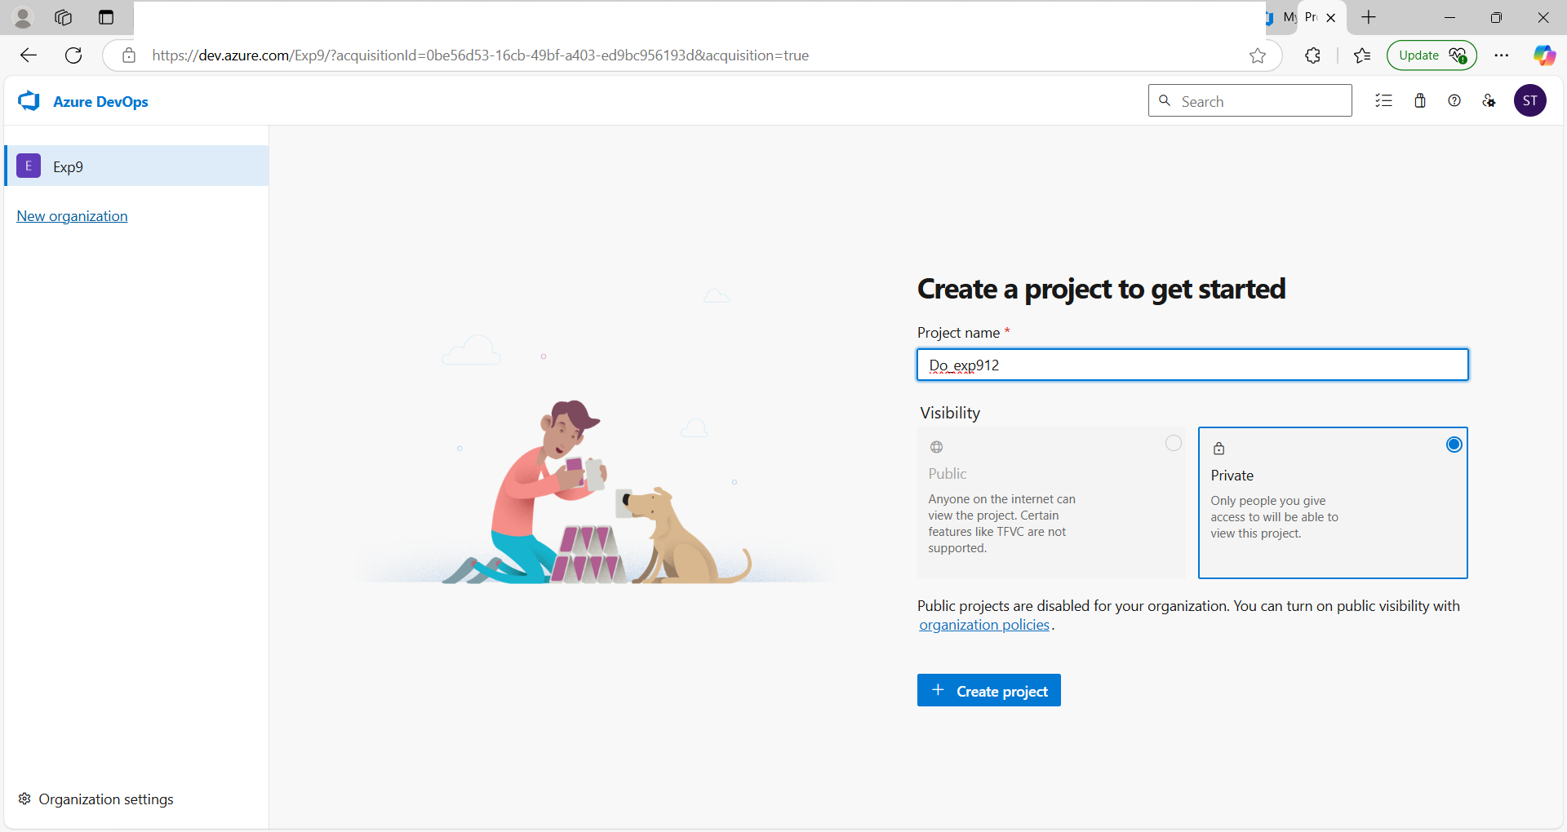
o Advanced Options (Optional): You can choose a version control system (Git is the default) and a work item process (Agile, Scrum, or Basic). For most beginners, the defaults are recommended.
o Click “Create”.
Step 2: Explore Your Project Dashboard
1. Project Overview:
o Once your project is created, you will be directed to the project dashboard. Here you will see navigation options for:
▪ Repos: Where your code is stored.
▪ Pipelines: For build and release automation.
▪ Boards: For work tracking and agile planning.
▪ Test Plans: For managing and running tests.
▪ Artifacts: For hosting packages.
2. Familiarize Yourself with the Interface:
o Click through each section (e.g., Repos, Pipelines, Boards) to get a sense of the available features.
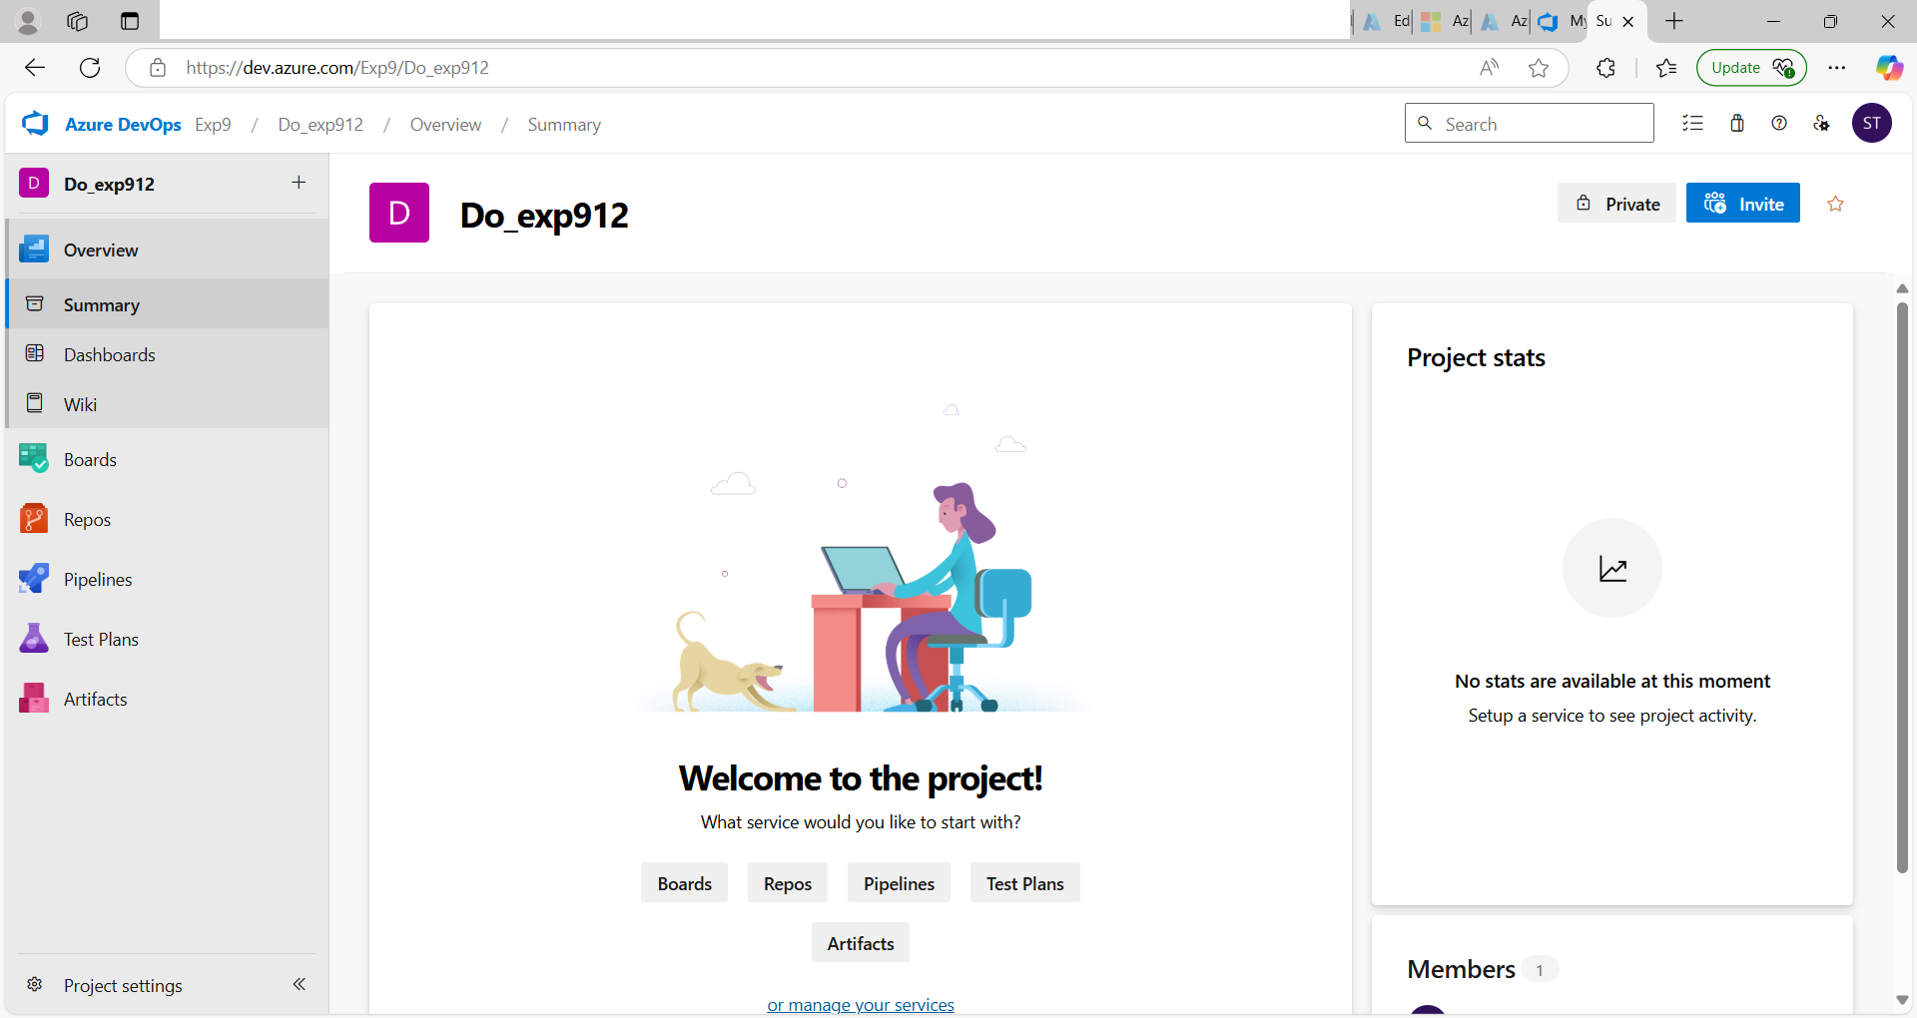

Experiment 10:
Creating Build Pipelines: Building a Maven/Gradle Project with Azure Pipelines, Integrating Code Repositories (e.g., GitHub, Azure Repos), Running Unit Tests and Generating
Reports

Microsoft Azure (usually just called Azure) is a cloud computing platform from Microsoft. It lets you rent computing power, storage, databases, and other services over the internet instead of owning physical servers.

What Azure is (simple view)
Think of Azure as a giant online data center where you can:
- Run apps and websites
- Store data
- Train AI models
- Host virtual machines (like remote computers)
- Build and deploy software
You pay only for what you use.

Key Features of Azure

1. Compute services
- Virtual Machines (VMs)
- App Services (for web apps)

2. Storage options
- Blob storage (files, images, videos)
- Disk storage (for VMs)
- Backup & archival

3. Networking
- Virtual networks
- VPN & private connections
- Load balancing

4. Databases
- Managed SQL databases
- NoSQL options like Cosmos DB

5. AI & Machine Learning
- Prebuilt AI APIs (vision, speech)
- Custom ML model training

6. DevOps & developer tools
- CI/CD pipelines
- Integration with GitHub and Microsoft tools

7. Security & Identity
- Azure Active Directory (login/authentication)
- Advanced threat protection

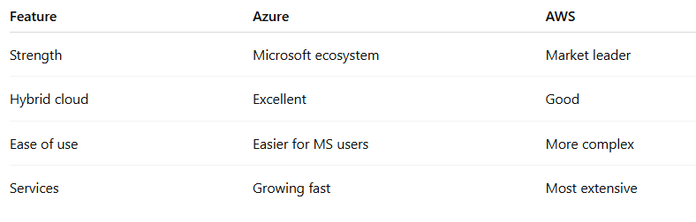

- Azure Pipelines: is a cloud service (part of Azure DevOps) that automatically builds, tests, and deploys your code whenever you make changes.

Simple Meaning
Azure Pipeline = automation for your software workflow
Instead of manually doing:
- Compile code
- Run tests
- Package app
- Deploy
👉 Azure Pipelines does all of this automatically.

Real-world Example
You push code to GitHub →
Azure Pipeline:
- Pulls your code
- Builds it (e.g., using Apache Maven)
- Runs tests
- Creates output (JAR/WAR)
- (Optional) Deploys to server/cloud

⚙️ What it actually does

1. Continuous Integration (CI)
- Automatically builds & tests code on every change
- Finds bugs early

2. Continuous Del

Experiment 10: steps

- Open your github account —> another tab : open https://github.com/mvsanthi123/

- Go to repository of https://github.com/mvsanthi123/ and fork following projects
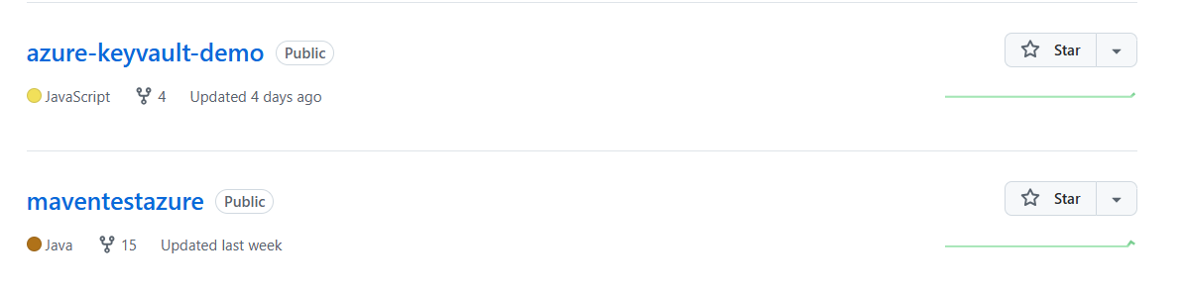

- Login to azure account
Below page will be displayed

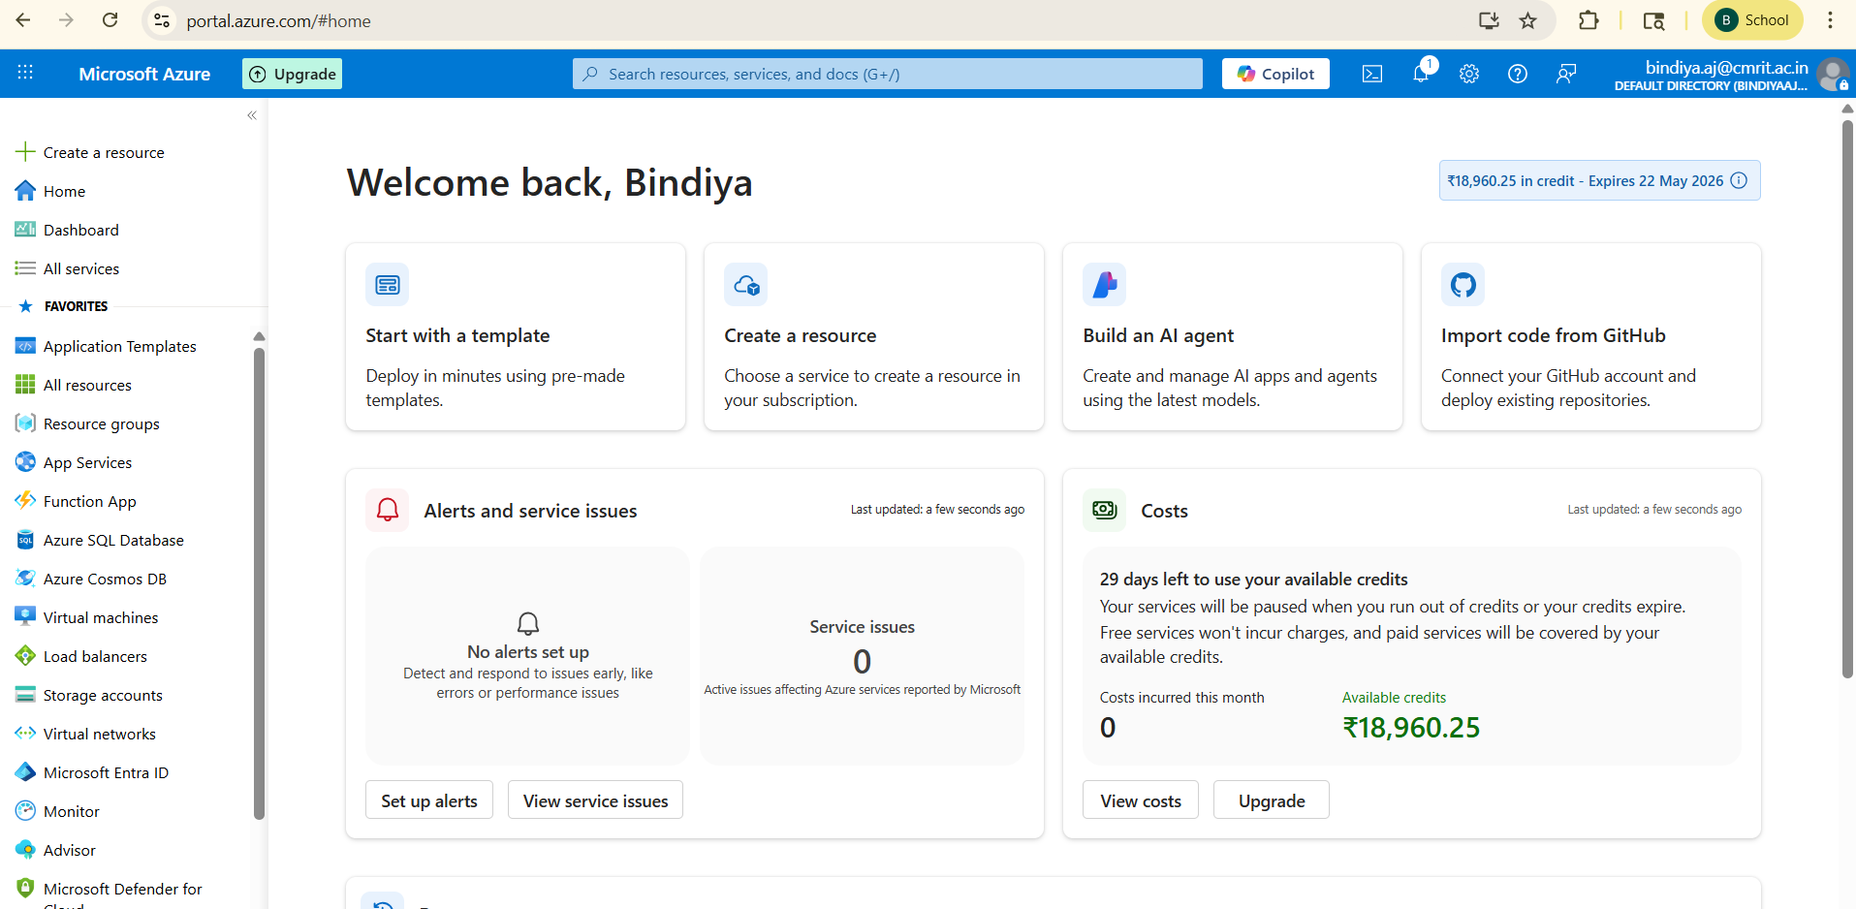Introduction about Microsoft Azure:

- Search azure devops organization
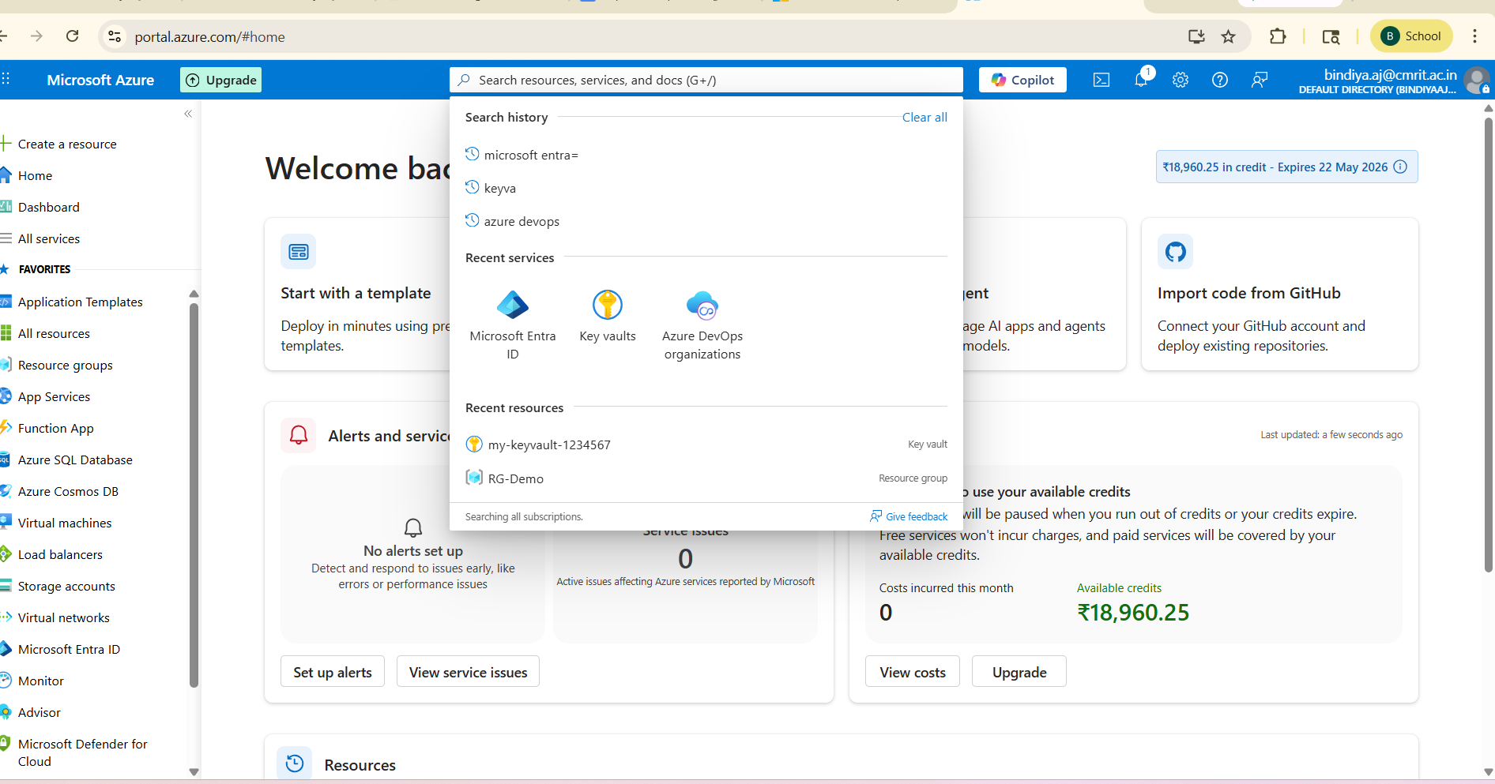

- Click on view my organization
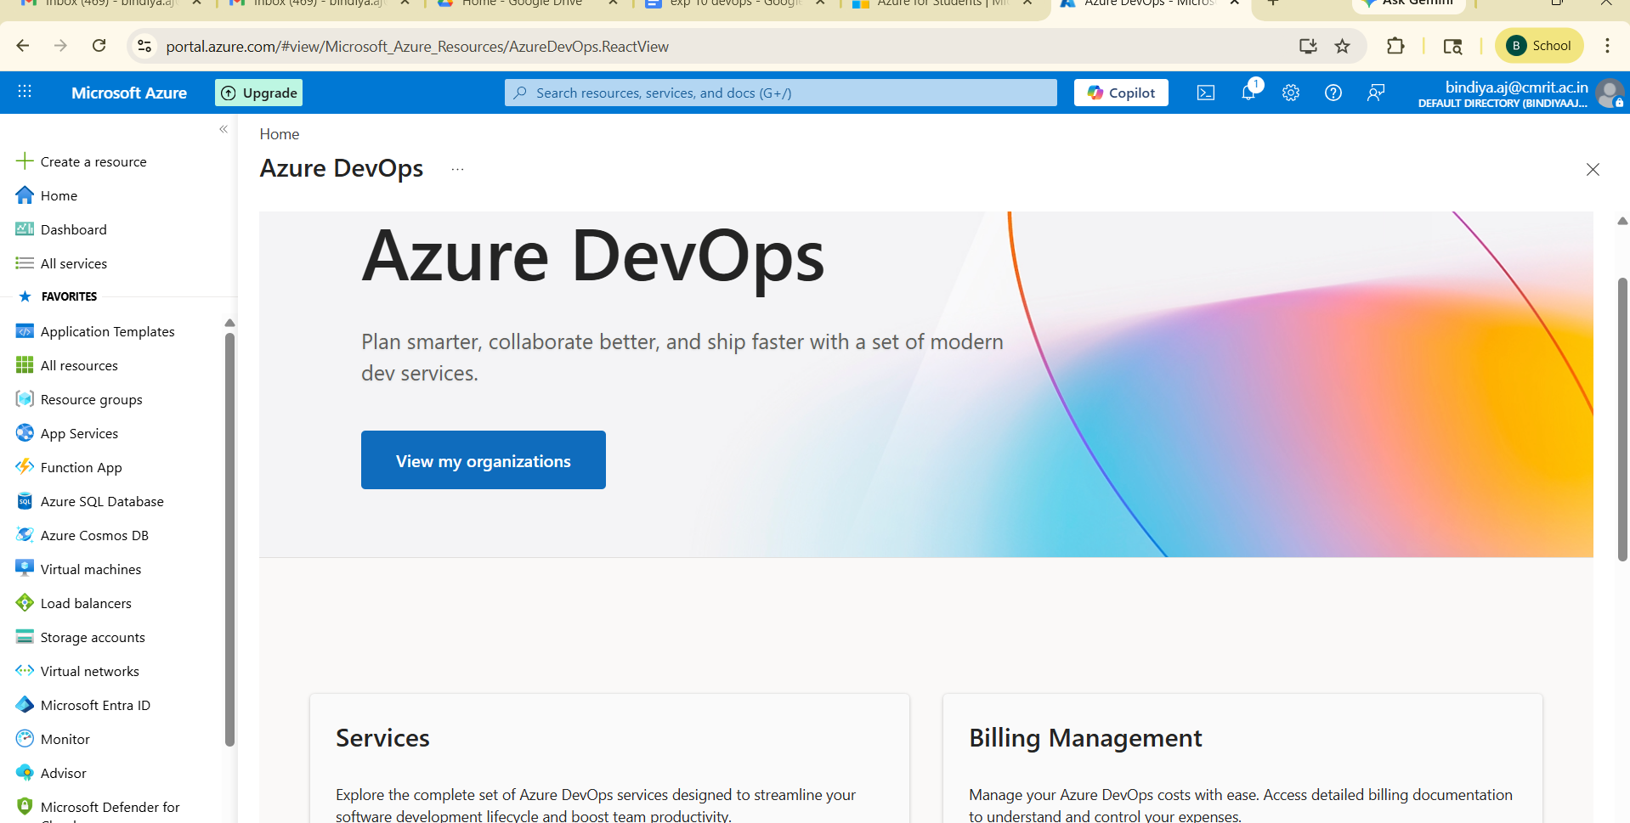

6)create new organization

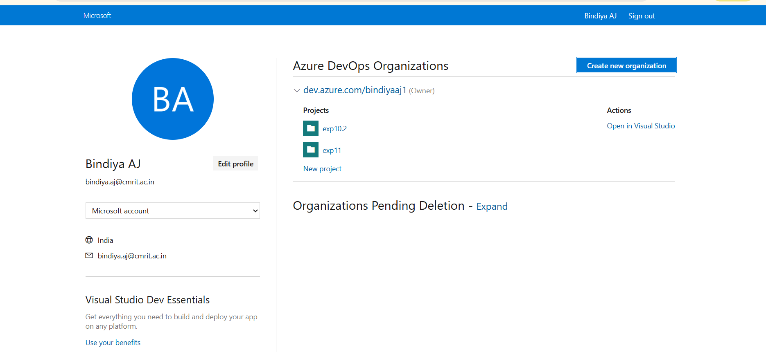

7)Give continue

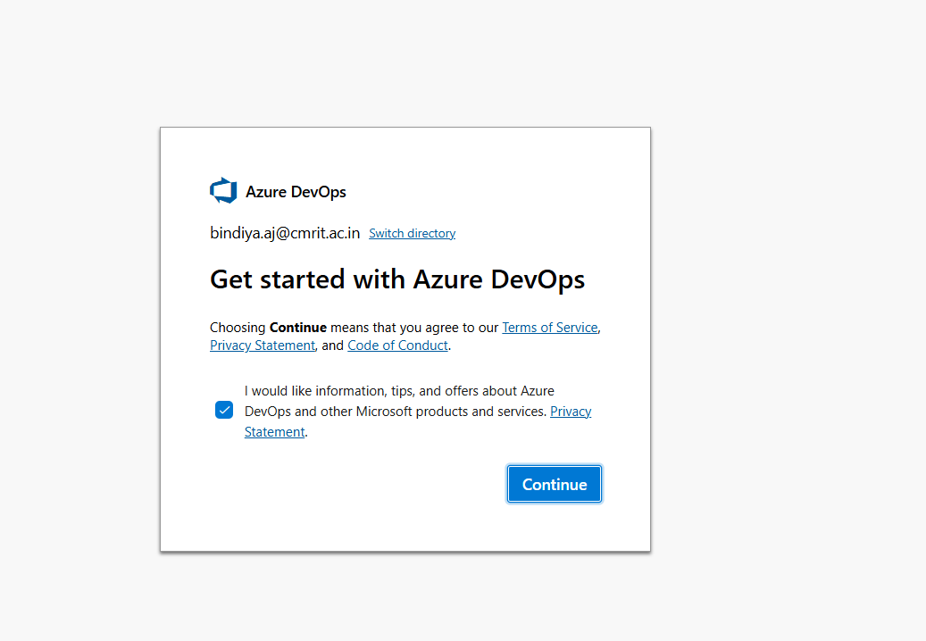

8)Continue with default name or give name of ur choice (Ex :bindiyaaj1) and give continue

dev.azure.com/ bindiyaaj

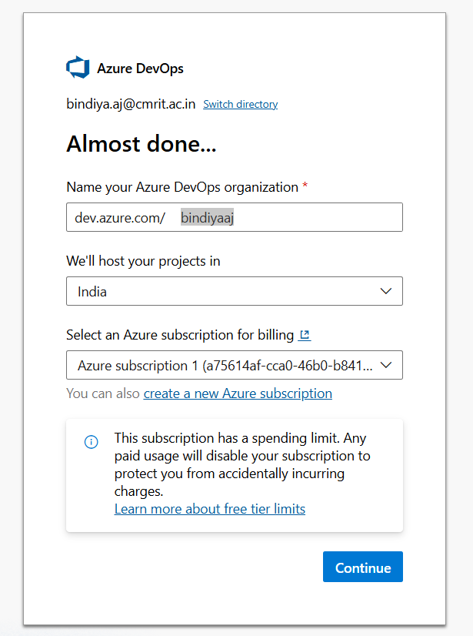

9) Below organization page will be displayed and now go to new projects

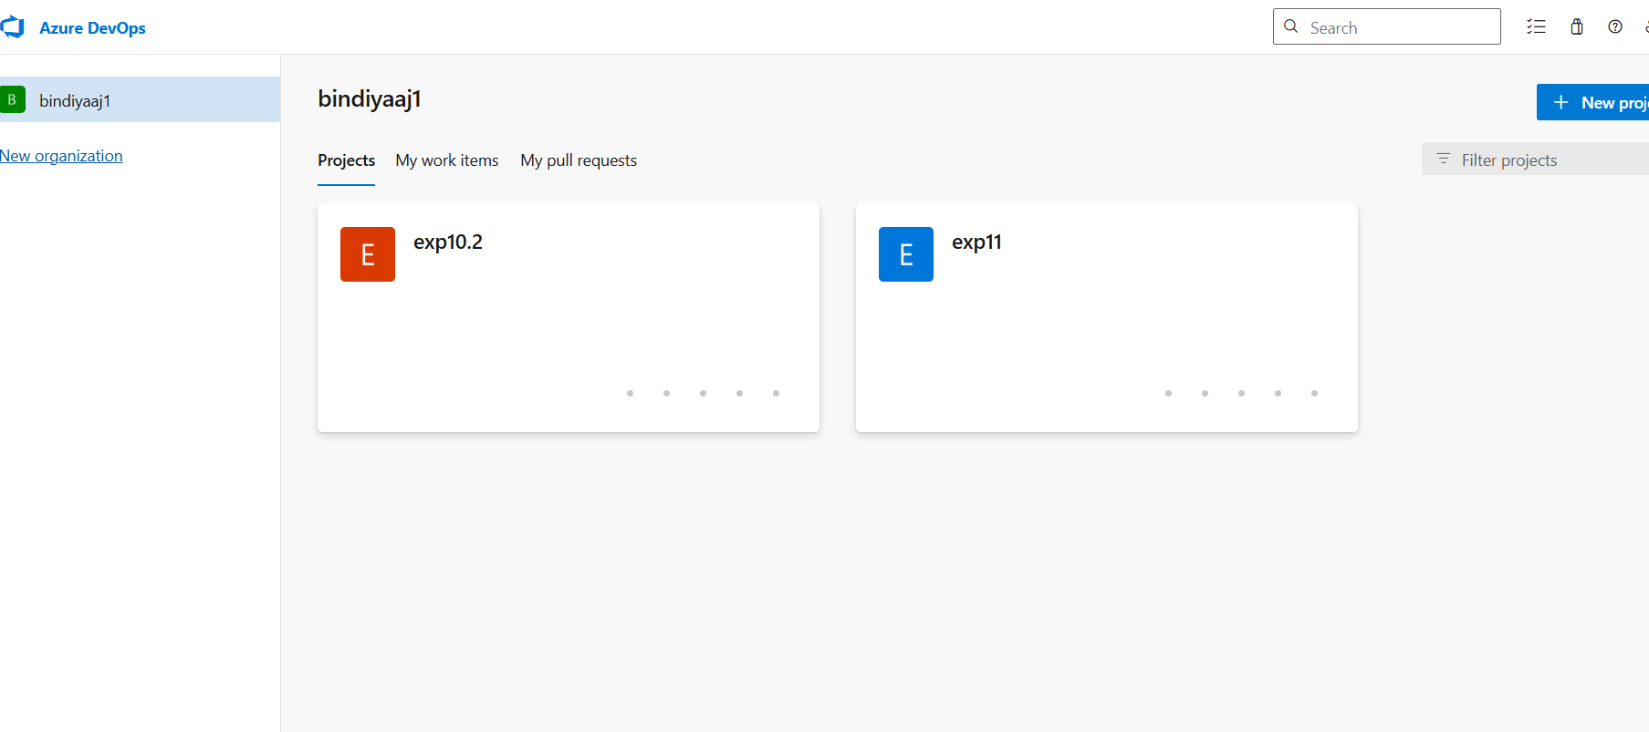
10)Go to new project+ enter project name and make sure visibility private.---> click on create

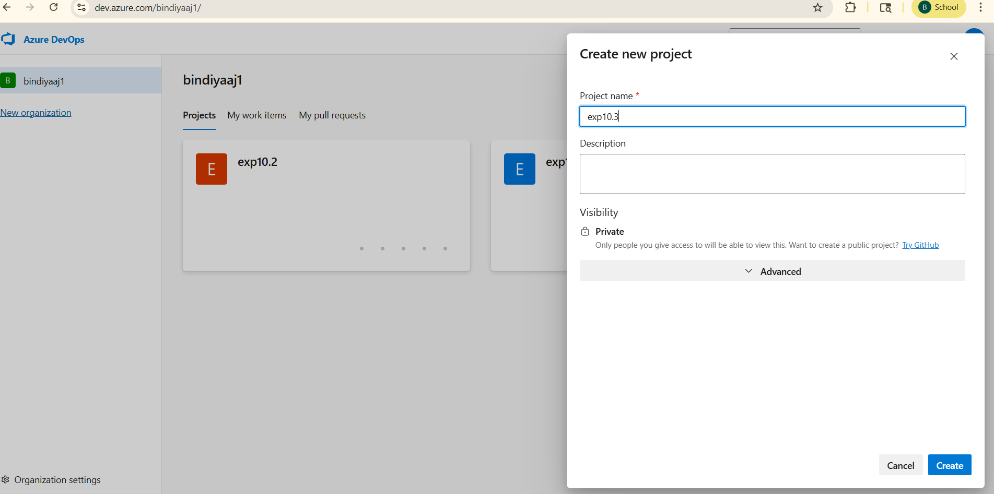

11)Below is the project page looks
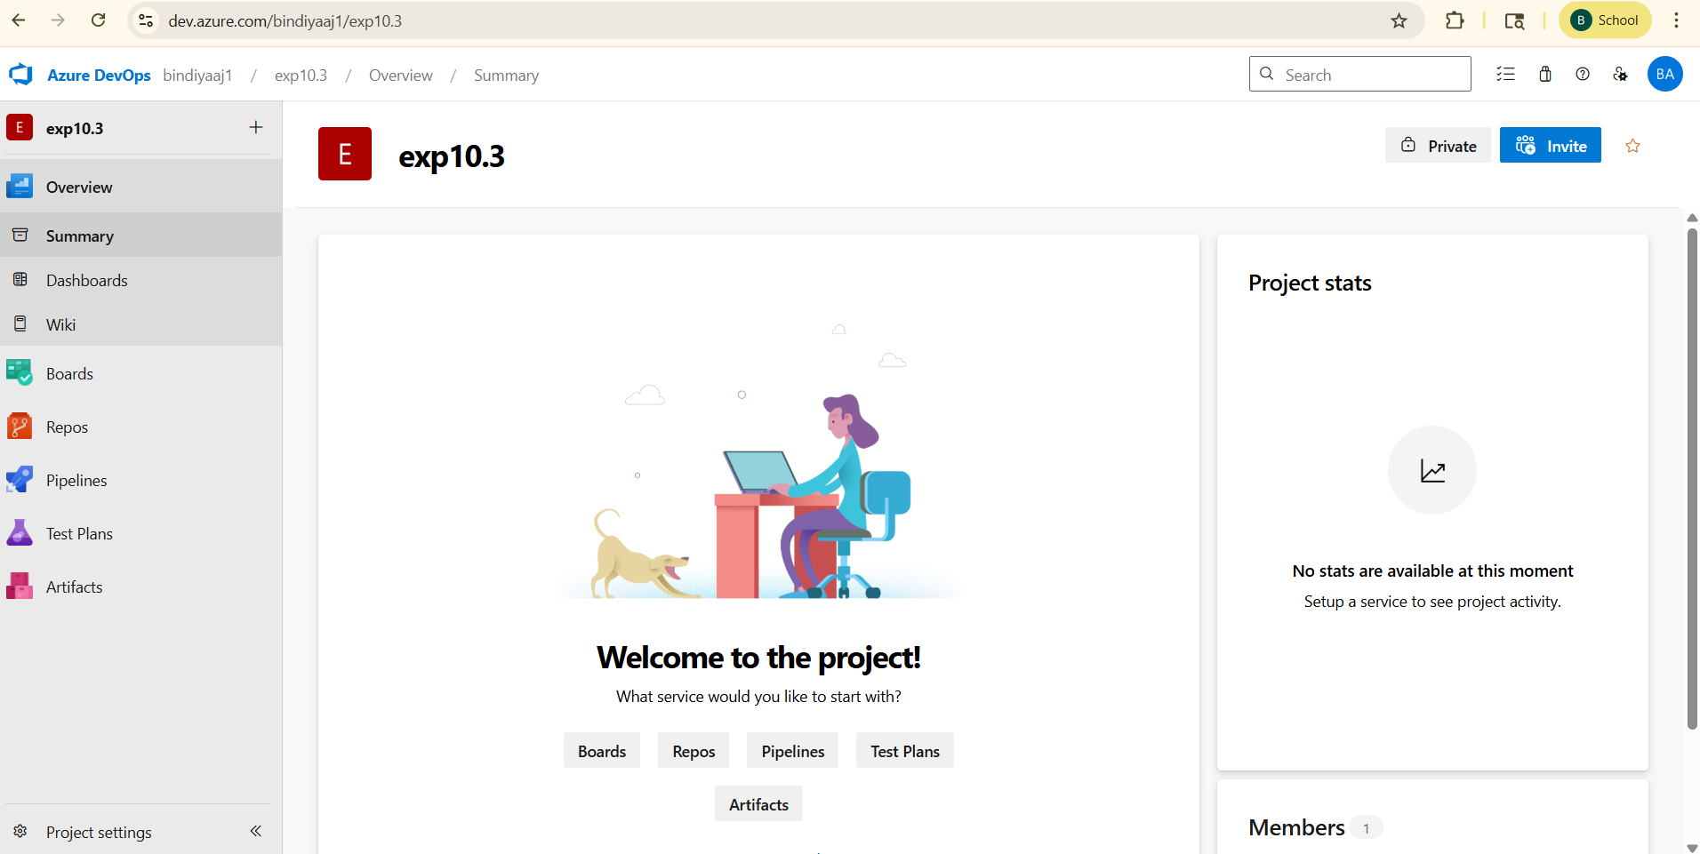

12) go to “pipeline “ in the left —>create pipeline

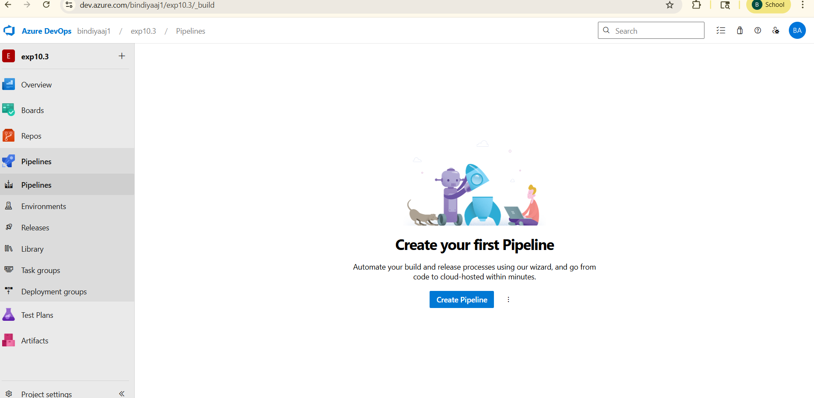

13) click on GitHub
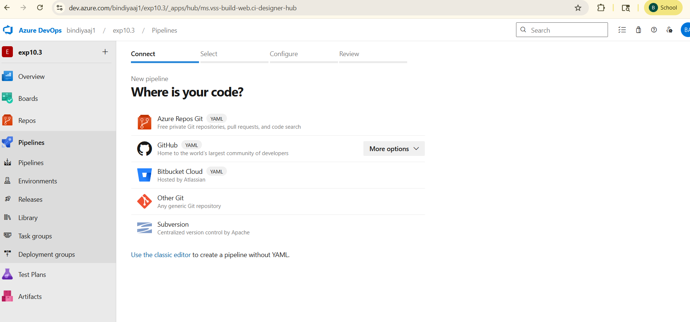

14) click on “maventestazure “ →

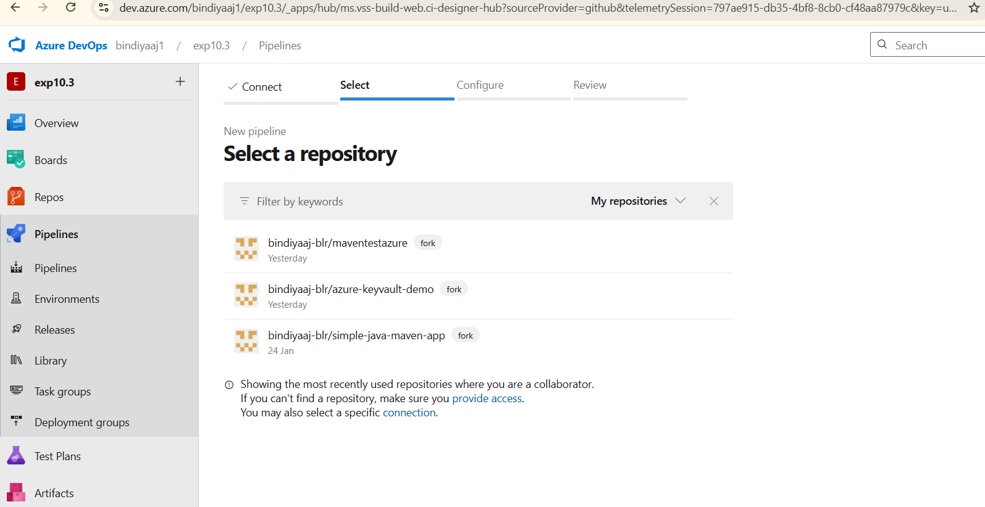

15) below page is displayed:
Copy below yaml file code:

trigger:
branches:
include:
- main
stages:
- stage: __default
jobs:
- job: Job
pool:
vmImage: ubuntu-latest
steps:
- task: Maven@3
inputs:
mavenPomFile: 'artifact1/pom.xml'
mavenOptions: '-Xmx3072m'
javaHomeOption: 'JDKVersion'
jdkVersionOption: '17'
jdkArchitectureOption: 'x64'
publishJUnitResults: true
testResultsFiles: '**/surefire-reports/TEST-*.xml'
goals: 'clean package'
- task: PublishBuildArtifacts@1
inputs:
PathtoPublish: 'artifact1/target'
ArtifactName: 'drop'
publishLocation: 'Container'

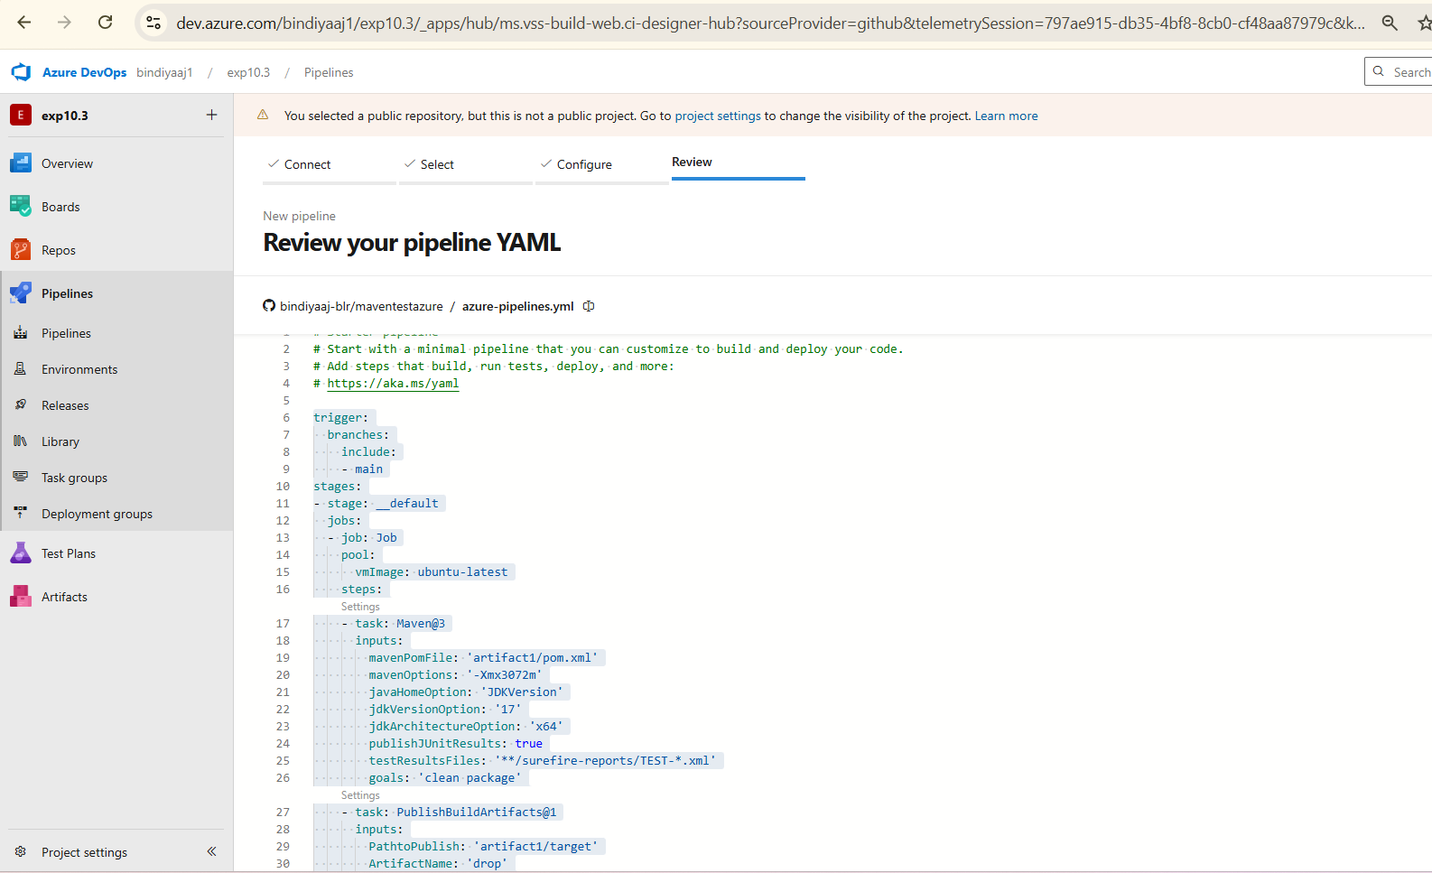

🔄 Full Flow (What Actually Happens)
- Code pushed to main
- Pipeline triggers
- Azure creates Ubuntu VM
- Runs Maven:
  - Builds project
  - Runs tests
- Test results published
- Build output stored as artifact (drop)

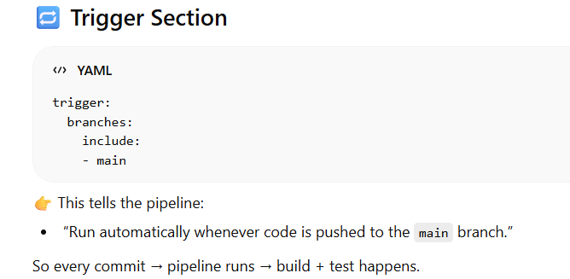
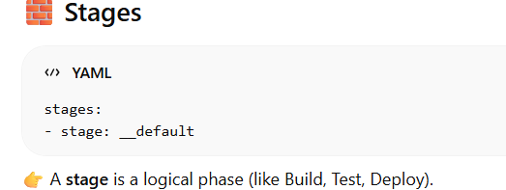
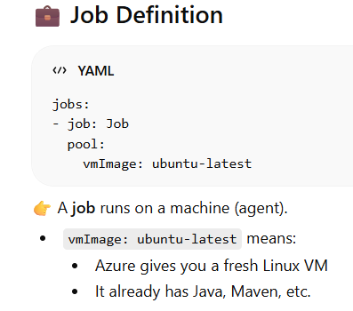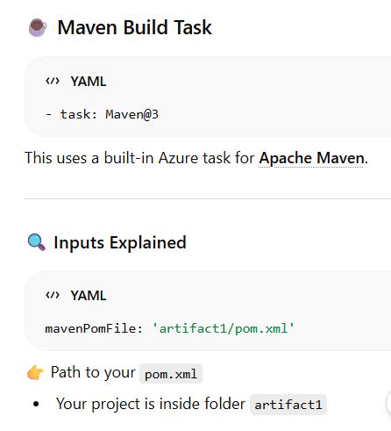
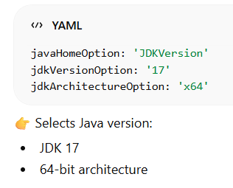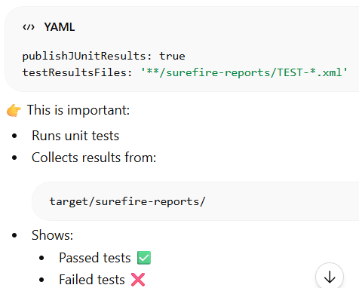
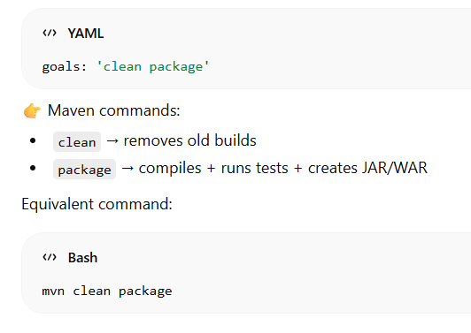
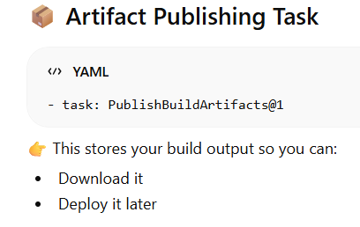
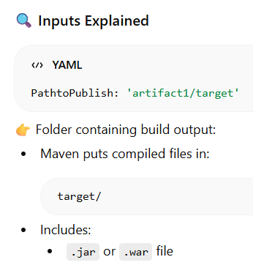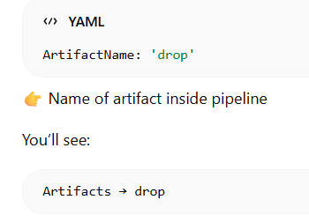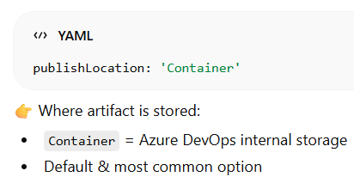

16) click on “RUN”

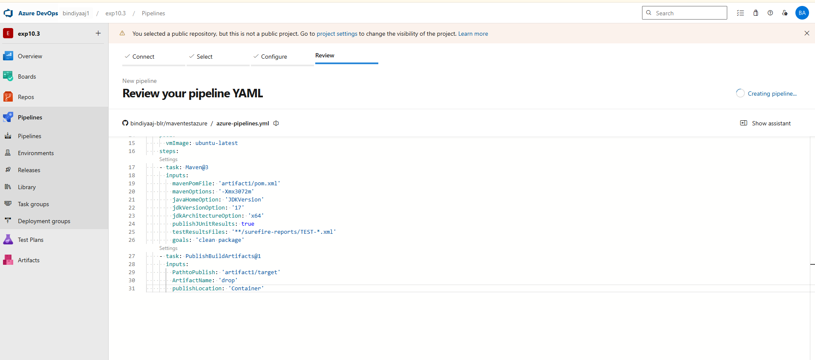

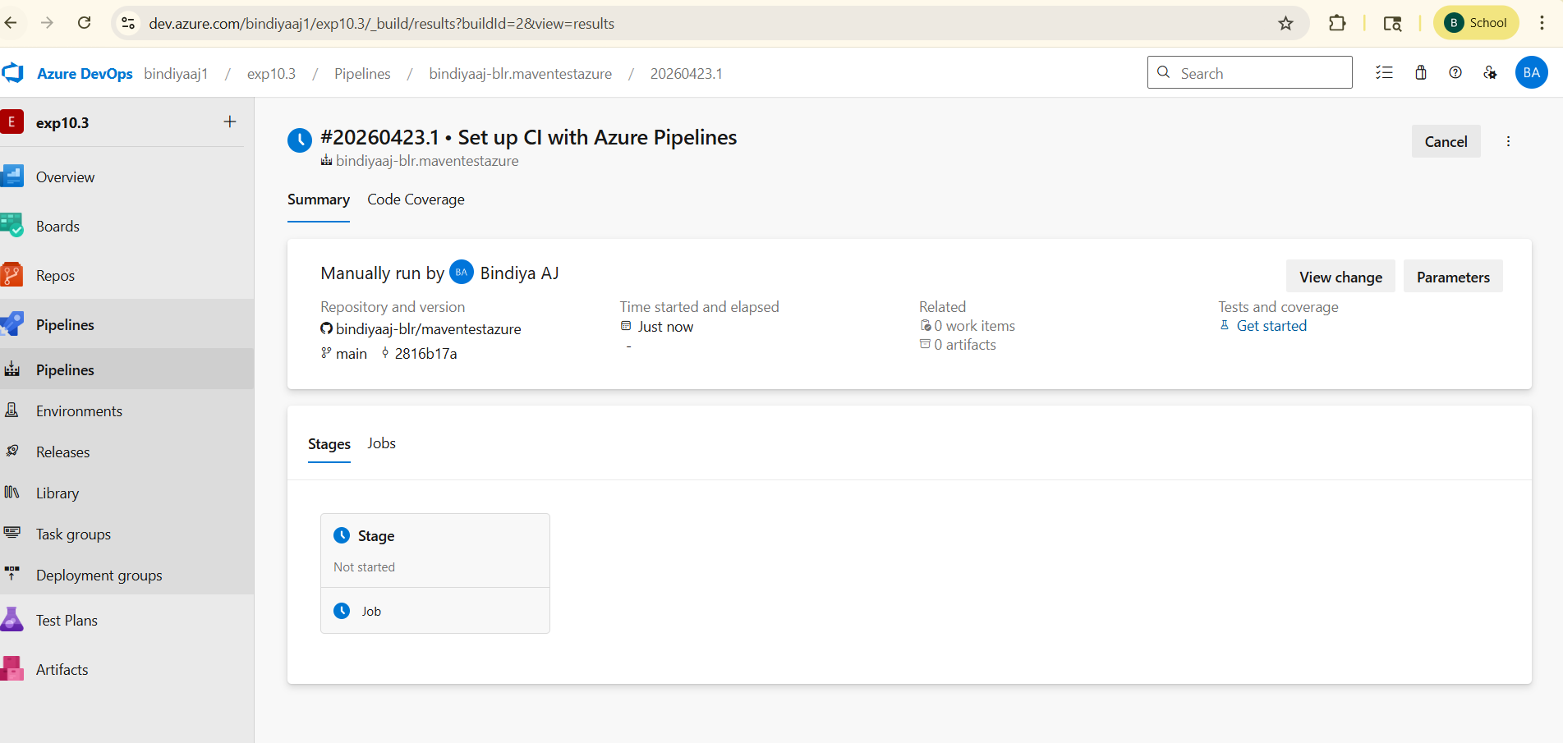

17)click on “stage” you will see below page→ job is not executed…..

Just scroll line 1: content to rightmost —> you will find a form —> copy paste in new tab and fill the form

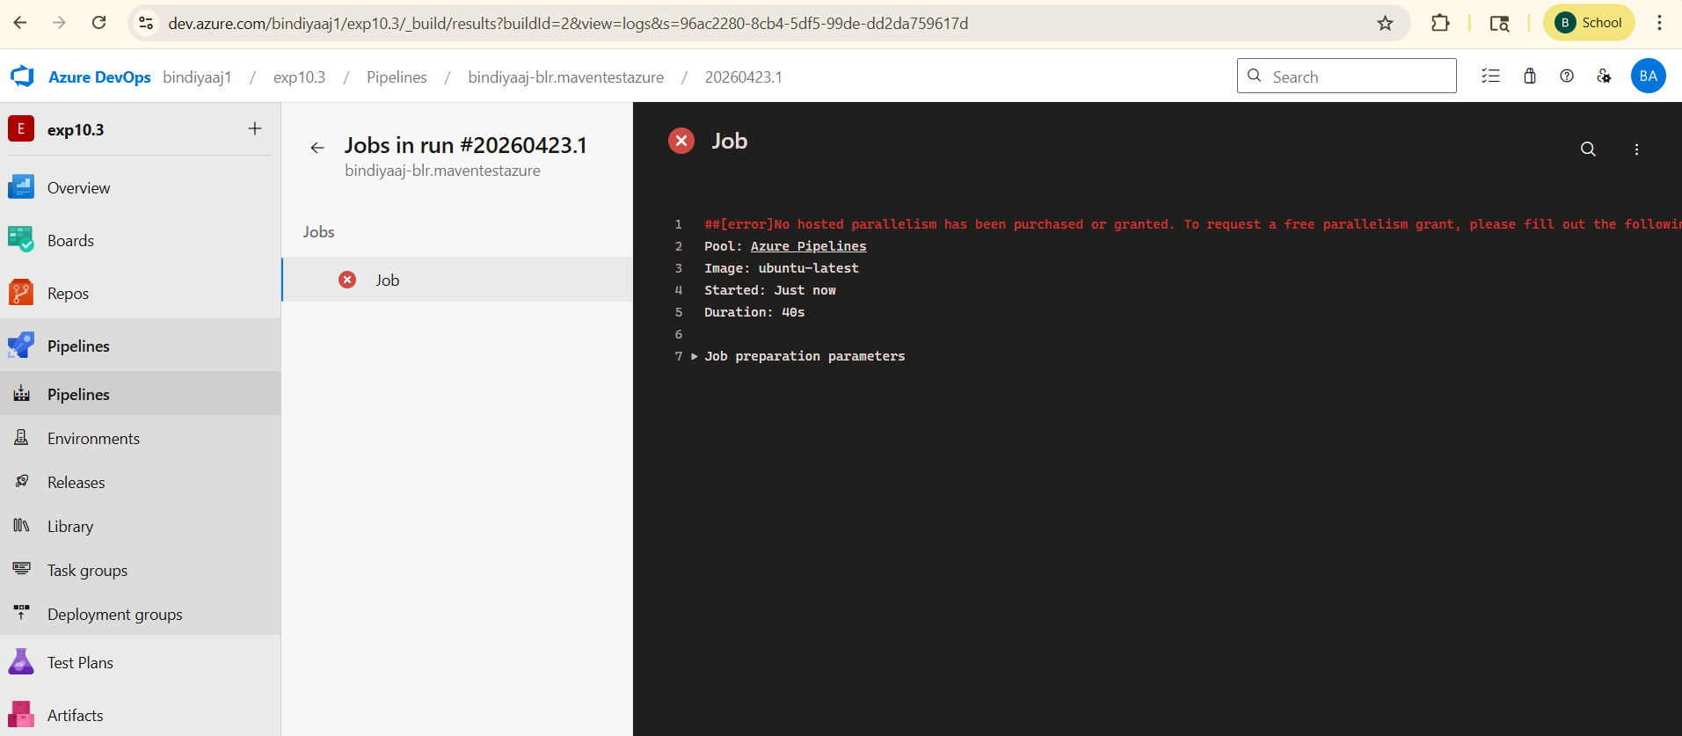

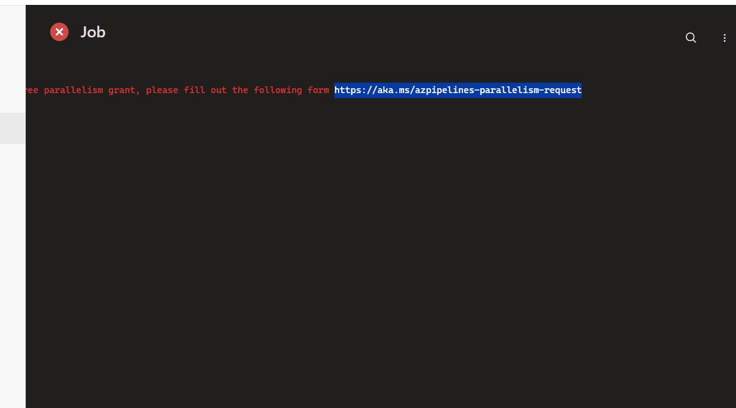

https://aka.ms/azpipelines-parallelism-request

Name:
Emai ID:
Azure Organization:
(example:https://dev.azure.com/bindiyaaj1/)
public/private: private

Click on “submit button”

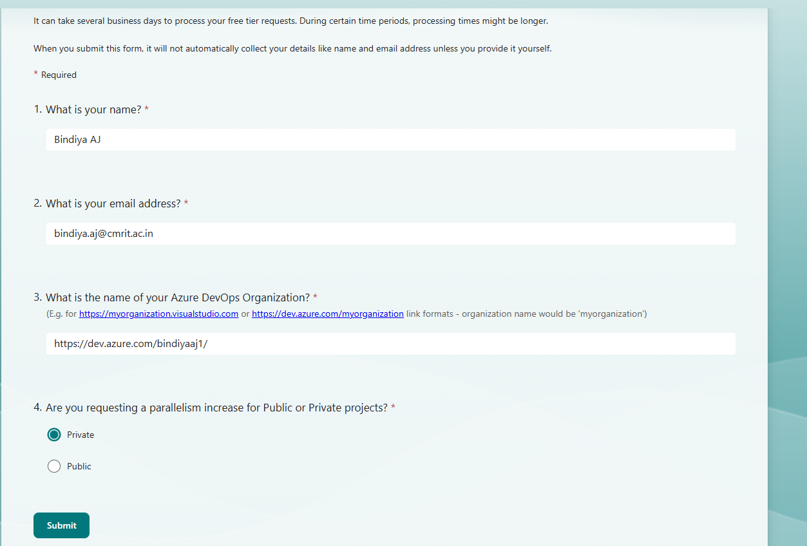

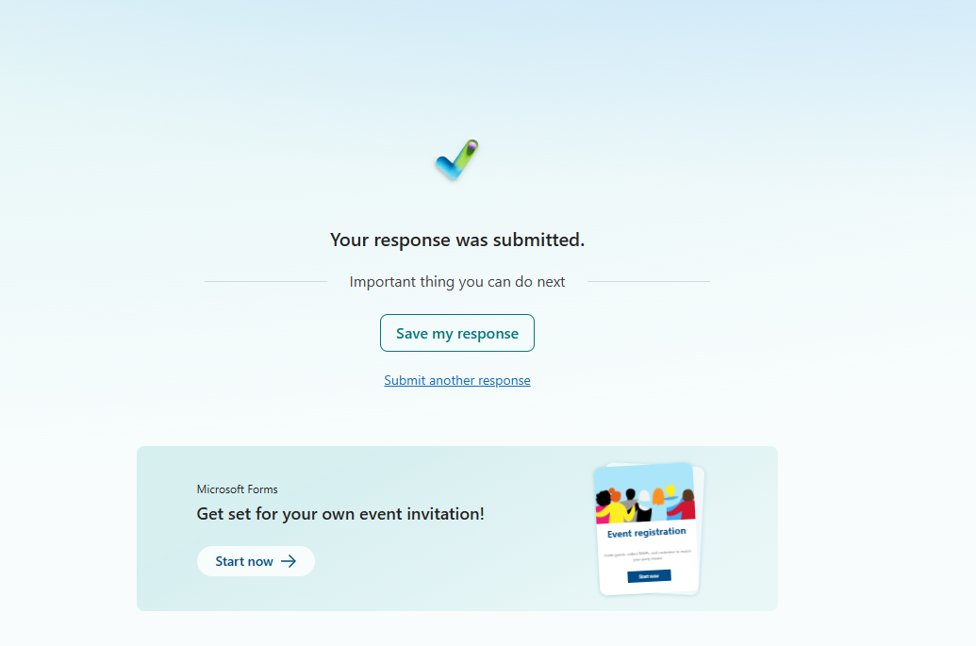

18) To complete task 48 hrs time needed…→ after that when we go to our devops organization:

And when we click on our project we will see project stats:pipeline:build succeeded

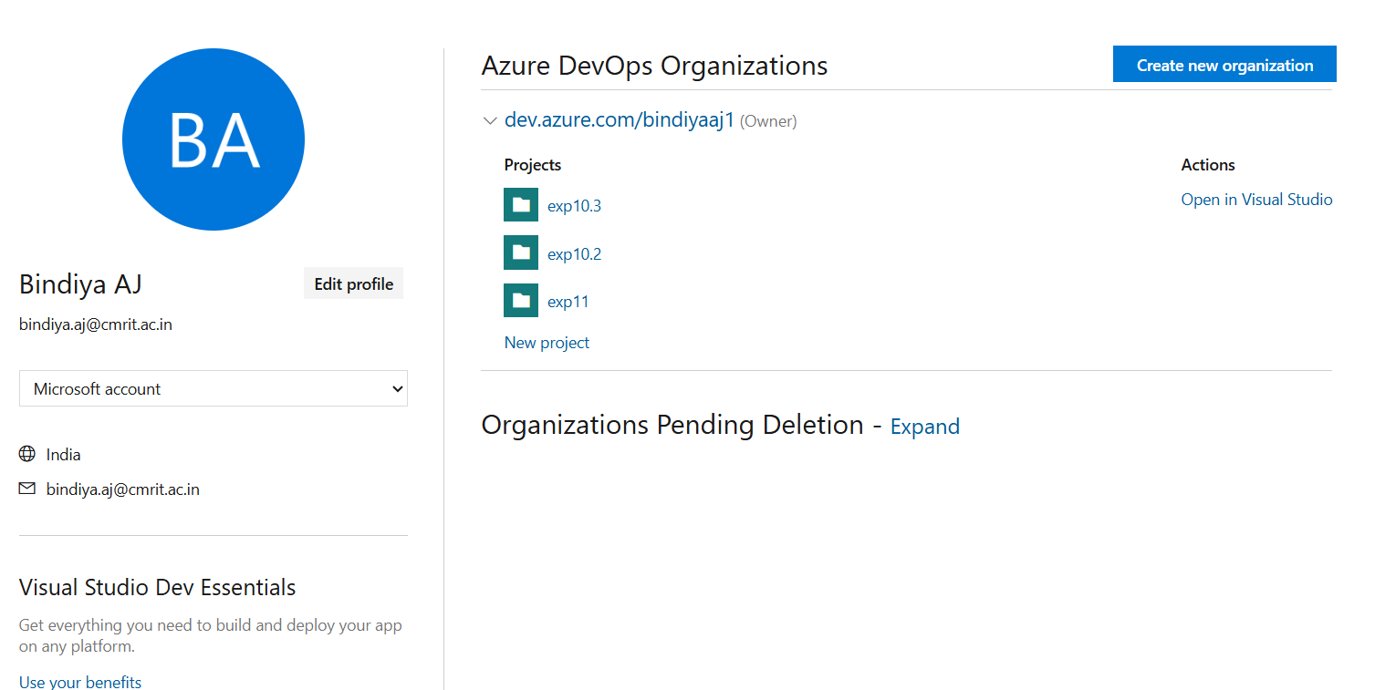

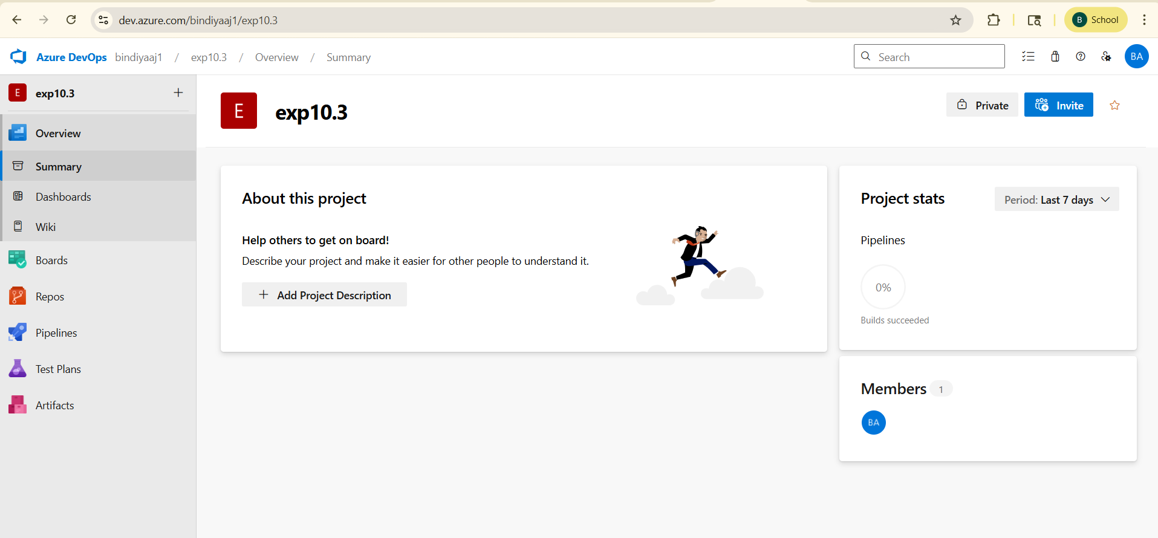

Experiment 11:
Creating Release Pipelines: Deploying Applications to Azure App Services, Managing Secrets and Configuration with Azure Key Vault, Hands-On:
Continuous Deployment with Azure Pipelines

EXP 11:
Creating Release Pipelines: Deploying Applications toAzureApp Services, Managing Secrets and Configuration with Azure Key Vault, Hands-On: ContinuousDeployment withAzure Pipelines

This “experiment” is basically a hands-on DevOps exercise focused on automating how an application gets built, configured, and deployed to the cloud using Microsoft Azure tools. It ties together three main concepts: release pipelines, deployment, and secure configuration management.

🔧 1. Creating Release Pipelines (CI/CD concept)
You use Azure Pipelines (part of Azure DevOps) to automate deployment.
What happens here:
- You connect your source code repository (like GitHub or Azure Repos)
- Define steps (pipeline stages) such as:
  - Build the app
  - Run tests
  - Package it
  - Deploy it
👉 Instead of manually uploading code, the pipeline does everything automatically whenever you push code.

☁️ 2. Deploying to Azure App Services
You deploy your application to Azure App Service.
What this means:
- Azure provides a ready-made environment to run web apps (no need to manage servers)
- Your pipeline pushes the built app to this service
- The app becomes live on a public URL
👉 So this step = hosting your application in the cloud

🔐 3. Managing Secrets with Azure Key Vault
Instead of hardcoding sensitive data, you use Azure Key Vault.
Secrets include:
- API keys
- Database passwords
- Connection strings
What you do:
- Store secrets securely in Key Vault
- Configure your pipeline or app to fetch them dynamically
👉 This improves security and avoids exposing sensitive info in code.

🔁 4. Continuous Deployment (CD)
You set up automatic deployment using Azure Pipelines.
What happens:
- Every time you update code (e.g., push to GitHub):
  - Pipeline triggers automatically
  - Builds the app
  - Deploys to Azure App Service
👉 No manual steps → faster and consistent releases.

🧪 So what is the experiment REALLY about?
In short, you are:
- Building a CI/CD pipeline
- Automatically deploying a web app to Azure
- Using Key Vault to securely manage secrets
- Enabling continuous deployment (auto-updates on code changes)

🎯 Final Outcome
By the end of the experiment, you should have:
- A working web app running on Azure
- A pipeline that deploys it automatically
- Secure handling of sensitive configuration
- Practical understanding of DevOps automation

- Duplicate the azure login tabs (2 tabs)

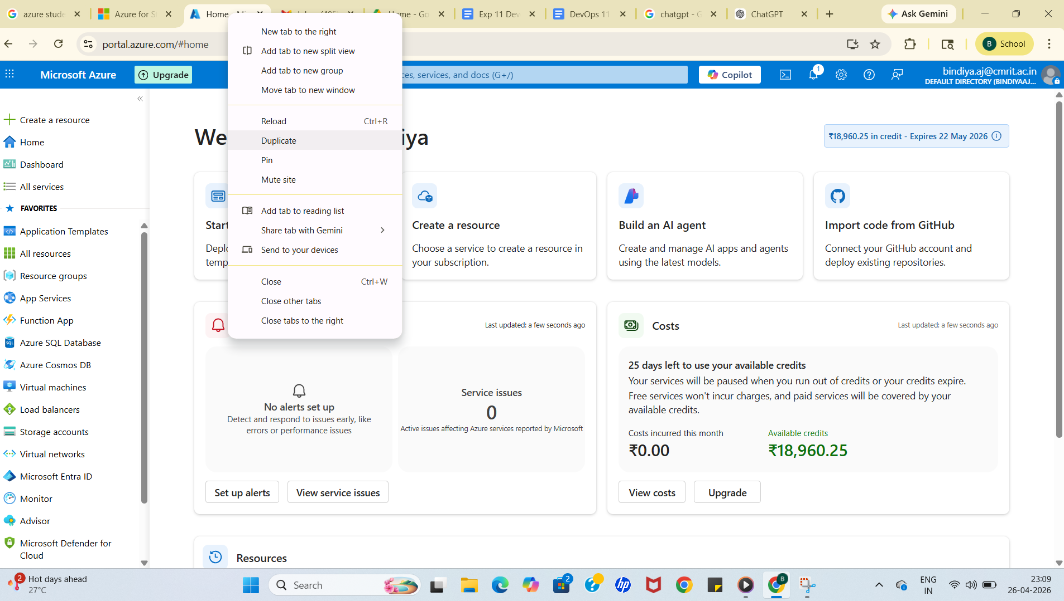

Tab1: search keyvaults

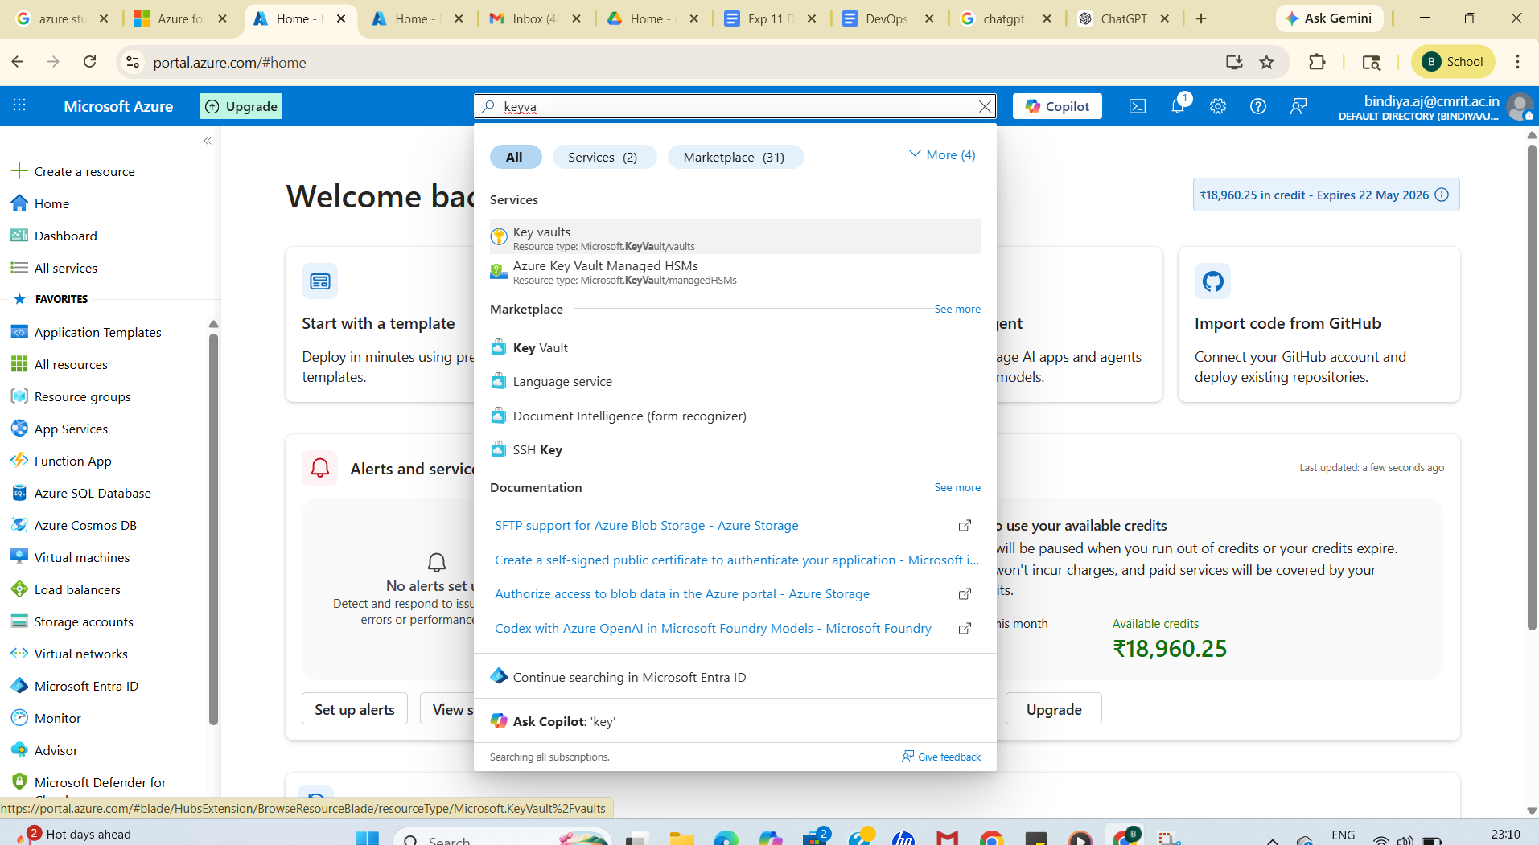

Click on + create

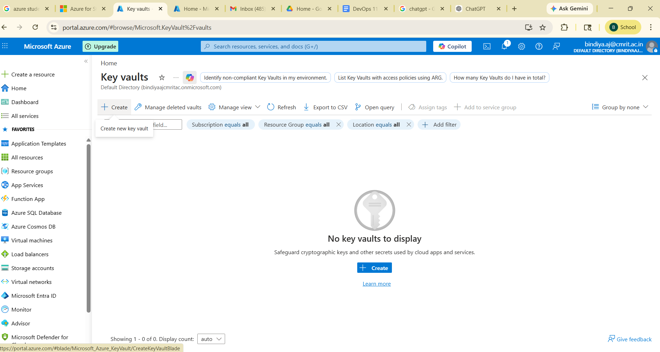

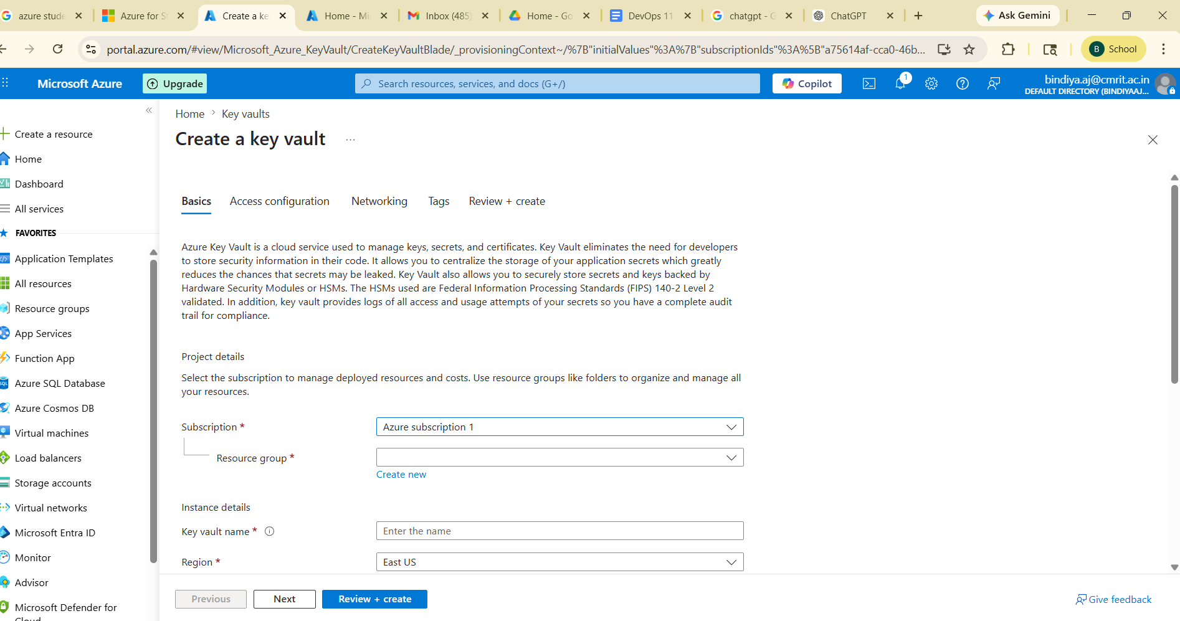

Copy subscription name : “ Azure subscription 1” and go to another azure tab
And search “app registration” —>click→+new registration —> enter name as “Azure subscription 1” →register

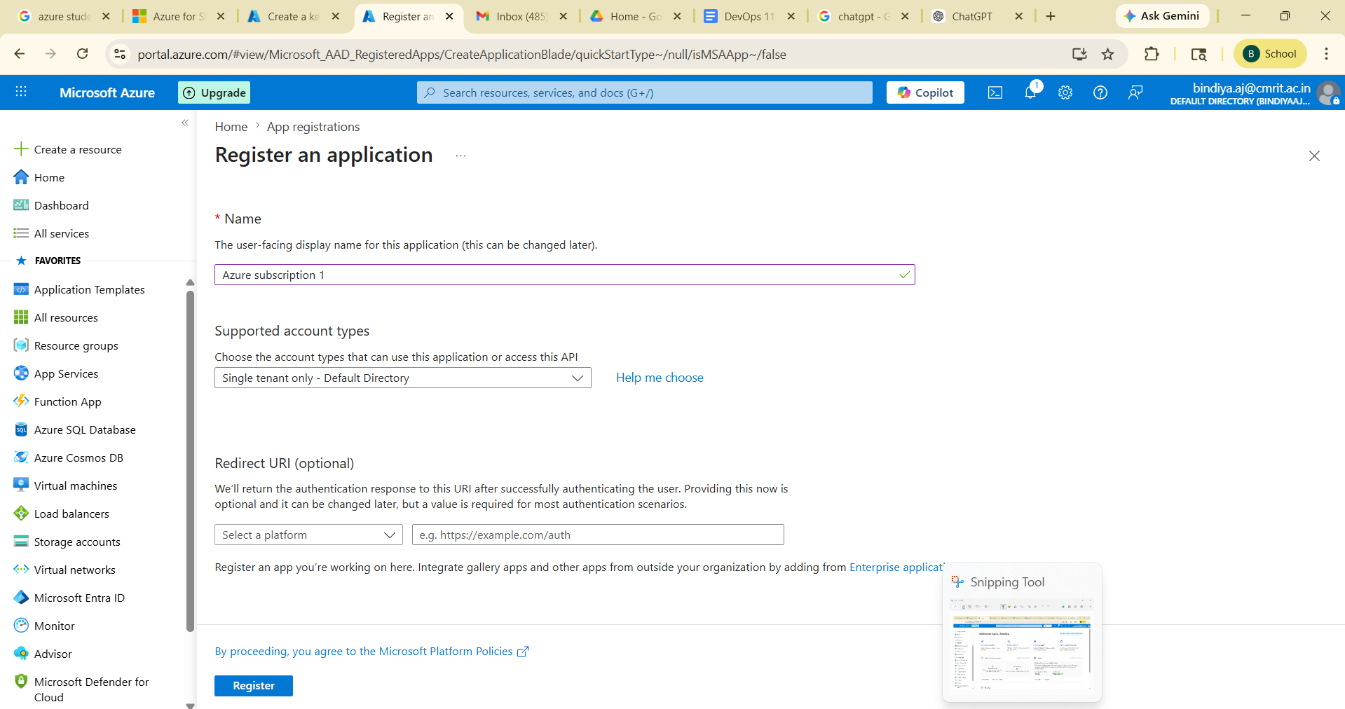

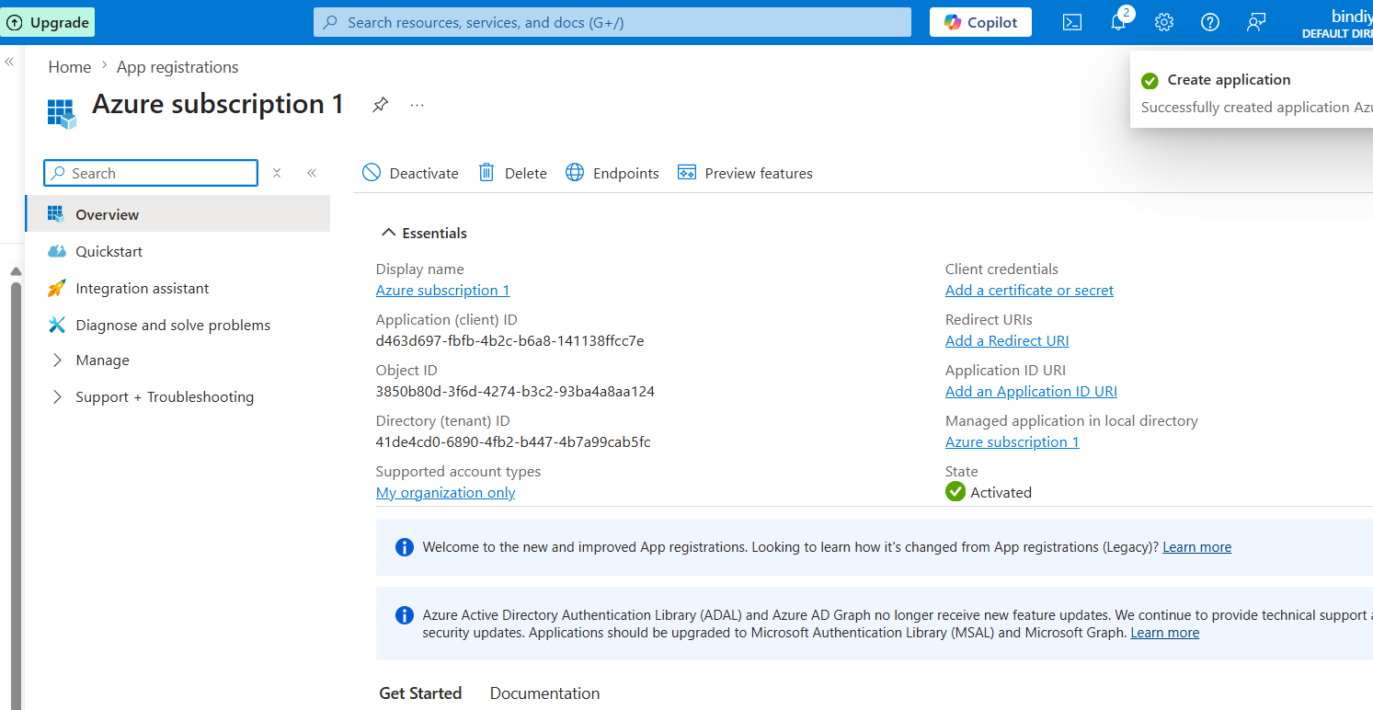

Display name
Azure subscription 1
Application (client) ID
d463d697-fbfb-4b2c-b6a8-141138ffcc7e
Object ID
3850b80d-3f6d-4274-b3c2-93ba4a8aa124
Directory (tenant) ID
41de4cd0-6890-4fb2-b447-4b7a99cab5fc
Supported account types
My organization only
Client credentials
Add a certificate or secret
Redirect URIs
Add a Redirect URI
Application ID URI
Add an Application ID URI
Managed application in local directory
Azure subscription 1
State

Click on “Add a certificate or secret” on right top—>
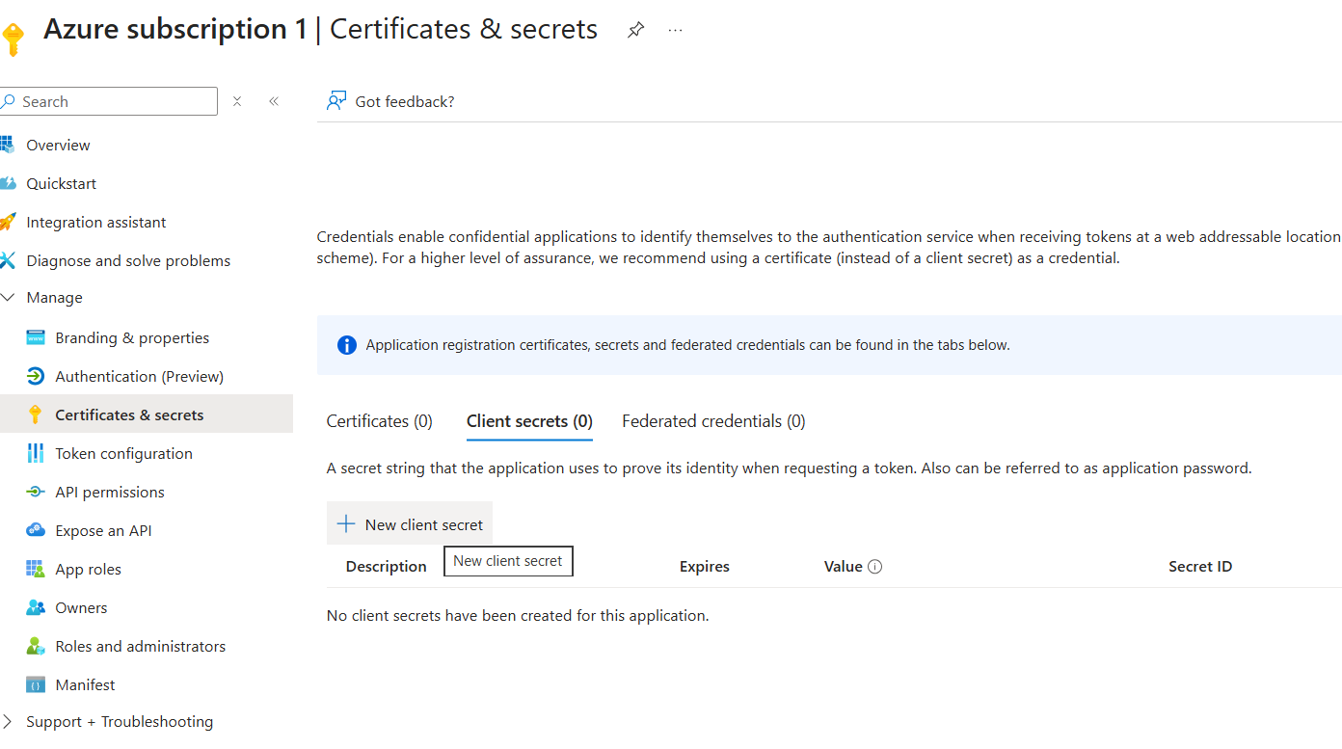

Click on →new client secret →name as “authenticate”-->expiry date: 365 days—> click on add
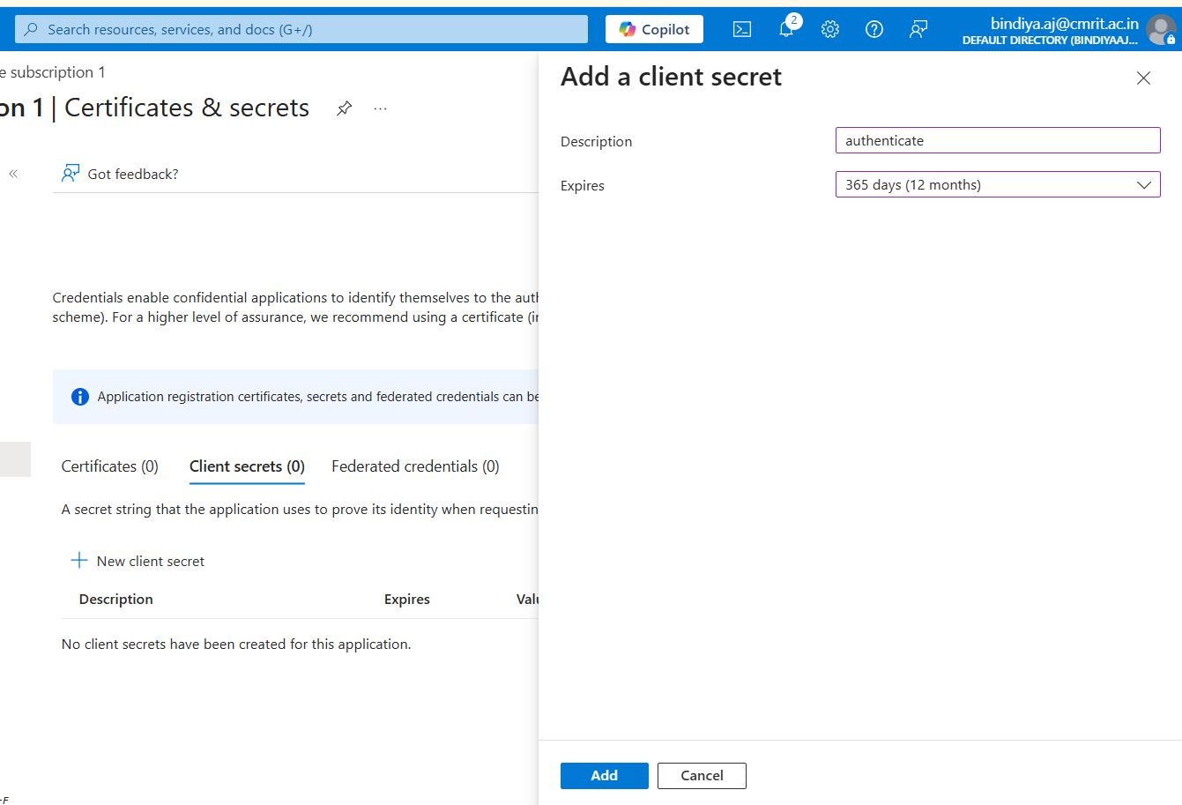

Click notepad and add 2 secret keys:

Value: 4B08Q~cA2.rmhO0Ib.iXQ2BpKuu-gippZvt4lbHH

Secret ID: 1b7146c6-84c4-4262-ac82-c94bb87d4d9d

Now go to keyvault tab—>create keyvault→give resource group→create new : RG-Demo→enter Key vault name: myKeyvault1990 —click next—>
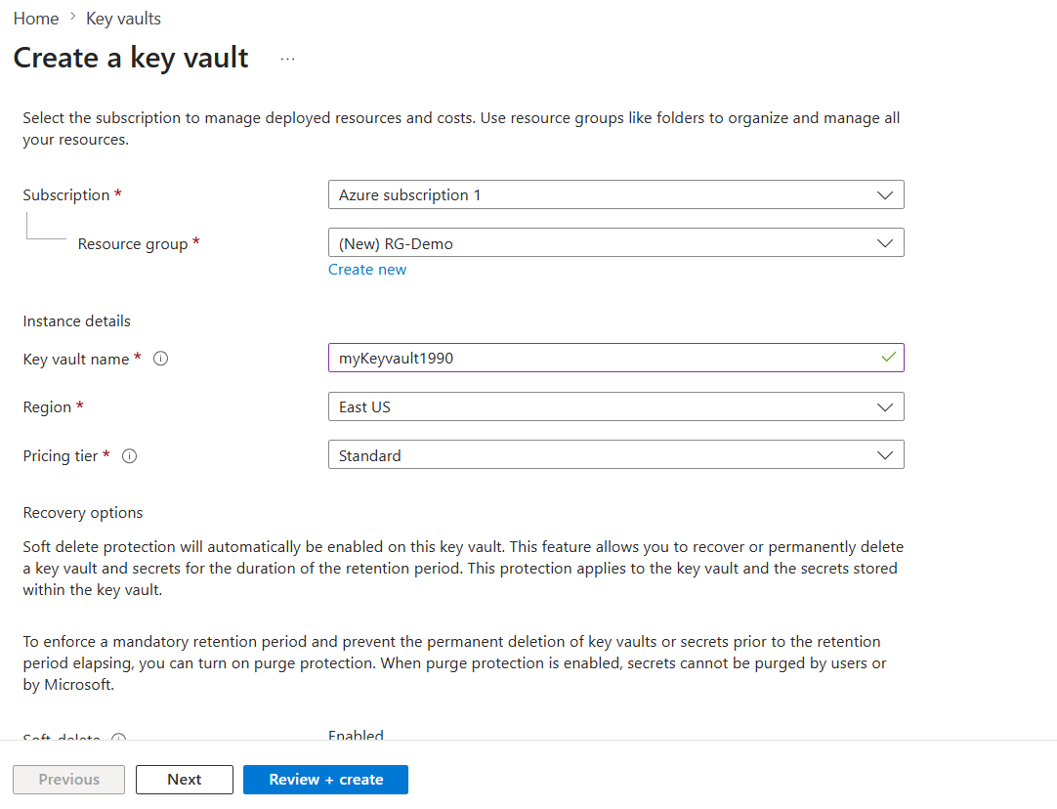

Select →Vault access policy—->click on + create —->select Secret permissions
—>select all —->next

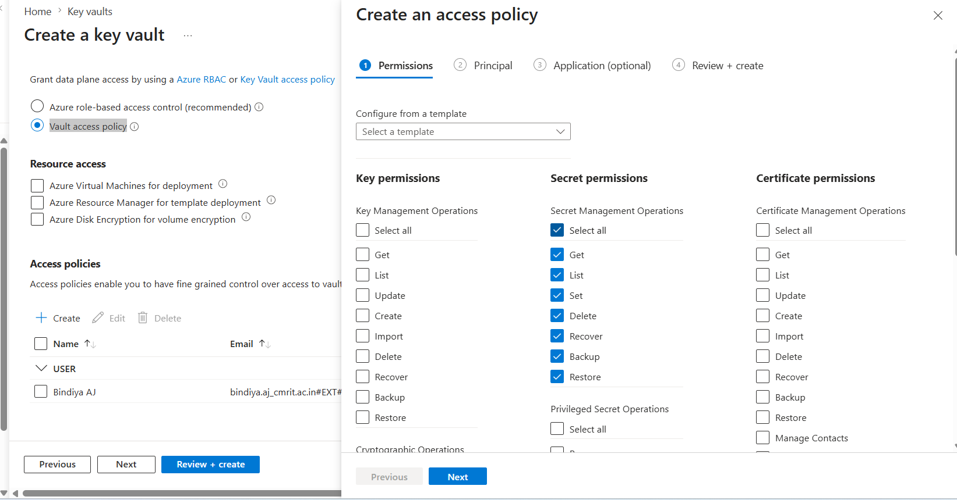

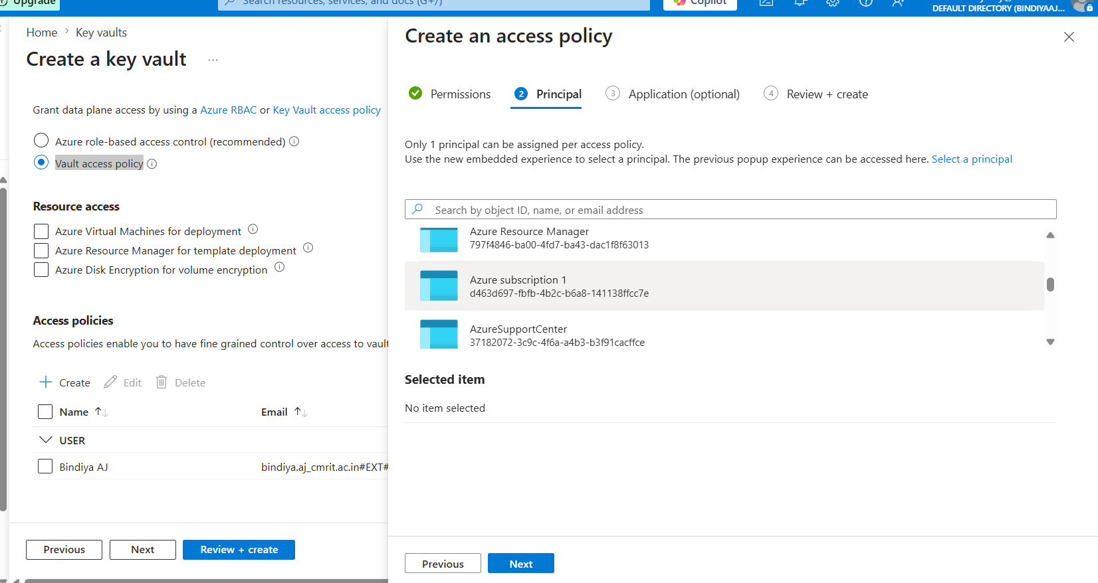

Search →Azure subscription 1—>next —>create

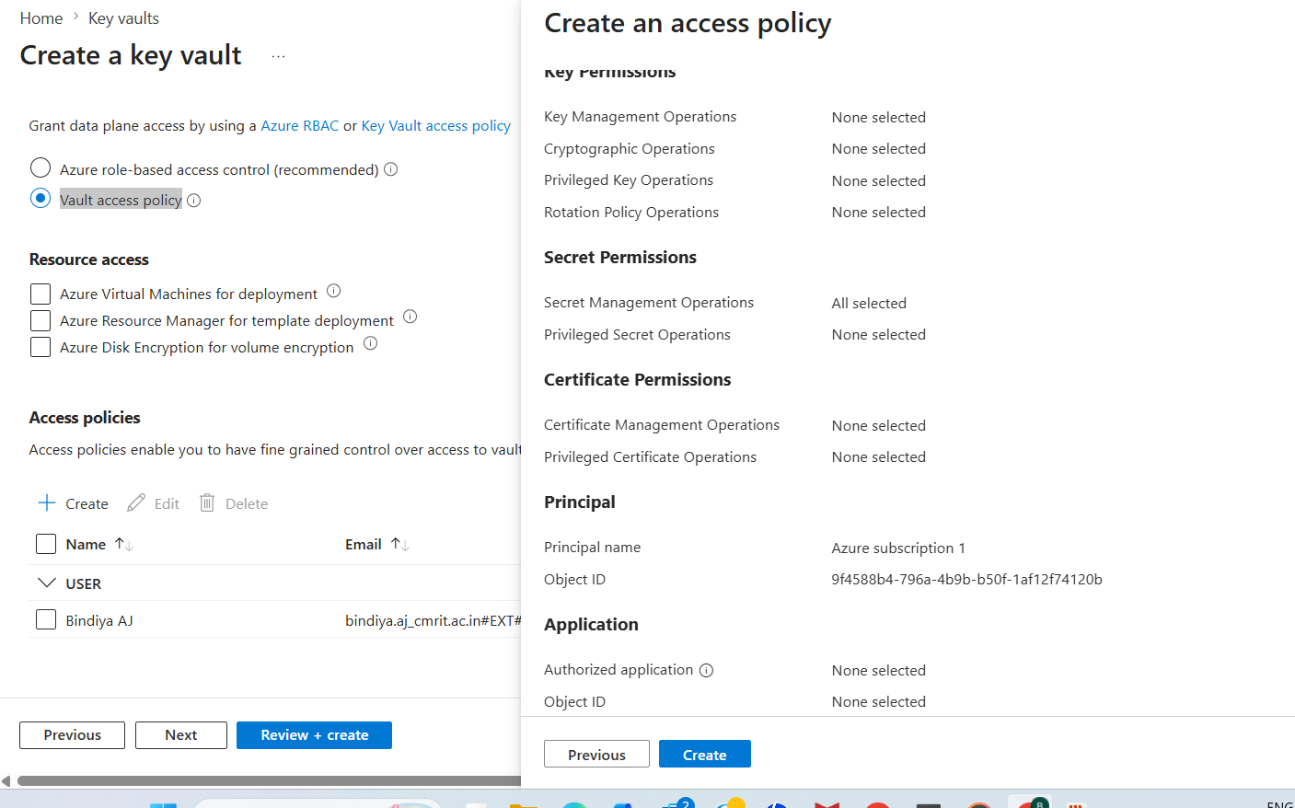

Select “azure subscription 1”-->click: review+create→wait for few seconds→click:create—>wait for few seconds
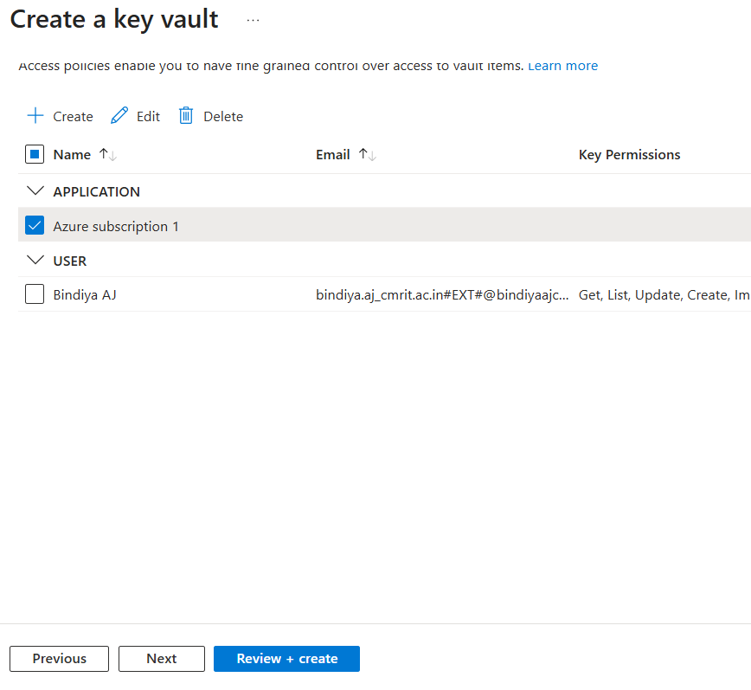
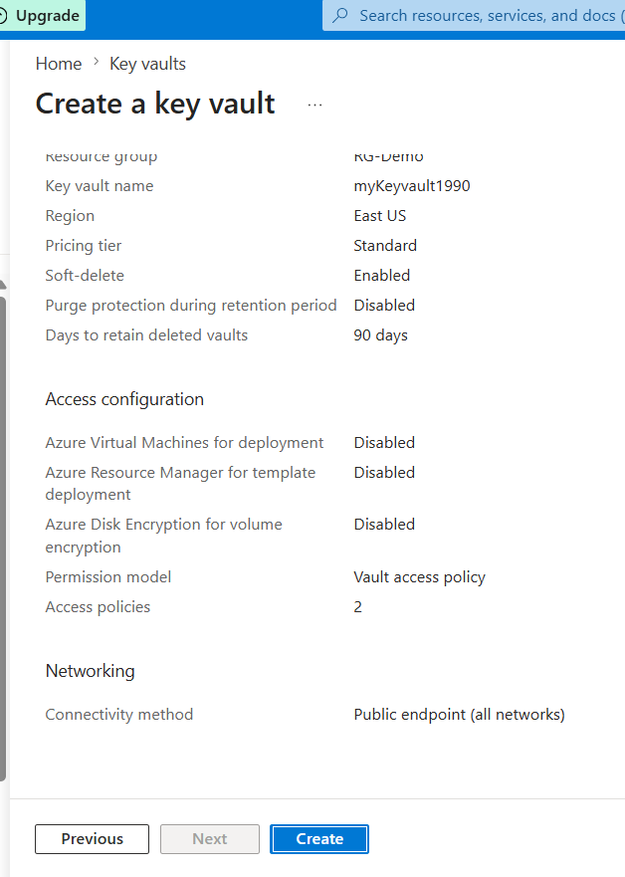
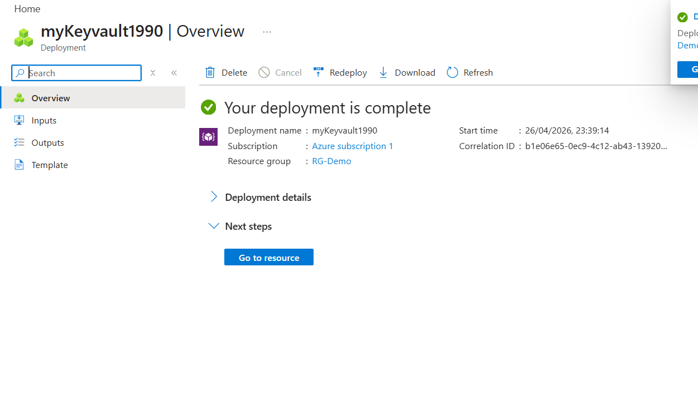
click→Go to resource→object→secrets→

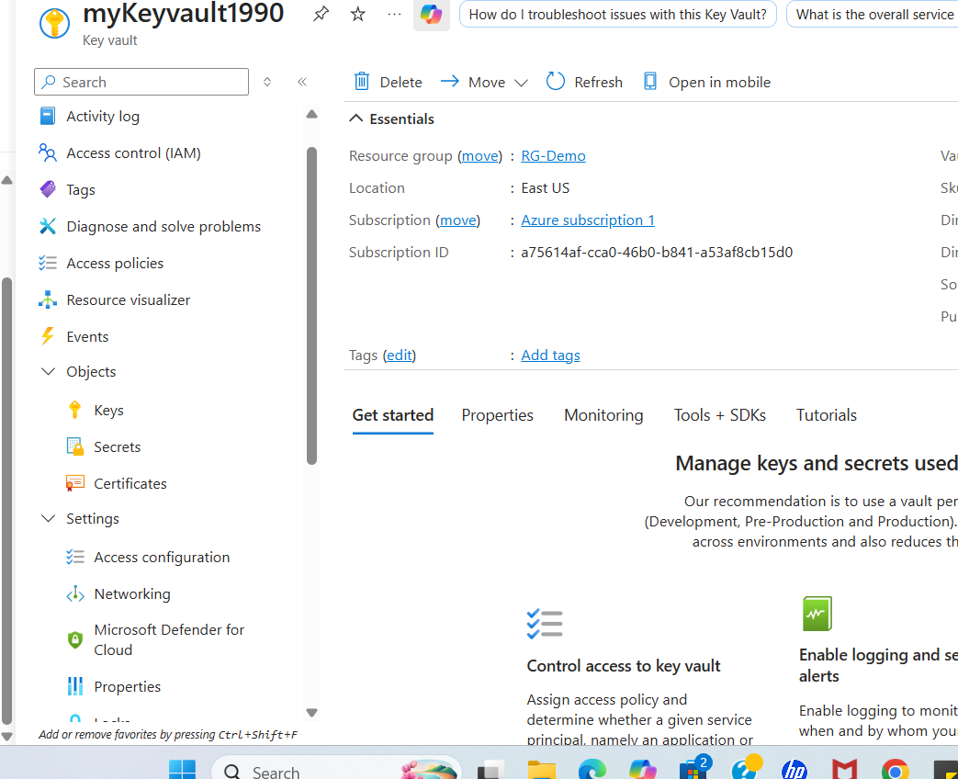

Click on →+generate/import→ upload action:manual—>name: MyName(any name)--->enter secret key and remember it
→click:create

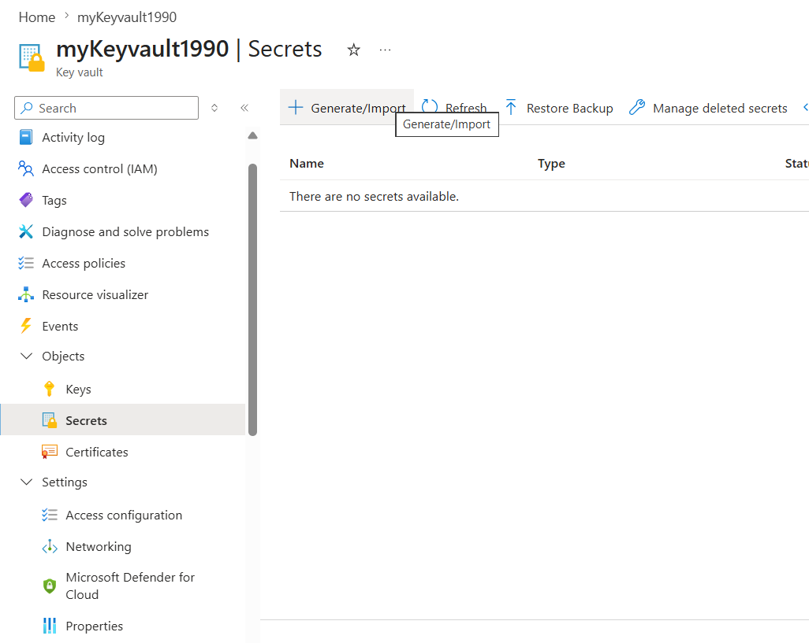
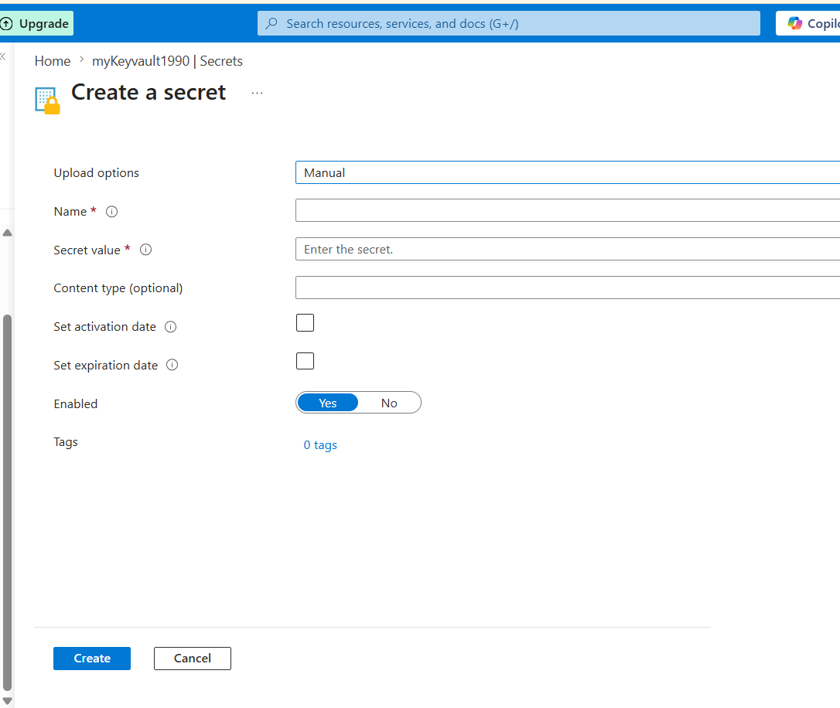

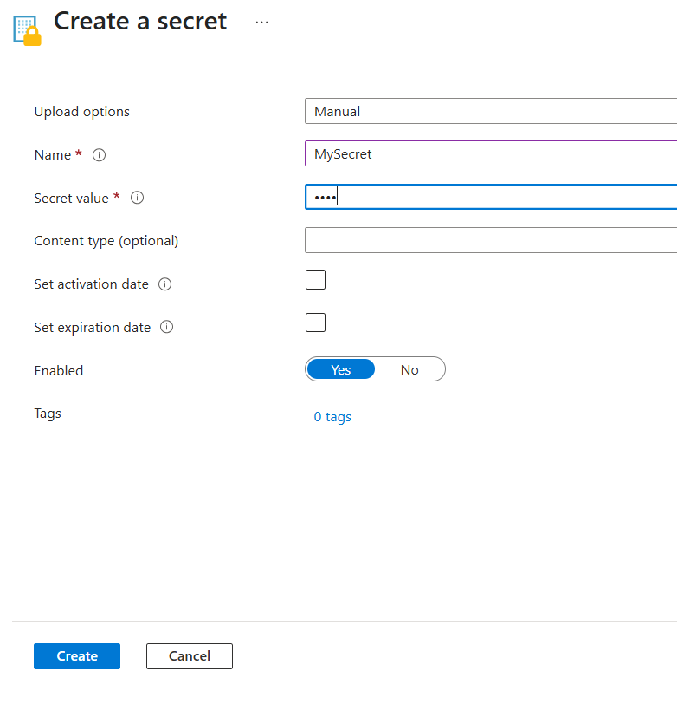

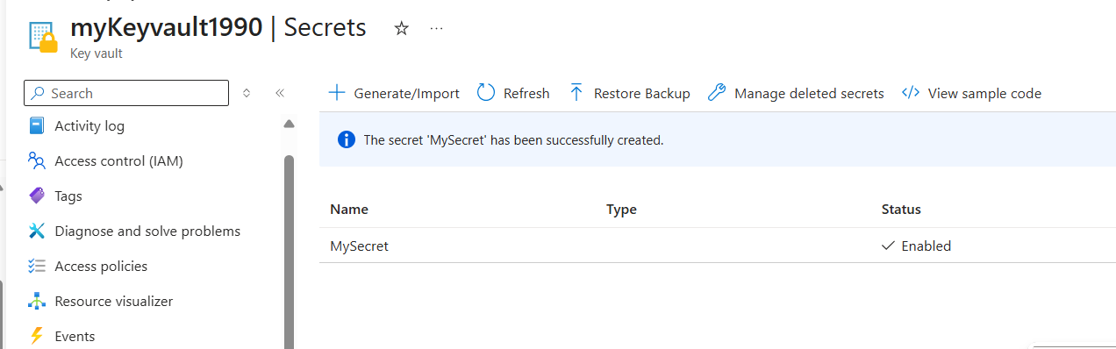

Step 2:

Go to home page:
Search→Azure devops organization
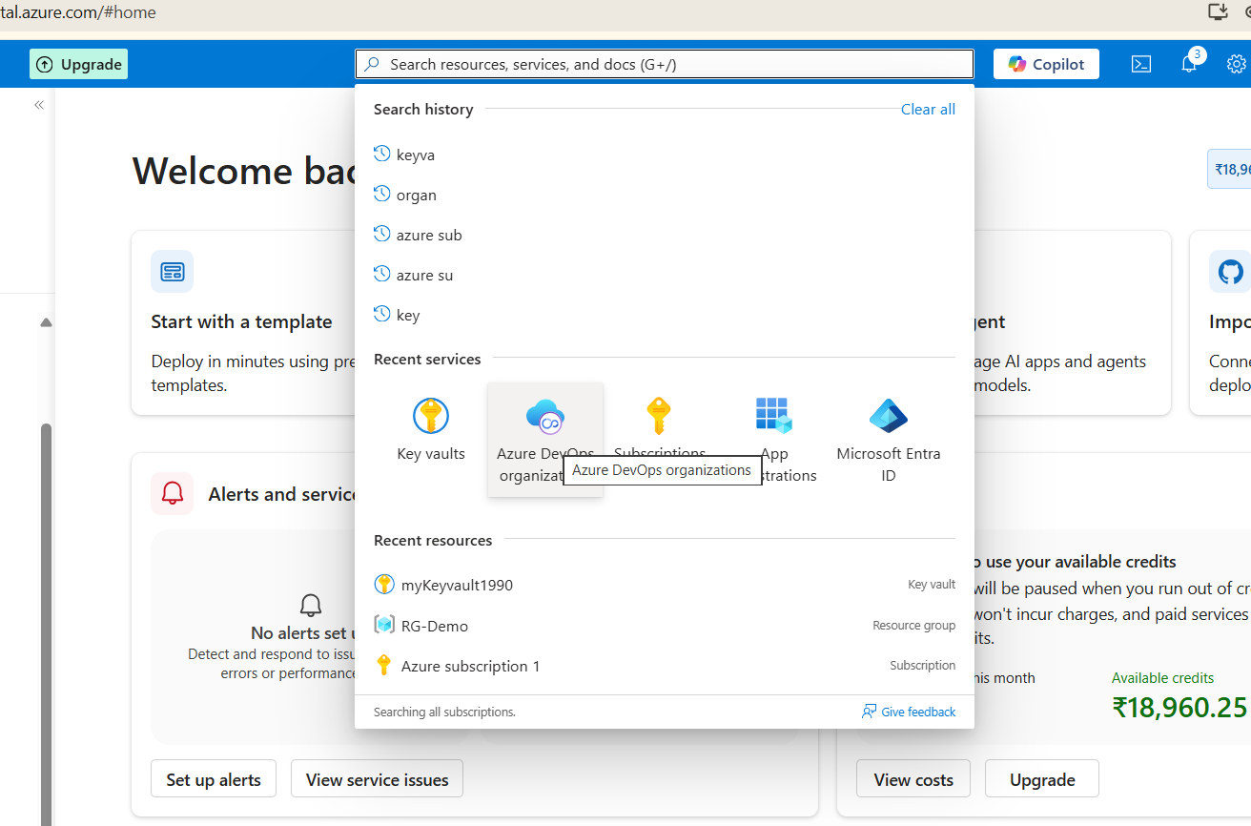

Click →:view my organization→go to ur organization→create new project: exp11—>create
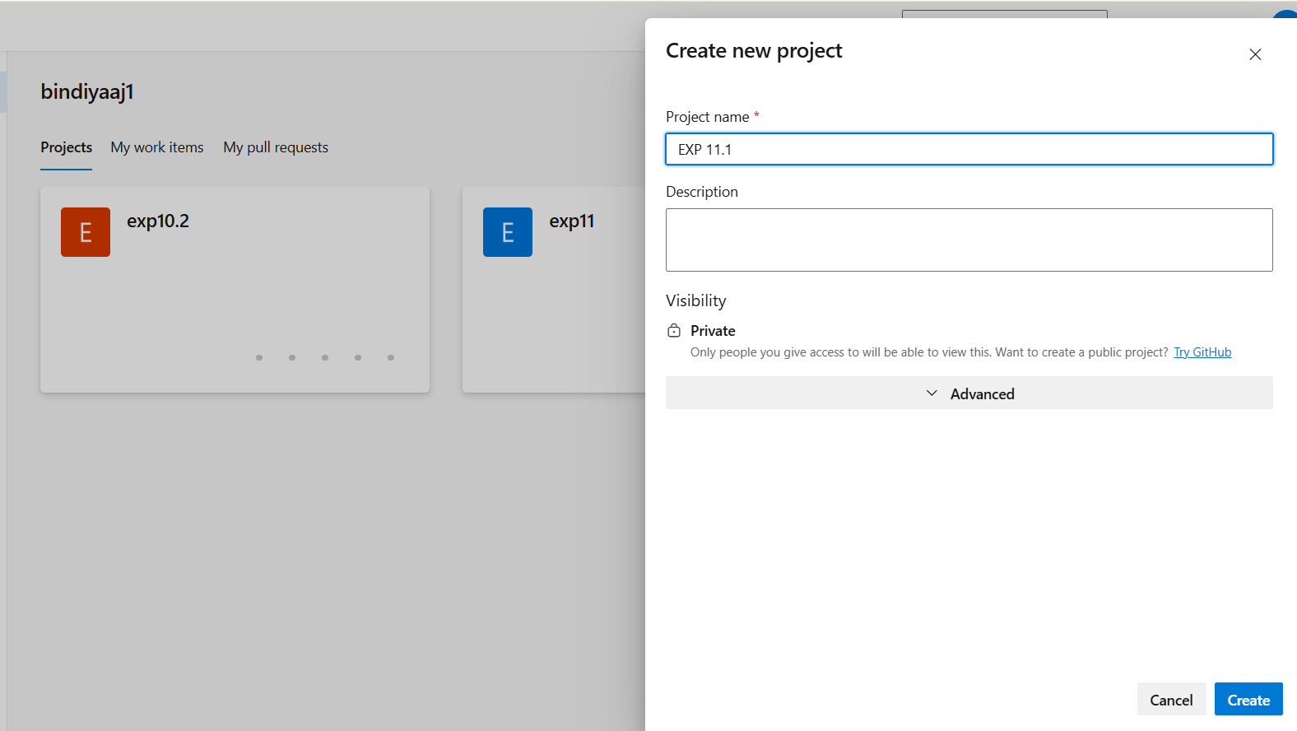

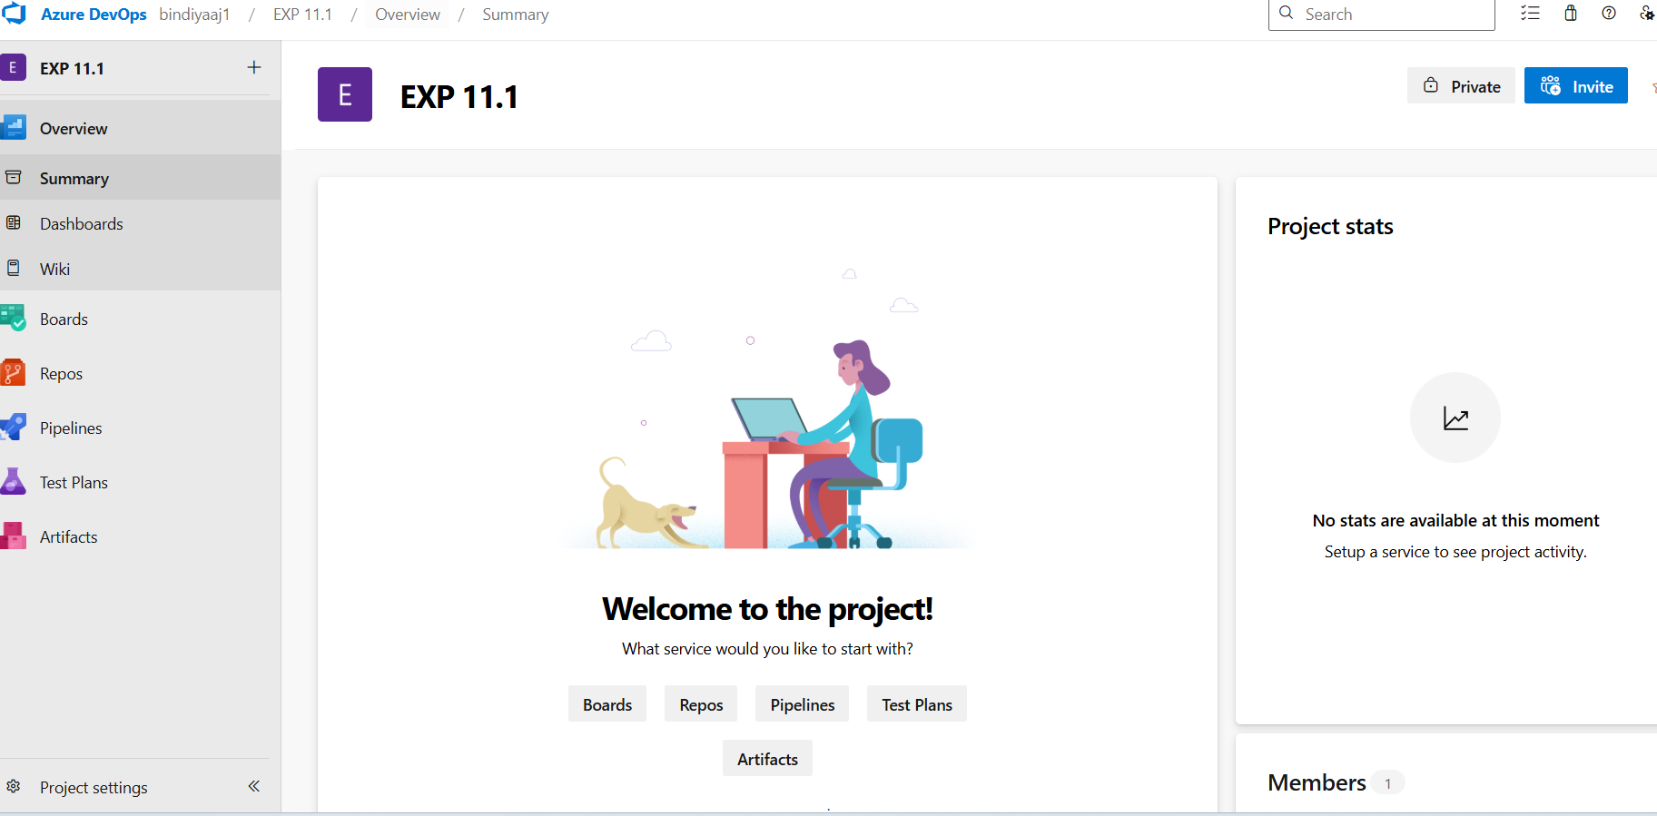

Click on “organization name” on top ex: bindiyaaj1 →go to “organization setting” down left corner→
Click

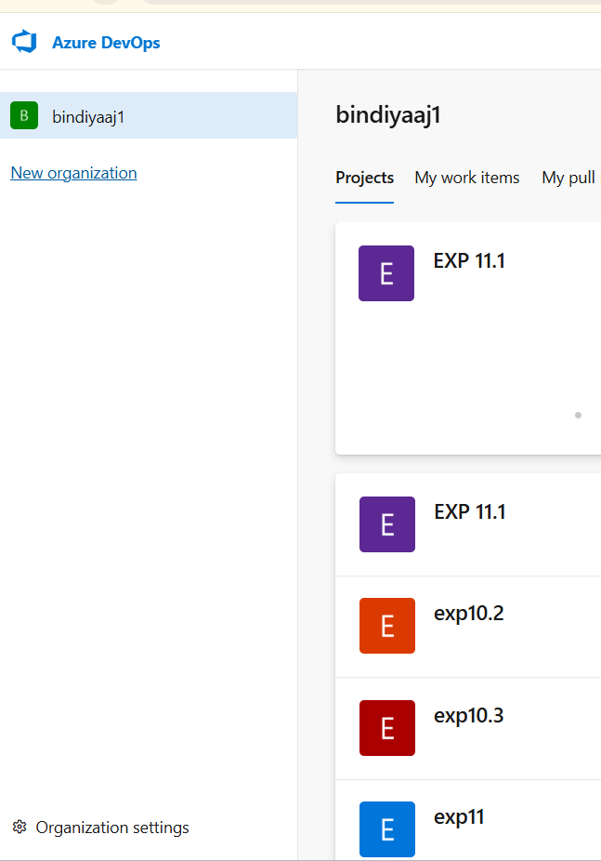

—> go to “settings “ on left →click—>make sure following things in screen shots gets disabled

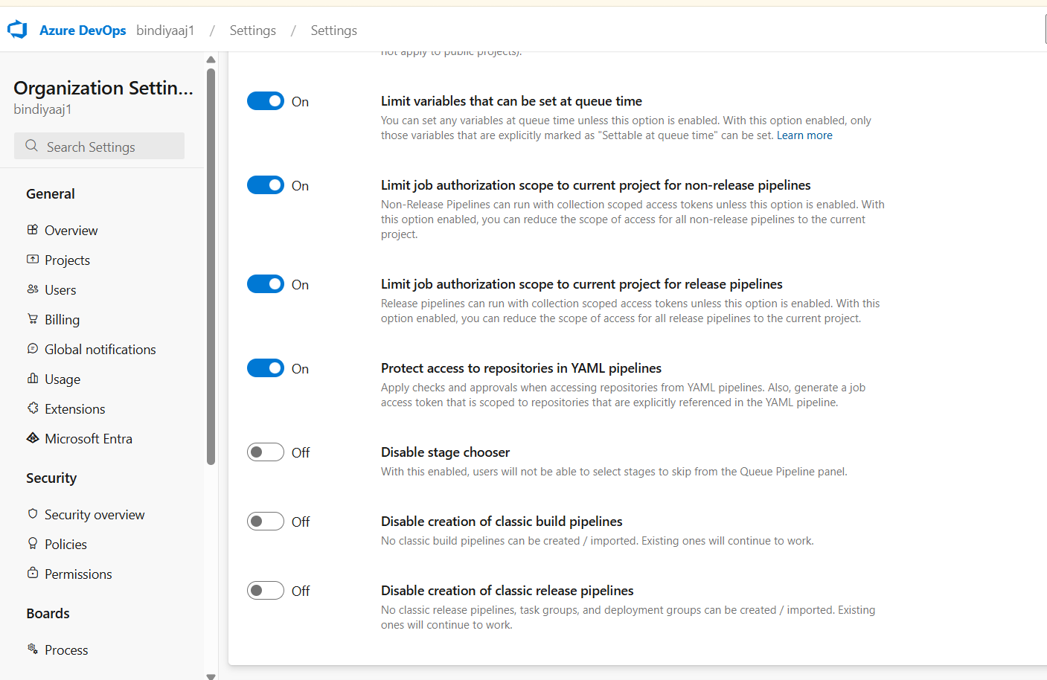

Now come back to project folder → search created new project ex: pgm11.1
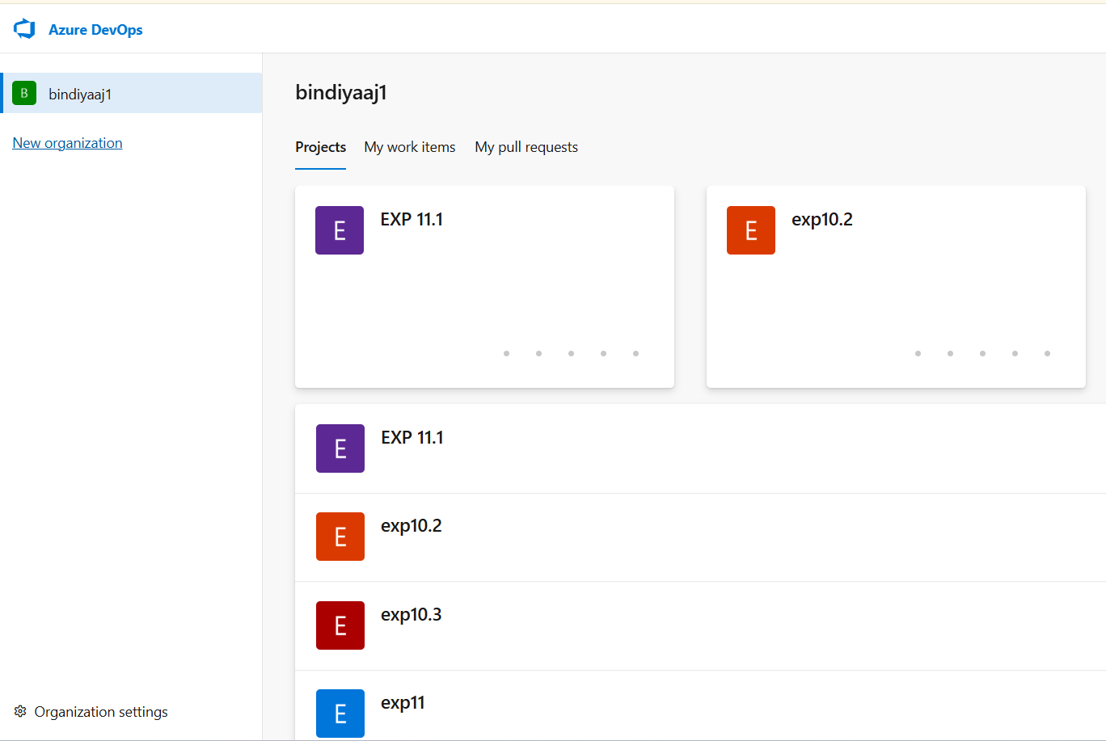
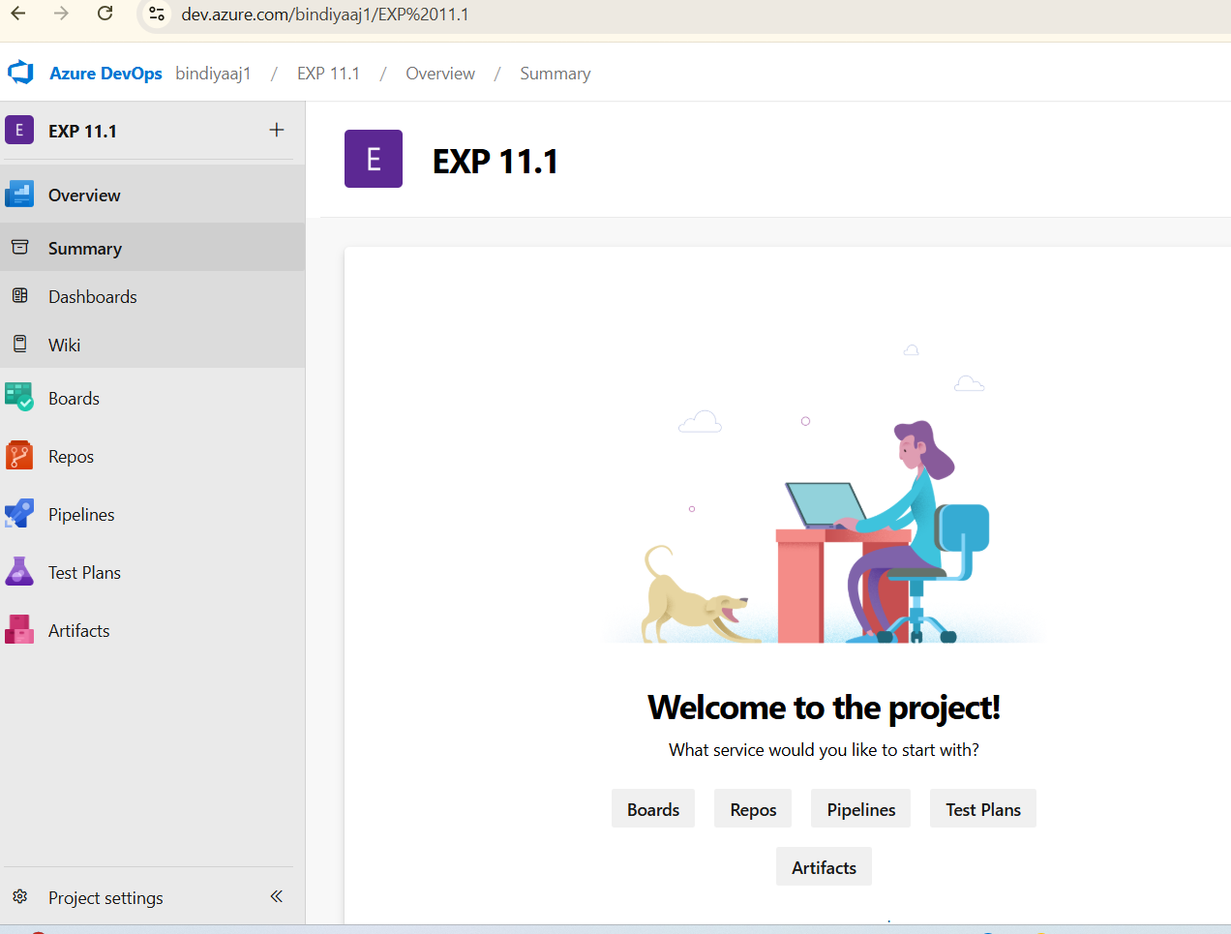

Go to pipeline→library

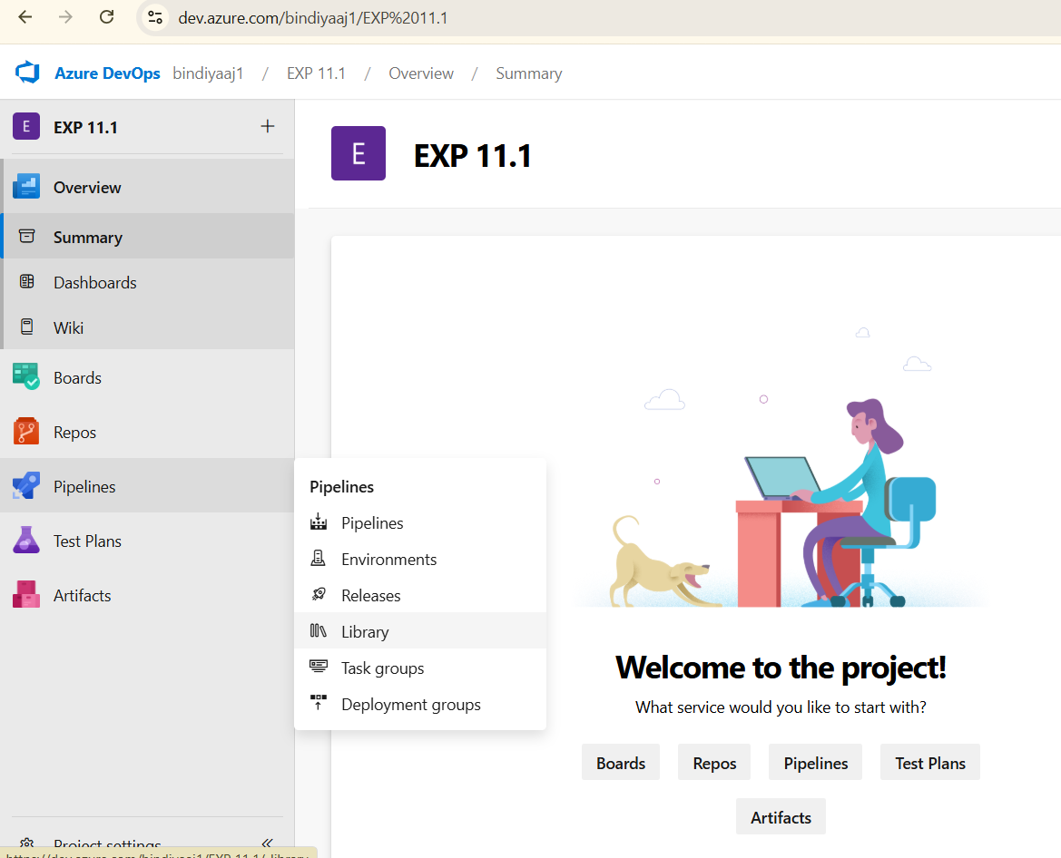

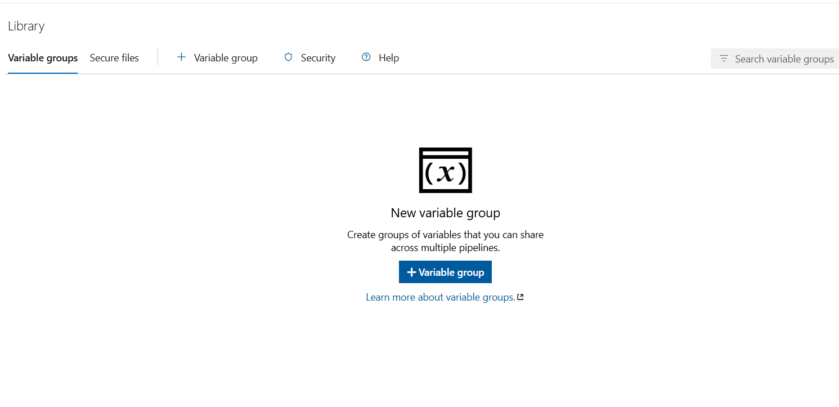

Click on →+variable group→select default variable group name→ enable : link secrets from azure keyvault→click :authorize→it will ask for microsoft login and enter secret key

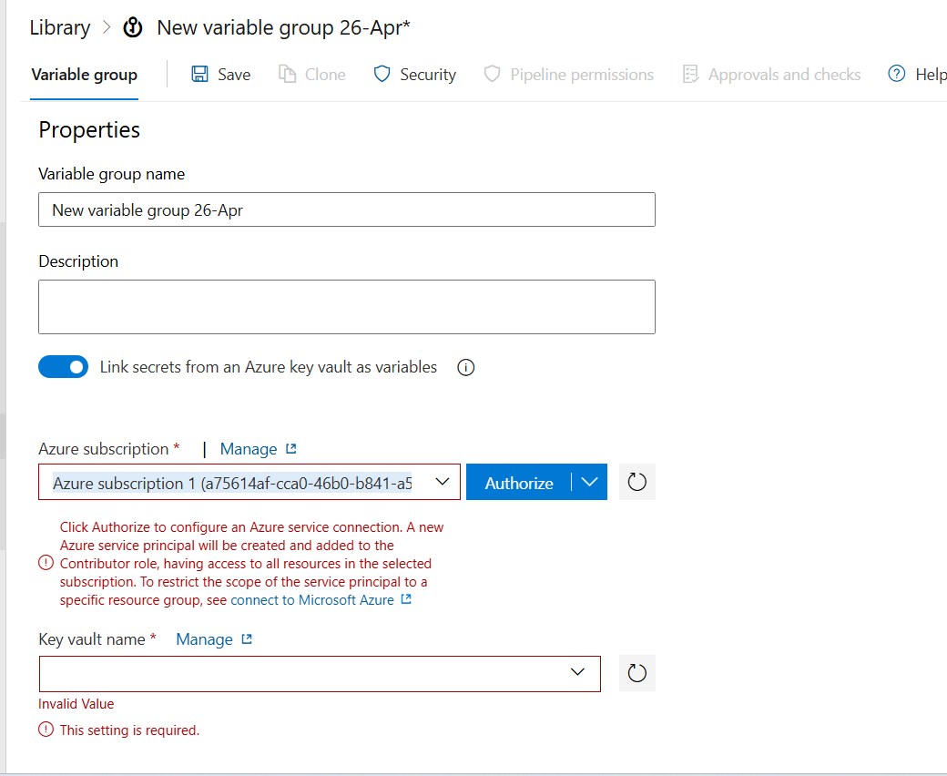

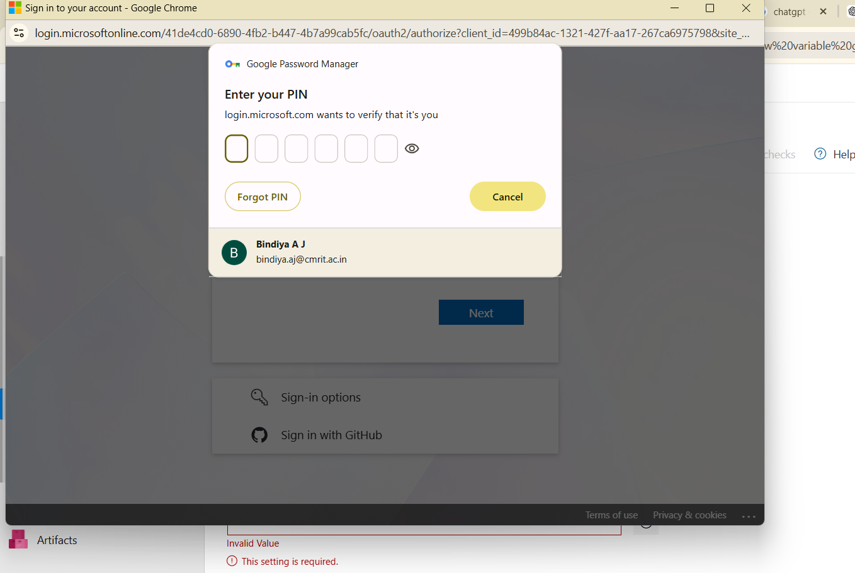

Now select: key vault name in drop down —>authorize with microsoft login and enter secret key
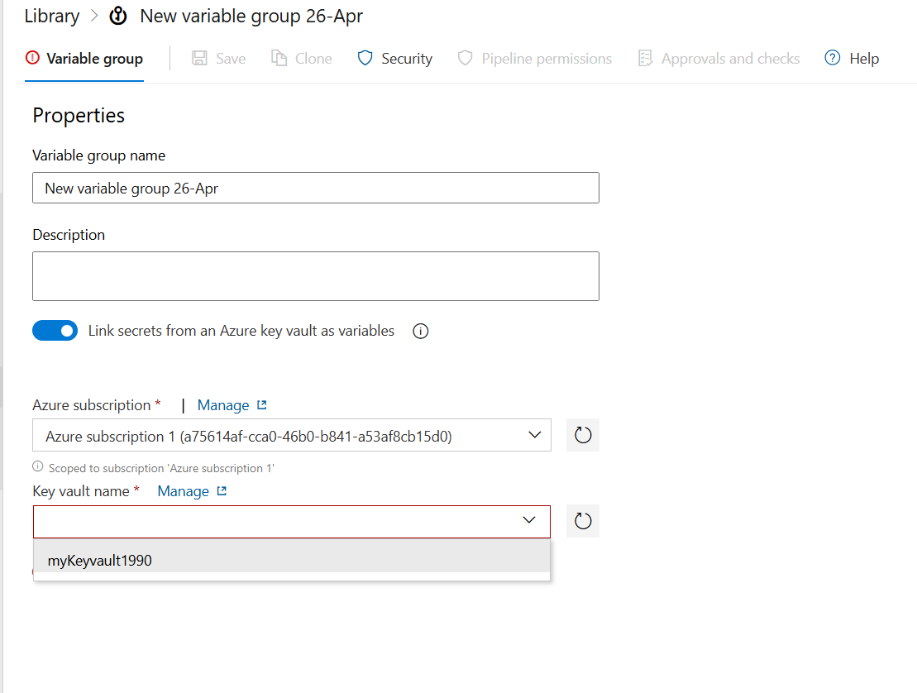

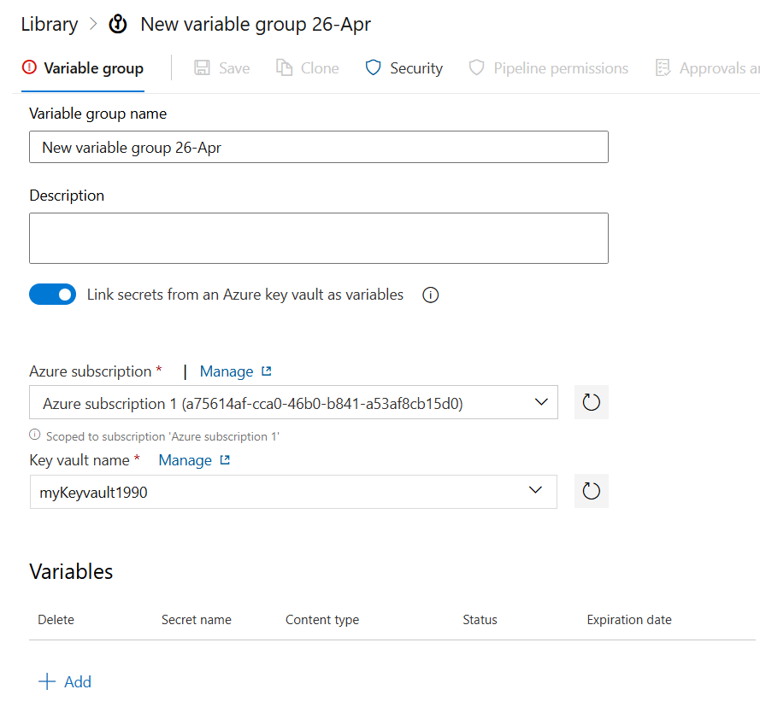

Click on :
+add→select your secret→ ok—>click on save

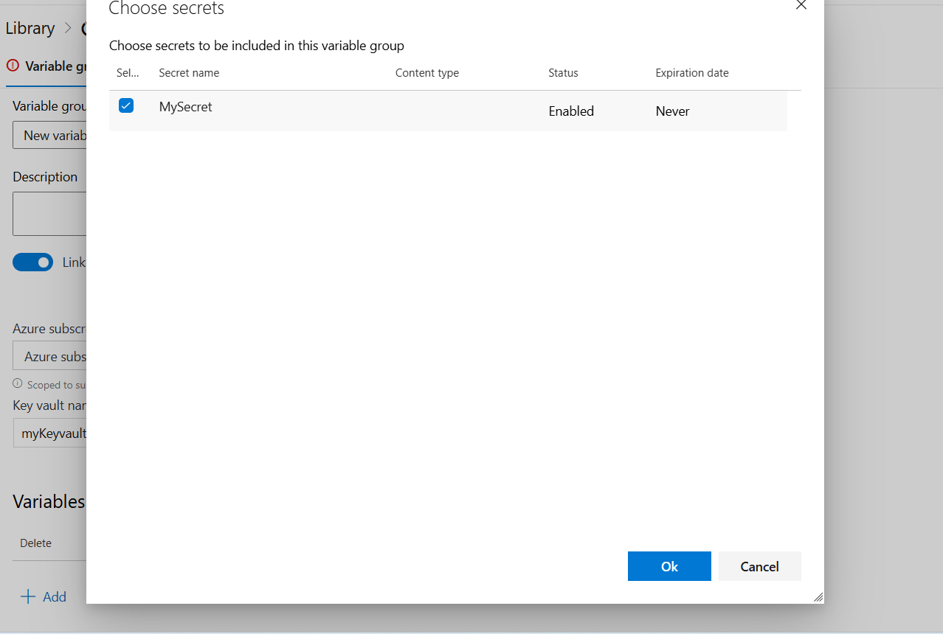

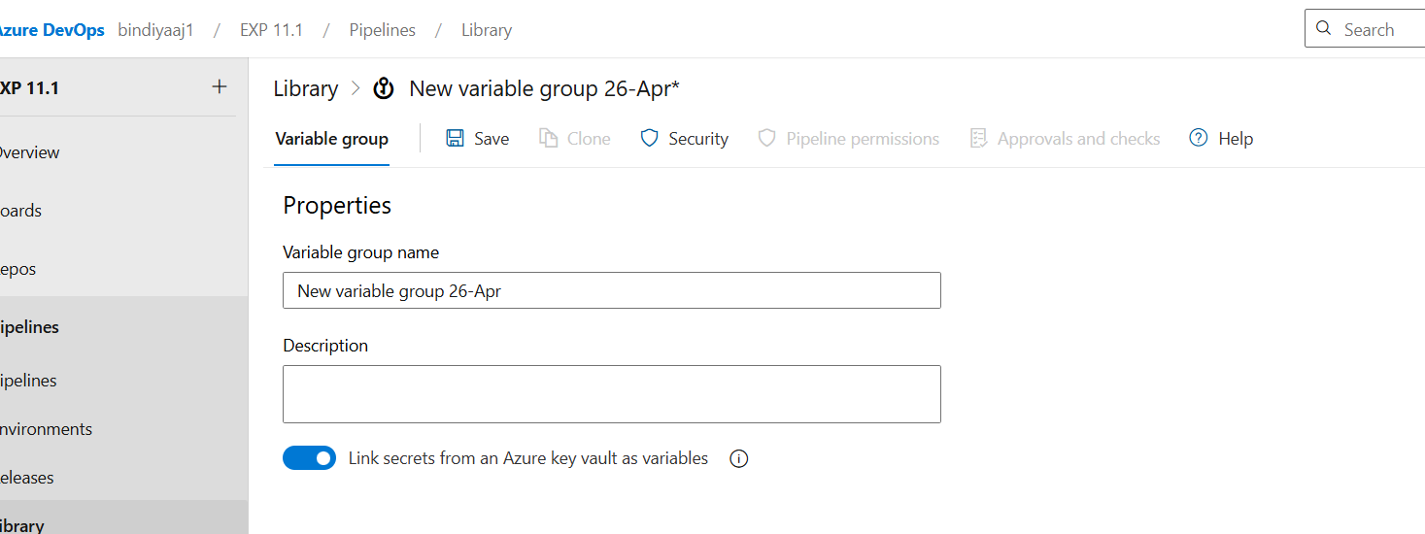

Now go to : pipeline →create pipeline —>select git→

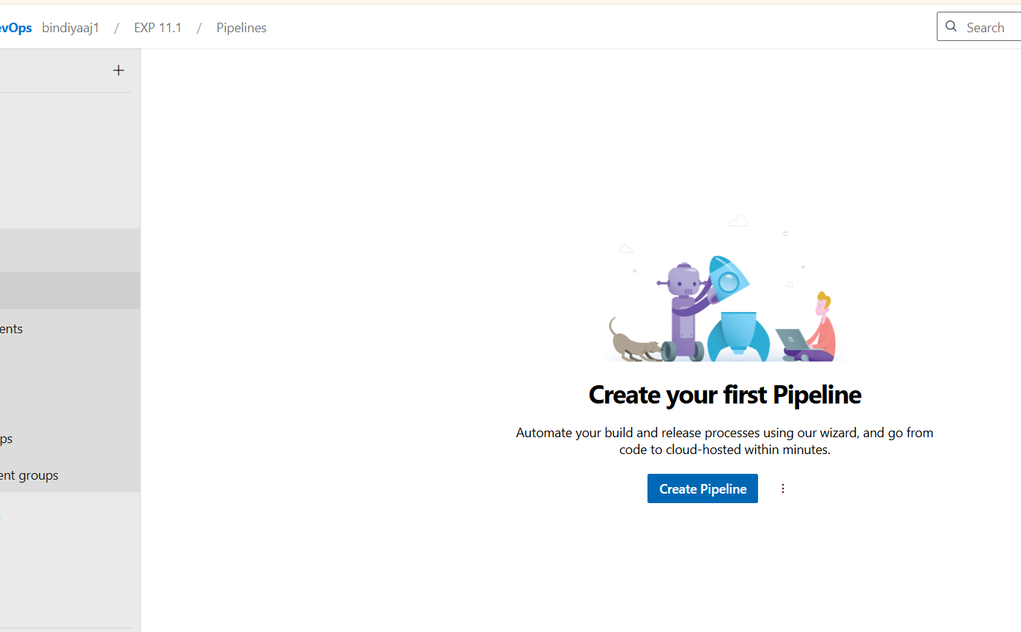

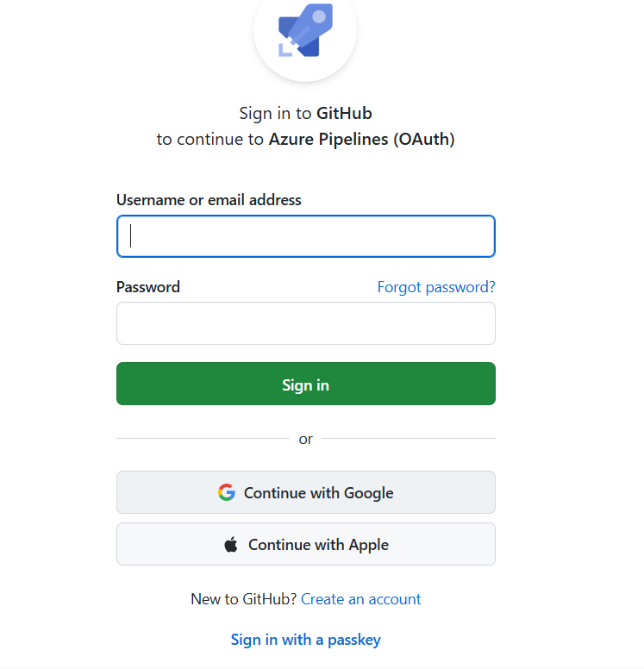

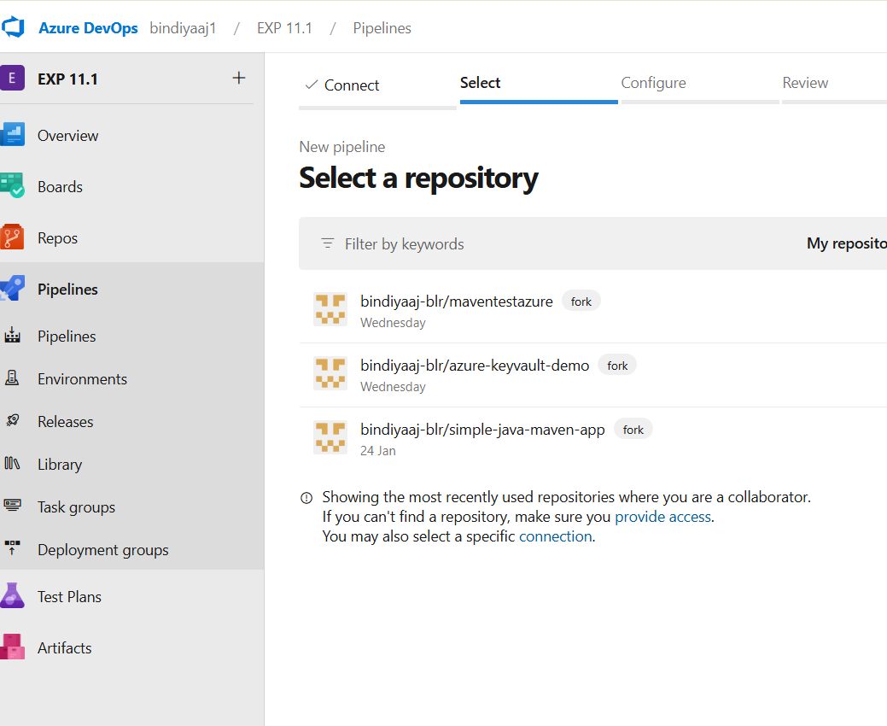

Click on “ azure-keyvault-demo”-->

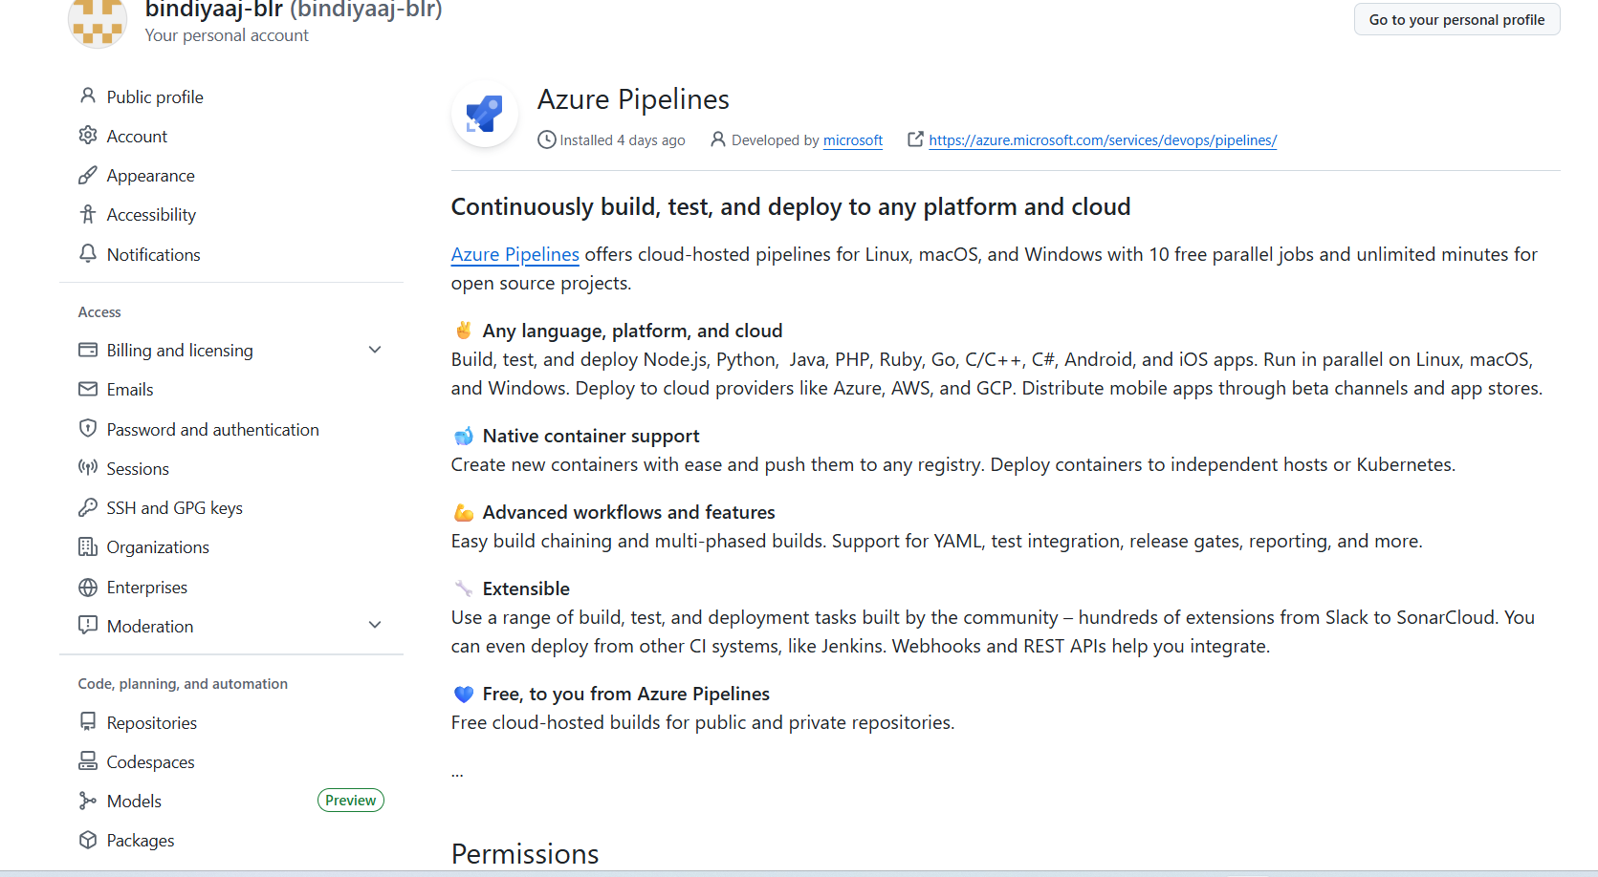

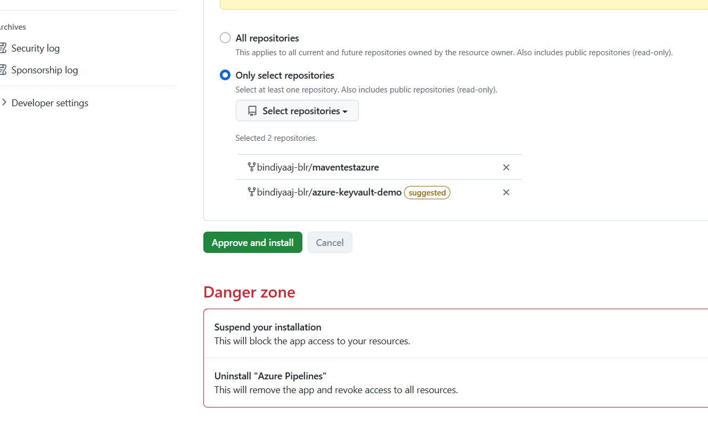

Click on :approve and install
It will ask for microsift login and finally directed to following screen
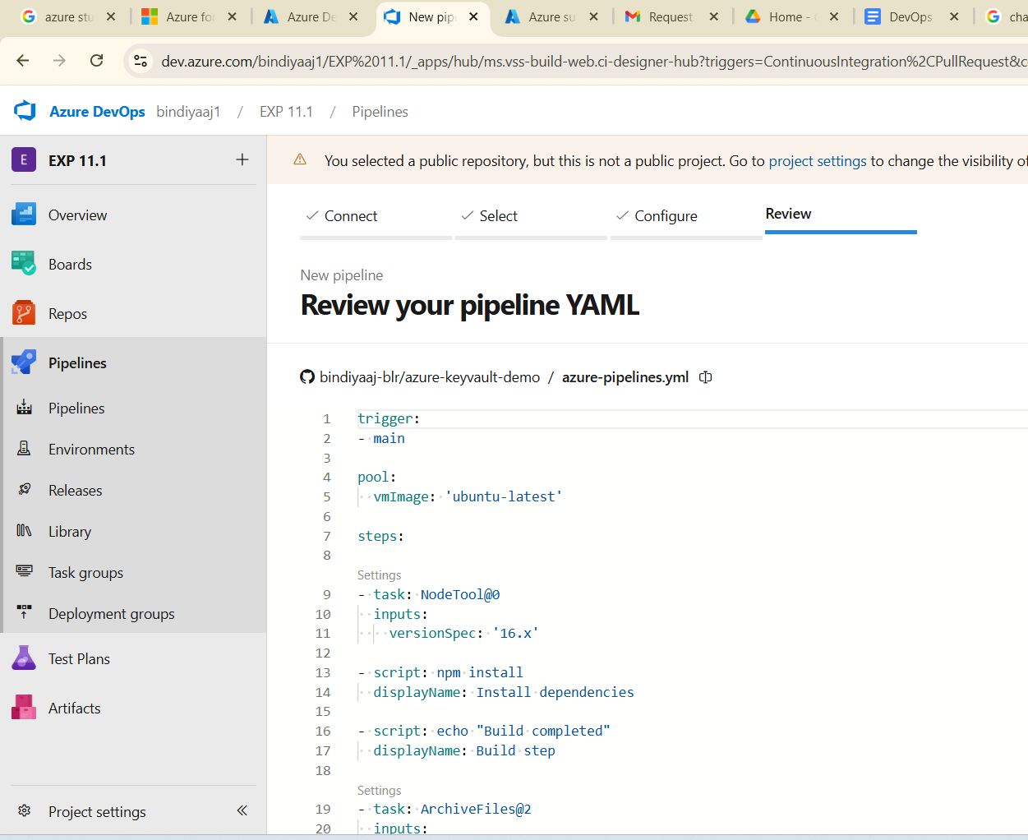

Now click on “RUN”

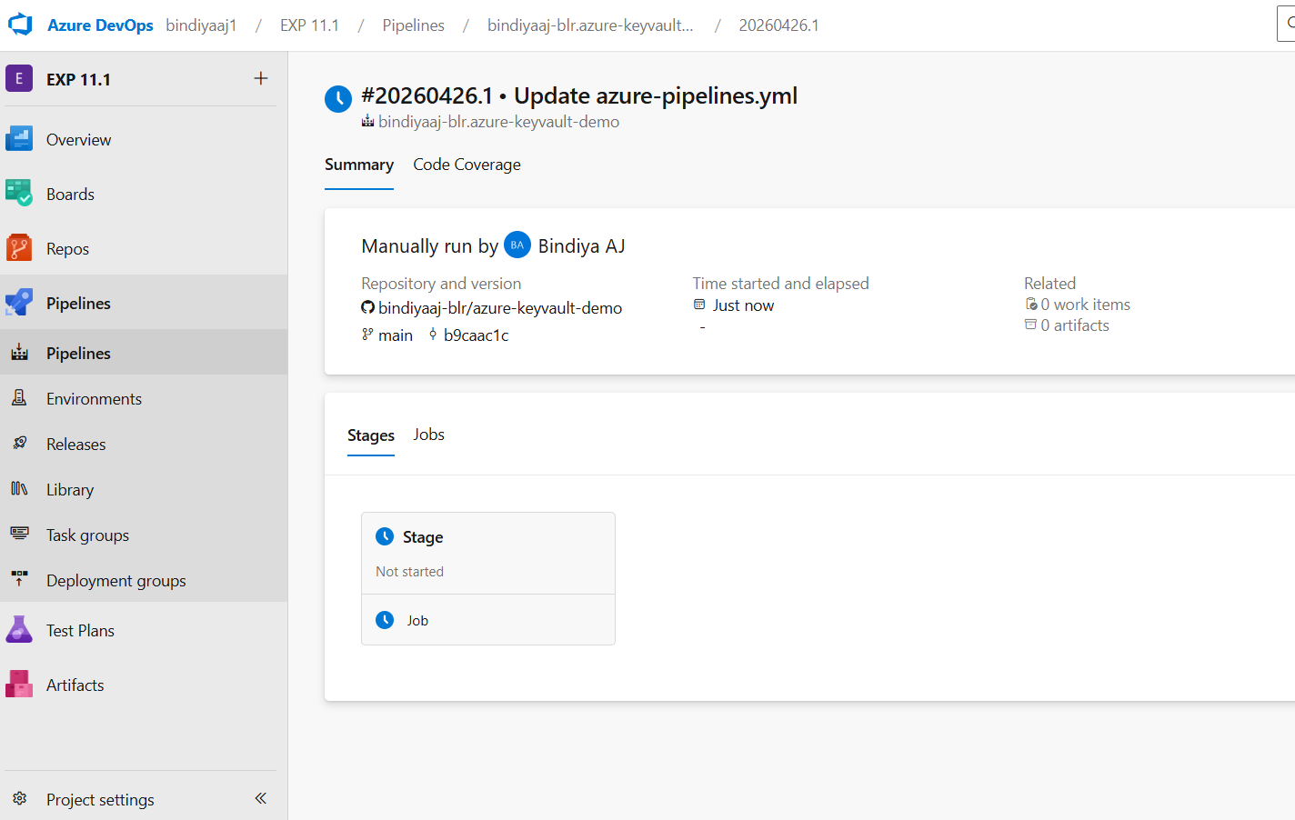

Click on “stage/job”
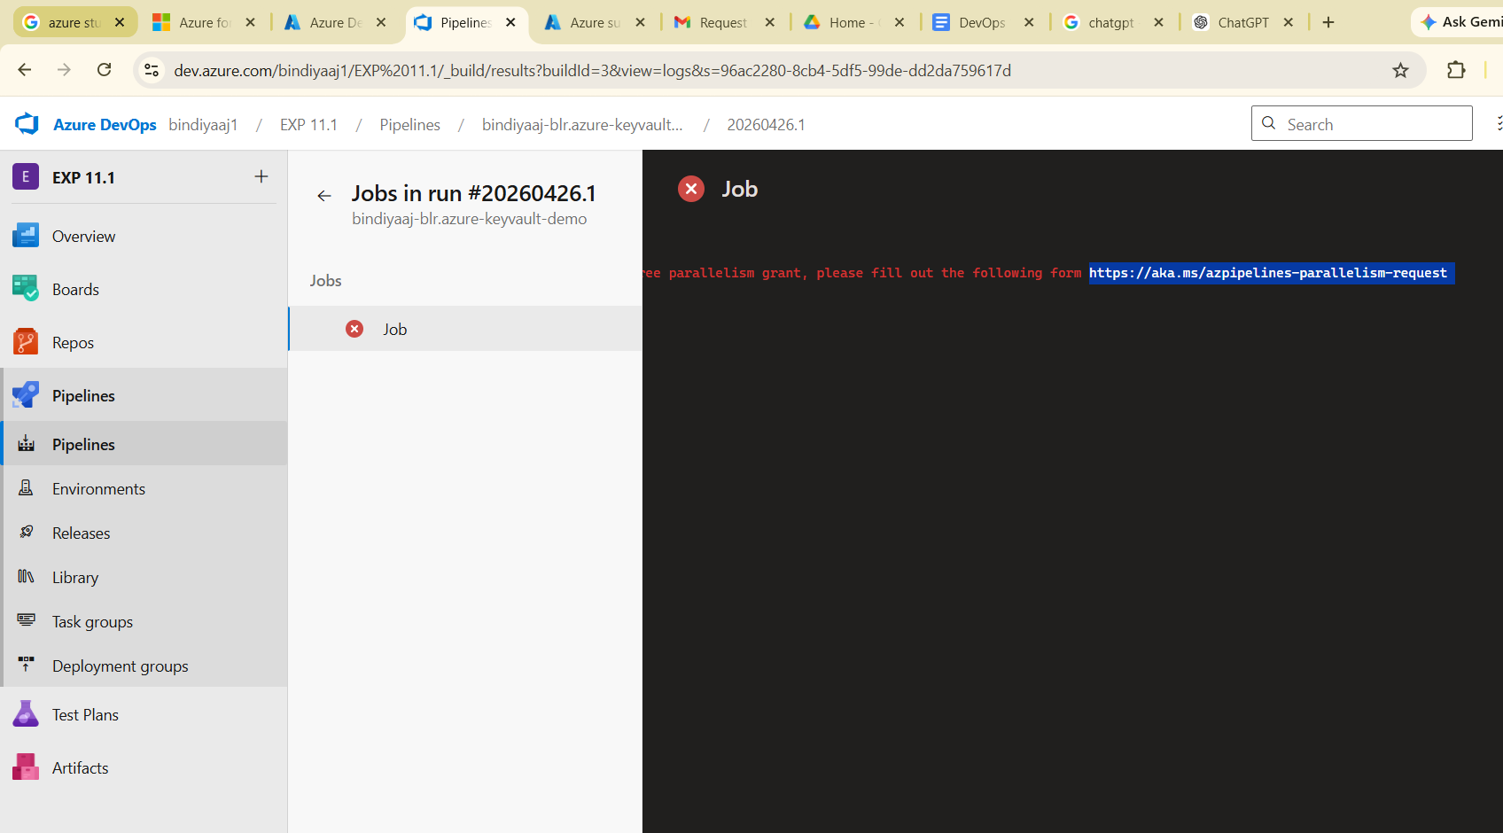

Fill the “request form”

https://aka.ms/azpipelines-parallelism-request

When you click on
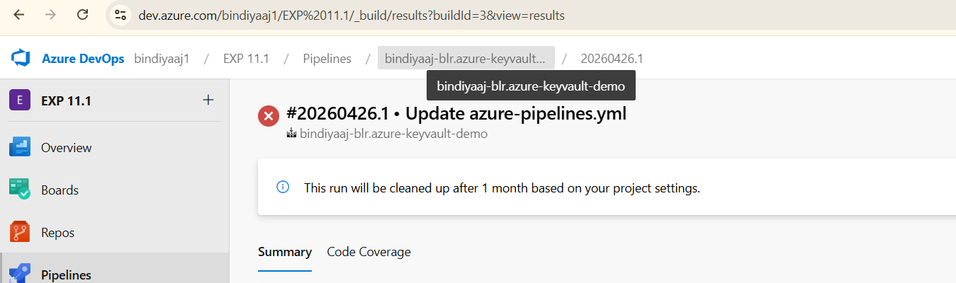

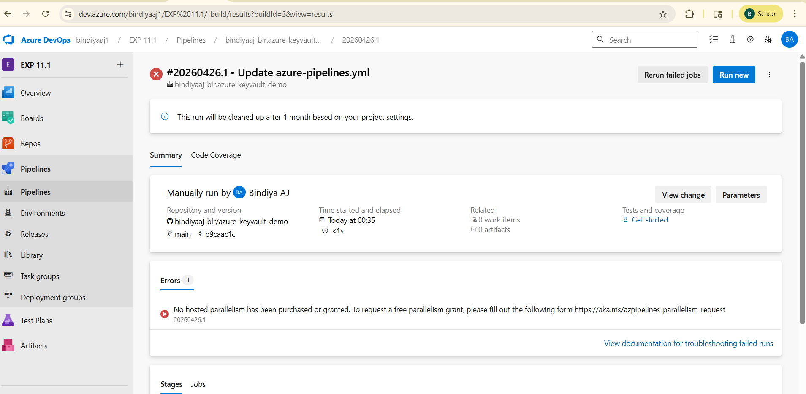

Click on “pipeline”

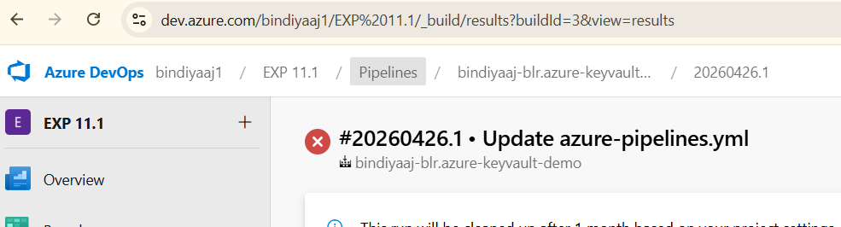

Goto “Pipeleine”-->release→>new pipeline

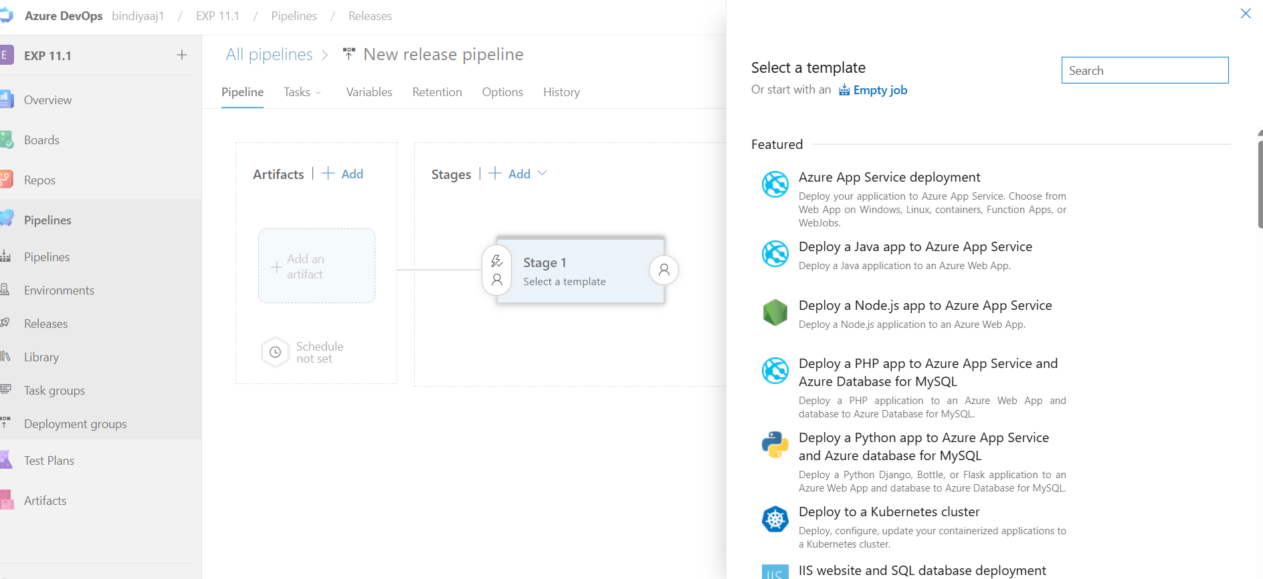

Select a template→empty job (on right->top)

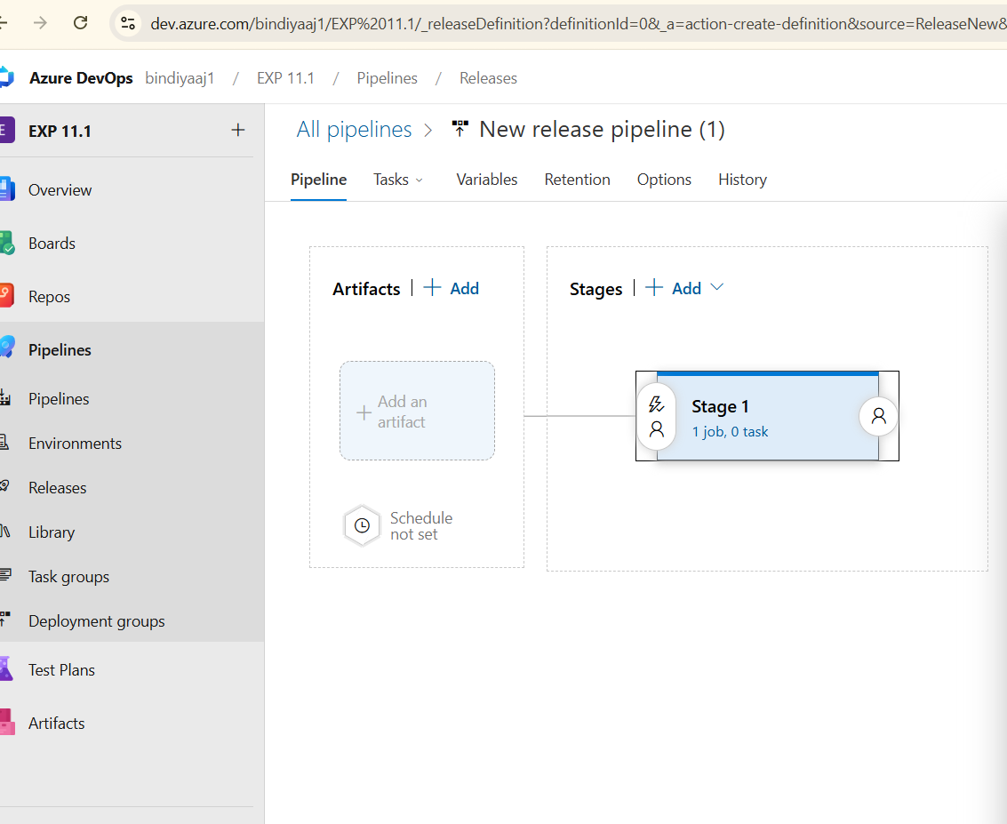

Click on stage1→jobs

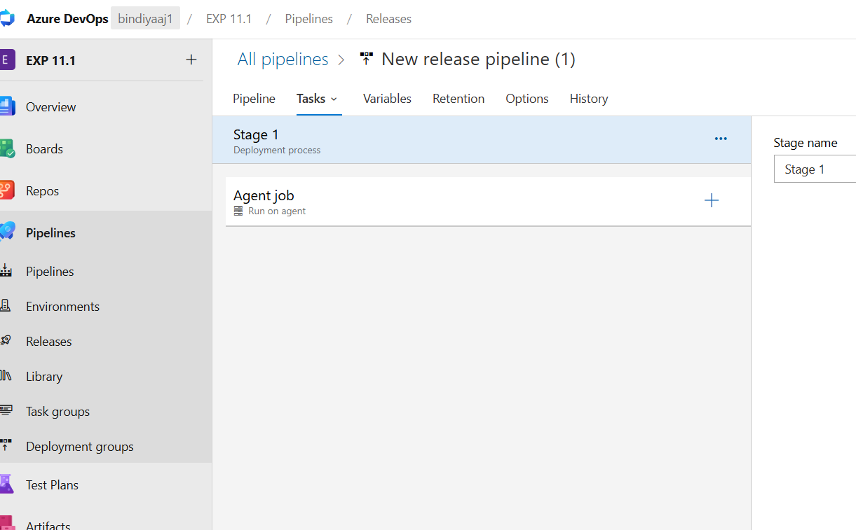

Click on “Agent Job” + —> “agent Job “vertical dots” || —>enter agent job details : such as “ agent pool→Agent pipelines” and “agent specification:windows-latest”

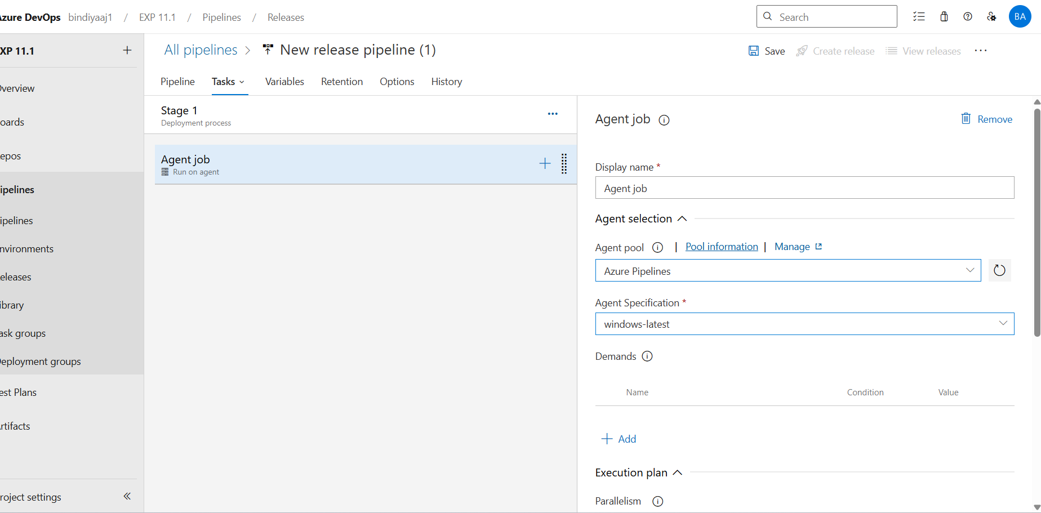
Click on “save” on top → click “ok”
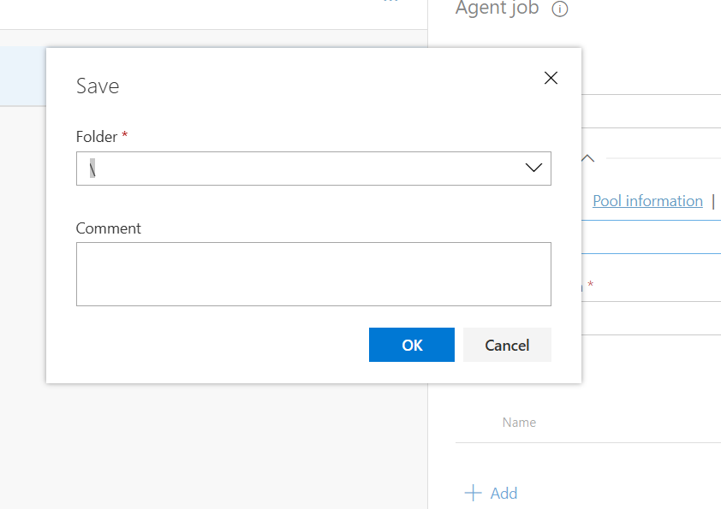

Click on “Agent Job +” → search “azure key vault” →add—>

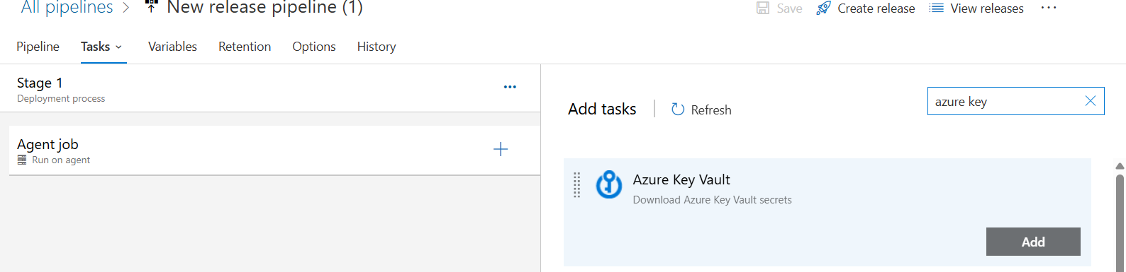

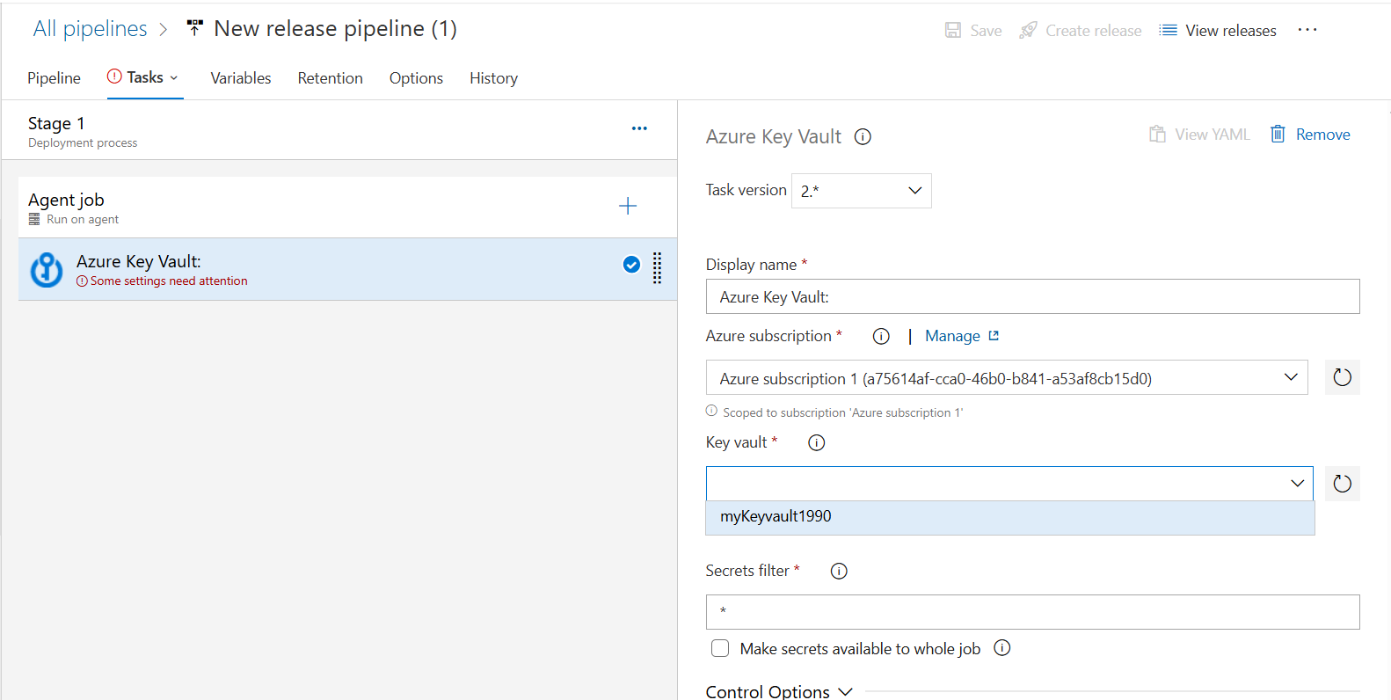

Select “Azure Key Vault” → enter “select “Azure Subscription” “→ select your “Key vault” → save
—-------------------------------------------------------------------------------------
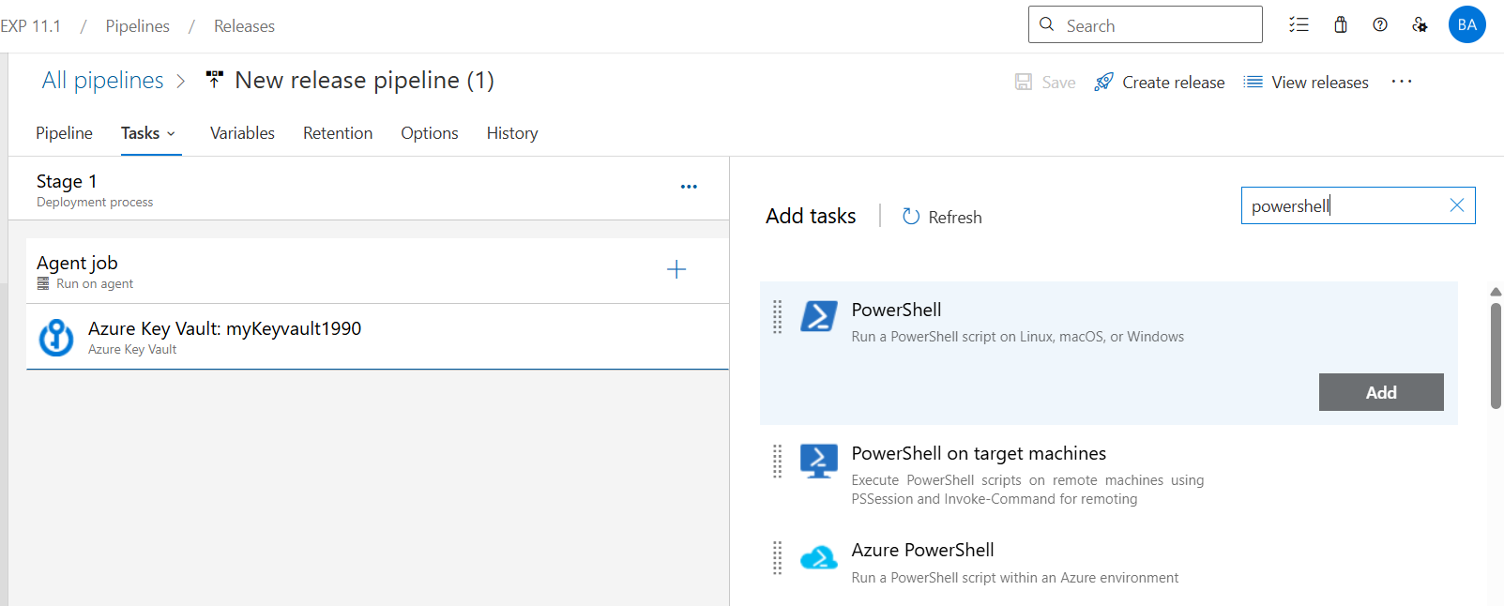

Search “power shell” → add —> select power shell→ select “inline”

Under scripts → add below code
Write-Host "$(MySecret)"

Here MySecret is the name of the “secret key” you created earlier

Click “save” → OK
—------------------------------------------------------------------------------------
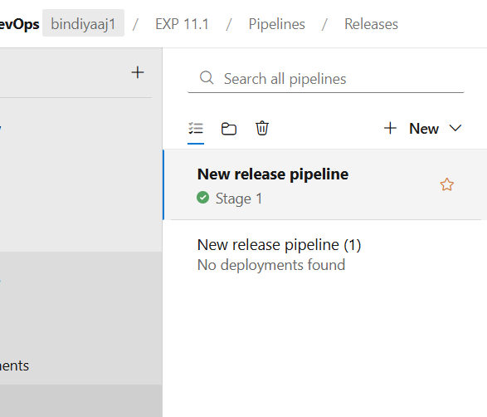

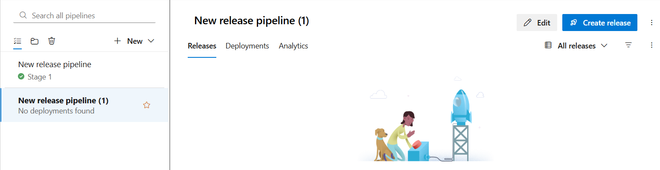

Go to “pipeline” —> releases →click on “new release pipeline”--> click on create release (right top)
—-------------------------------------------------
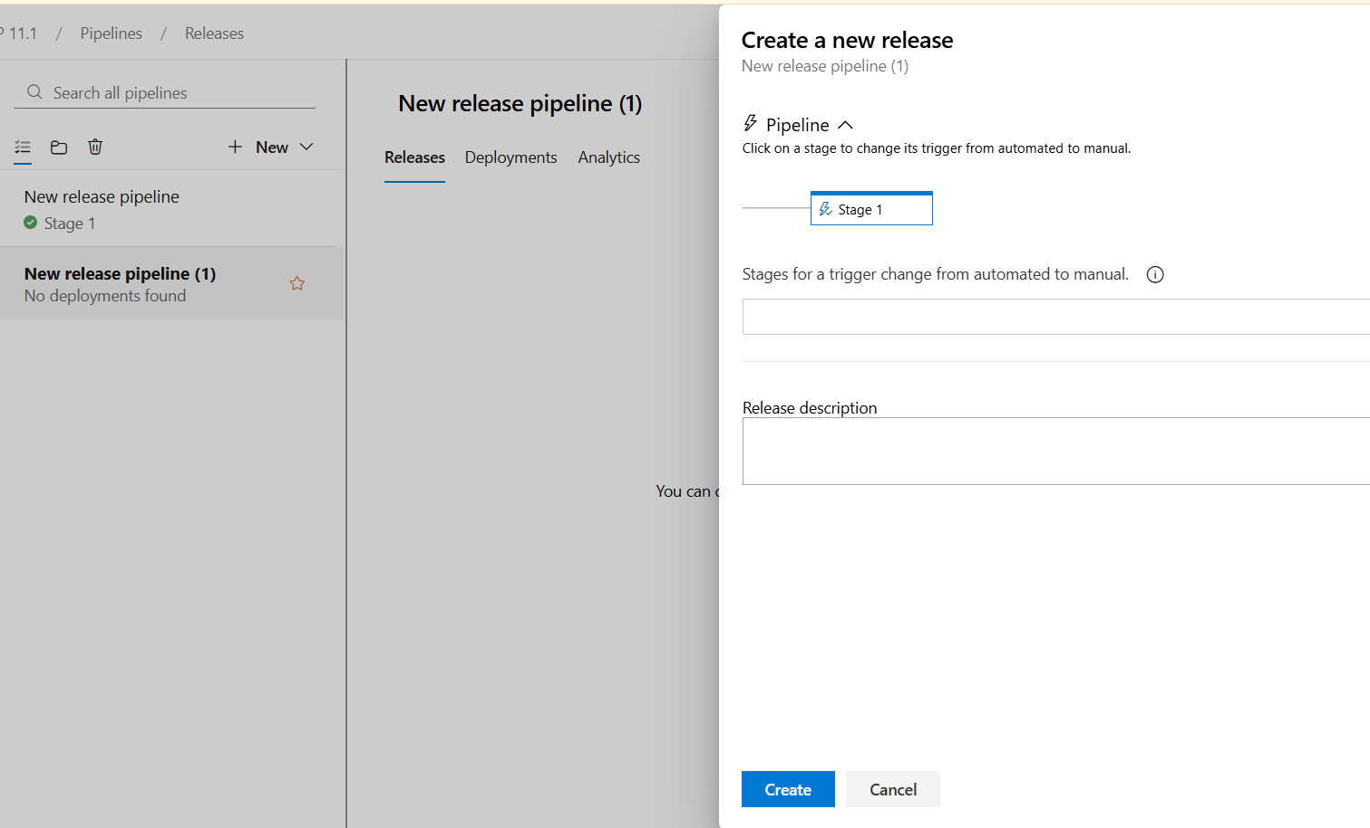

Click → create
—---------------------------------
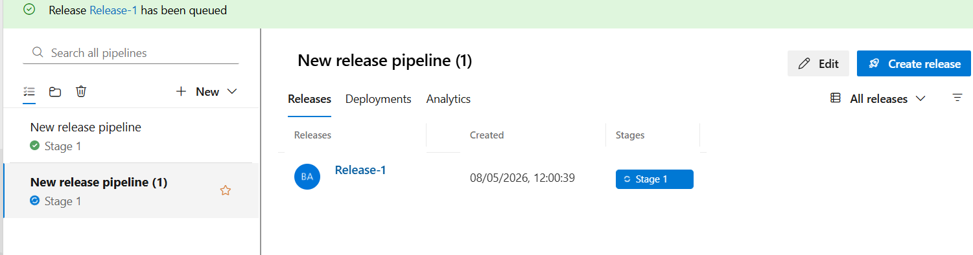

Wait for some seconds
—----------------------------------------

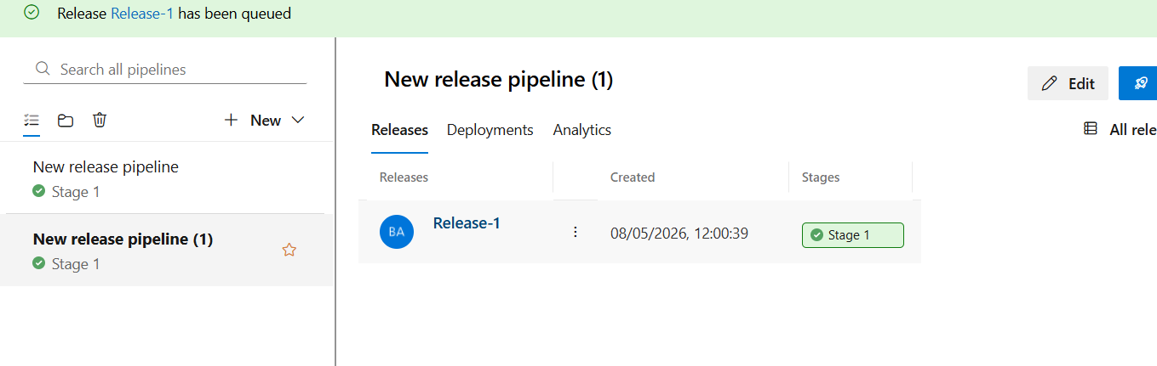

Click on “ Release-1” blue color

—------------------------------------------------------------------------

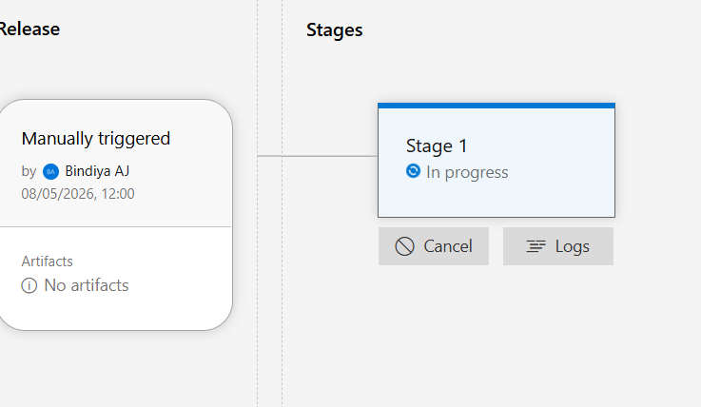
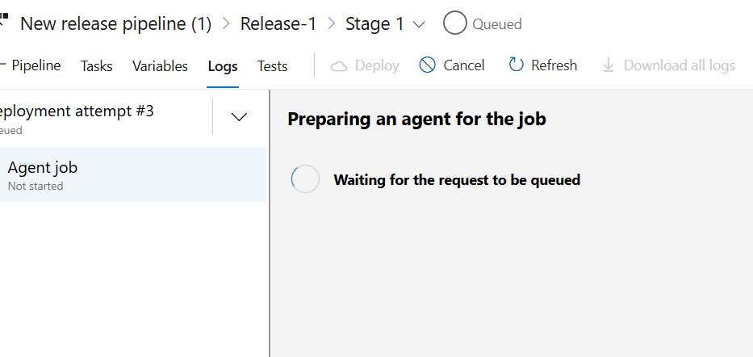

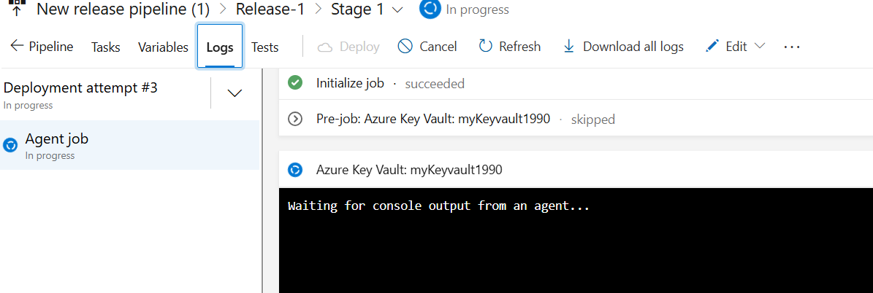

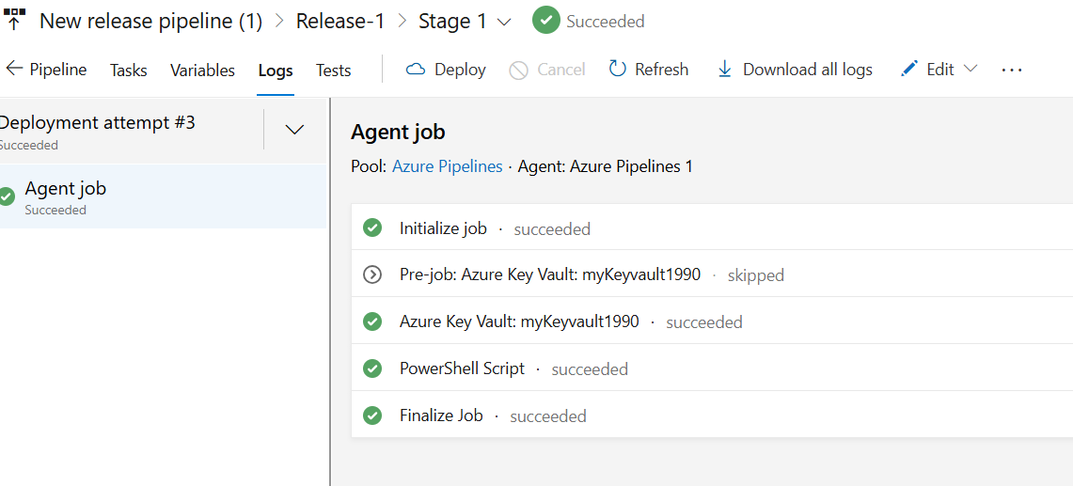

Click on “stage 1” → wait for few seconds—> if you click on logs you will find the stages in release
—---------------------------------------------------------------

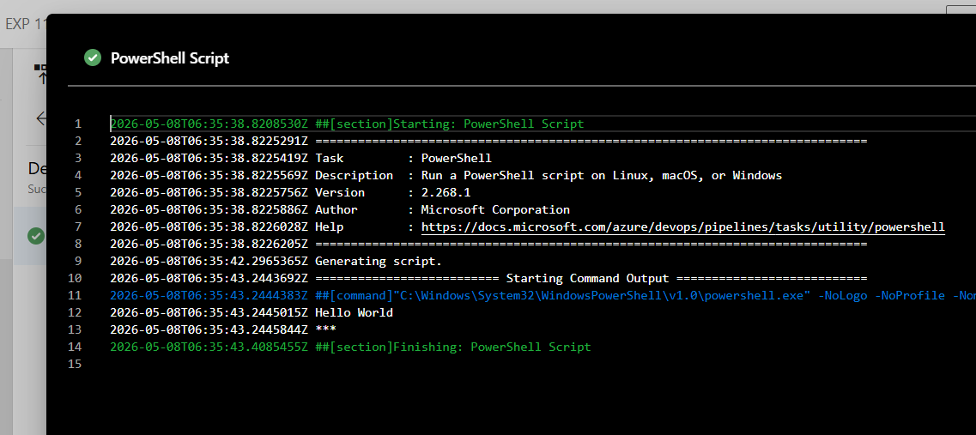

If you click on “ poweshell scrpt” —> you can see “hello world” and secret key : ***

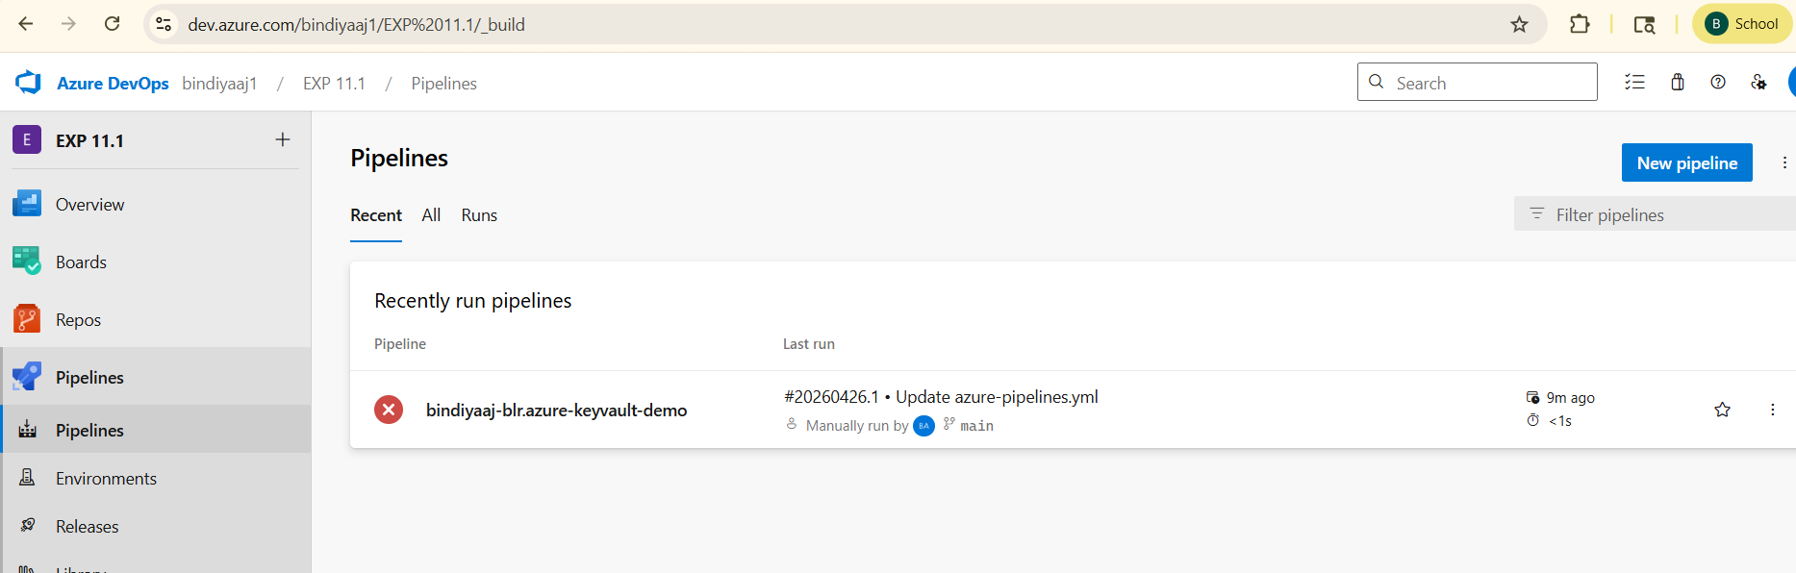

Goto :”Exp 11.1”

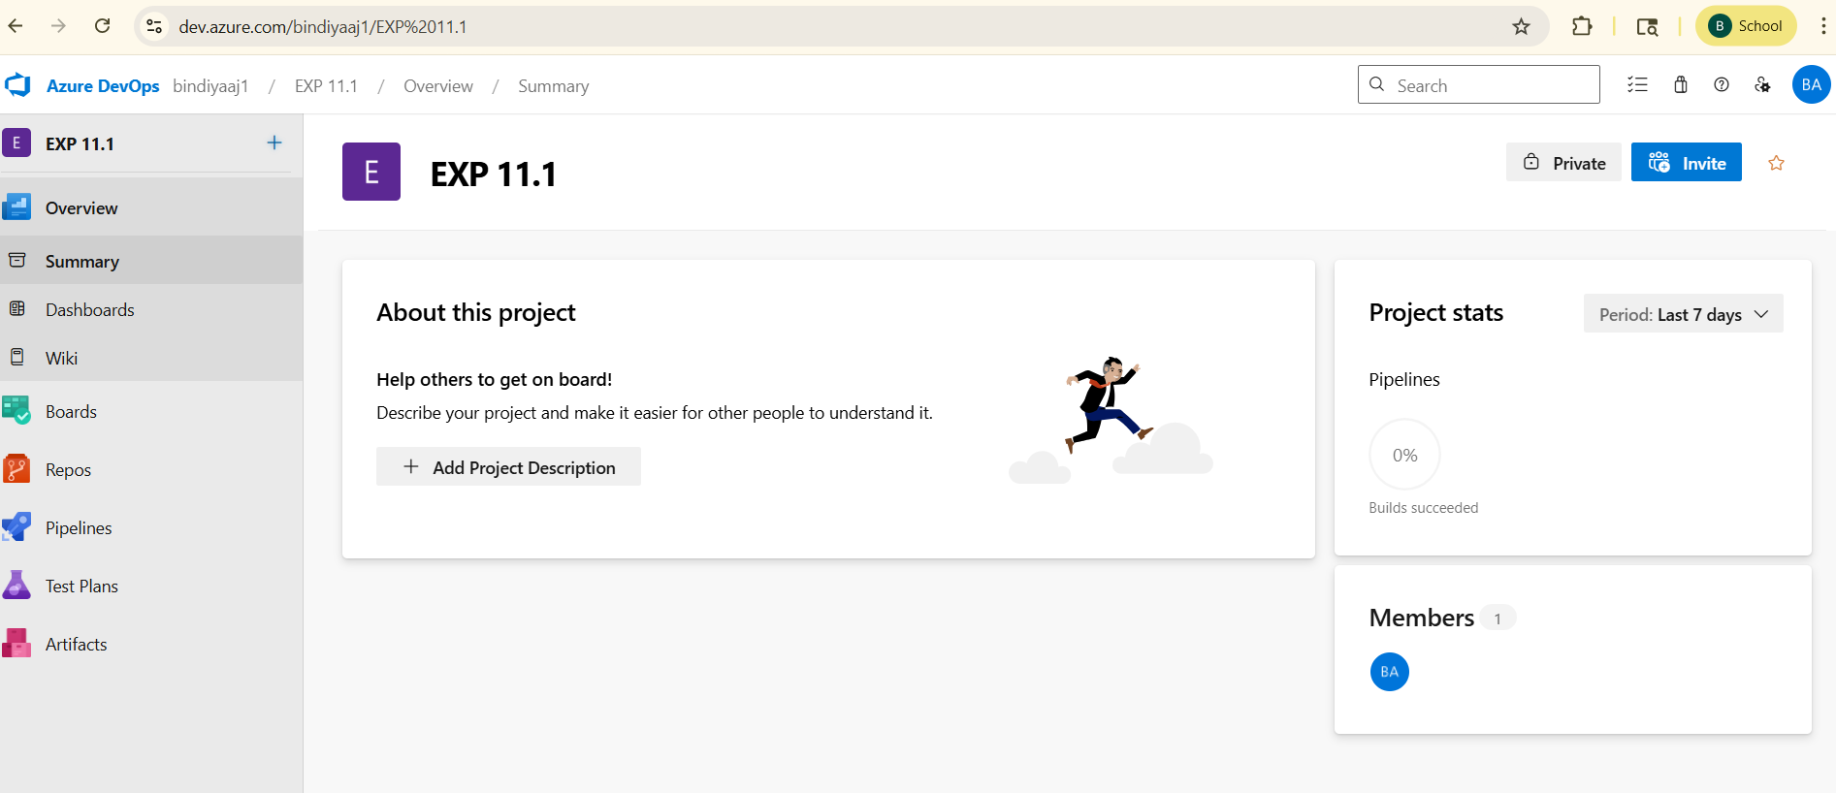

_________________________________________________________________________________________________________

*******************************************************************************************************

Program 12:
Practical Exercise and Wrap-up for Build and Deploy a Complete DevOps Pipeline. Title: Build and Deploy a Complete DevOps Pipeline This program exercise helps you apply all major DevOps tools in one integrated workflow.

OObjective: To build and deploy a complete CI/CD pipeline using tools like Git, Jenkins, Docker, and Kubernetes. Tools Required: Git (for version control) Jenkins (for CI/CD automation) Docker (for containerization) Kubernetes or Docker Compose (for container orchestration) GitHub (as the remote repository)A sample web app (Node.js, Python Flask, or any simple web app)

Steps to Implement the Pipeline: 1. Source Code Management (Git & GitHub): Create a GitHub repository and push a simple web app (e.g., Python Flask with app.py and requirements.txt).

Example repo structure: - app.py - requirements.txt - Dockerfile - Jenkinsfile

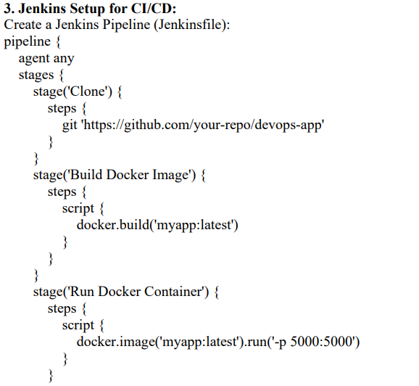

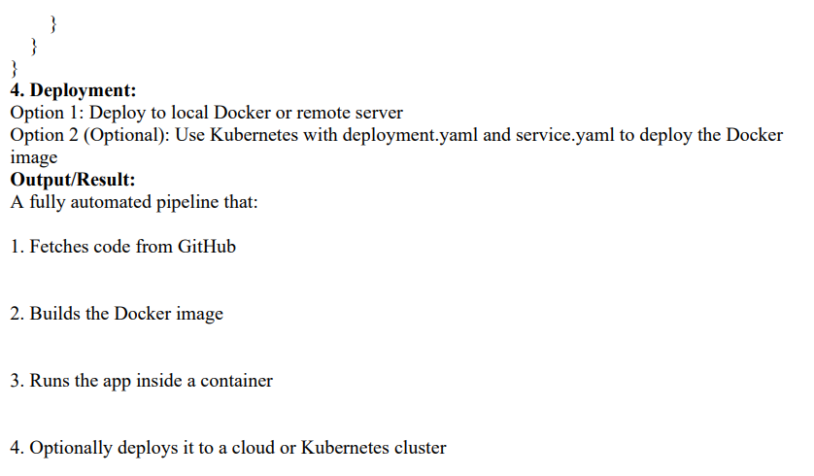

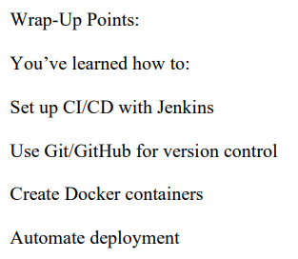

Additional Programs:
Experiment 1: Jenkins Automatic Build Trigger using Poll SCM
Aim
To configure Jenkins job for automatic build triggering using Poll SCM feature.
Requirements
- AWS EC2 Ubuntu Instance
- Jenkins installed
- Git installed
- GitHub repository
Theory
Poll SCM in Jenkins periodically checks the Git repository for changes. If changes are detected, Jenkins automatically triggers the build process.
Step 1: Connect to AWS EC2 Instance
ssh -i mykey.pem ubuntu@<public-ip>
Step 2: Verify Jenkins Service
sudo systemctl status jenkins
Expected Output:
active (running)
Step 3: Install Git
sudo apt install git -y
Step 4: Open Jenkins Dashboard
Open browser:
http://<public-ip>:8080
Login to Jenkins.
Step 5: Create New Freestyle Job
1. Click New Item
2. Enter Job Name: AutoBuildJob
3. Select Freestyle Project
4. Click OK
Step 6: Configure Git Repository
Under Source Code Management select Git.
Enter Repository URL:
https://github.com/username/repository.git
Step 7: Configure Poll SCM
Under Build Triggers select Poll SCM.
Enter schedule:
* * * * *
Jenkins checks repository every minute for code changes.
Step 8: Add Build Step
Under Build Steps select Execute Shell.
Add command:
echo "Automatic Build Triggered"
date
Step 9: Save Jenkins Job
Click Save.
Step 10: Modify GitHub Repository
git add .
git commit -m "Updated project"
git push origin master
Step 11: Observe Automatic Build
Jenkins automatically starts build after detecting repository changes.
Step 12: View Console Output
Click Build Number → Console Output
Expected Output:
Automatic Build Triggered
Output
Jenkins automatically detects repository changes and triggers build successfully.
Result
Successfully configured Jenkins automatic build trigger using Poll SCM on AWS EC2 machine.

Experiment 2) Install and Run Docker Container on AWS EC2

Aim
To install Docker on AWS EC2 instance and run an Nginx container.

Requirements
- AWS Account
- EC2 Ubuntu Instance
- SSH Key Pair
- Internet Connection

Step 1: Launch AWS EC2 Instance
1. Login to AWS Console
2. Open EC2 Dashboard
3. Click Launch Instance
4. Select Ubuntu Server and t2.micro
5. Create/Select Key Pair
6. Allow SSH (Port 22) and HTTP (Port 80)
7. Launch Instance

Step 2: Connect to EC2 Instance
ssh -i mykey.pem ubuntu@<public-ip>

Step 3: Update System Packages
sudo apt update

Step 4: Install Docker
sudo apt install docker.io -y

Step 5: Start Docker Service
sudo systemctl start docker
sudo systemctl enable docker

Step 6: Verify Docker Installation
docker --version

Step 7: Pull Nginx Docker Image
sudo docker pull nginx

Step 8: Run Nginx Container
sudo docker run -d -p 80:80 nginx

Step 9: Check Running Containers
sudo docker ps

Step 10: Verify Output in Browser
Open browser and enter:
http://<public-ip>
Output:
Welcome to nginx!

Output
Docker container runs successfully on AWS EC2 instance.

Result
Successfully installed Docker and deployed Nginx container on AWS EC2 machine.

